

**COMSATS University Islamabad (CUI)**

**Digital Bites**

***By***

**Nida Shahid CIIT/FA16-BCS-014/ISB**

**Areeb Siddiqui CIIT/FA16-BCS-084/ISB**

**Taha Jamil CIIT/FA16-BCS-114/ISB**

***Supervisor*Mr. Tehseen Riaz Abbasi**

***Bachelor of Science in Computer Science (2016-2020)***

**The candidate confirms that the work submitted is their own and appropriate  
 credit has been given where reference has been made to the work of others**.



**COMSATS University Islamabad (CUI)**

**Digital Bites**

**A project presented to**

**COMSATS Institute of Information Technology, Islamabad**

**In partial fulfillment**

**of the requirement for the degree of**

***Bachelors of Science in Computer Science (2016-2020)***

**By**

**Nida Shahid CIIT/FA16-BCS-014/ISB**

**Areeb Siddiqui CIIT/FA16-BCS-084/ISB**

**Taha Jamil CIIT/FA16-BCS-114/ISB**

**DECLARATION**

We hereby declare that this software, neither whole nor as a part has been copied out from any source. It is further declared that we have developed this software and accompanied report entirely on the basis of our personal efforts. If any part of this project is proved to be copied out from any source or found to be reproduction of some other. We will stand by the consequences. No Portion of the work presented has been submitted of any application for any other degree or qualification of this or any other university or institute of learning.

|  |  |  |
| --- | --- | --- |
| Nida Shahid | Taha Jamil | Areeb Siddiqui |
| --------------------------- | --------------------------- | --------------------------- |

**CERTIFICATE OF APPROVAL**

It is to certify that the final year project of BS (CS) “Digital Bites” was developed by   
**Nida Shahid (CIIT/FA16-BCS-014), Areeb Siddiqui (CIIT/FA16-BCS-084)** and **Taha Jamil (CIIT/FA16-BCS-114)** under the supervision of “SUPERVISOR NAME” and co supervisor “CO-SUPERVISOR NAME” and that in (their/his/her) opinion; it is fully adequate, in scope and quality for the degree of Bachelors of Science in Computer Sciences.

---------------------------------------

**Supervisor**

---------------------------------------

**Co-Supervisor**

---------------------------------------

**External Examiner**

---------------------------------------

**Head of Department**

**(Department of Computer Science)**

**Executive Summary**

In public places, there is often a need for monitoring people and different activities going on, which can be referred later for many reasons including security. Appointing humans for this task involves many problems such as increased employee hiring, accuracy problem, trust, no proof for later use, and also the fact that a human can remember things till a certain time limit. Talking about the current security system, they use dumb still cameras with a continuous recording facility irrespective of the fact that any event may happen or not. Moreover, they are usually pointing at a specific user defined location so more than one cameras are required to cover the entire region.

To prevent all these problems from prevailing, the CSCS is developed. It is a surveillance system, which provides solution to many of these problems. It is a stand-alone application which doesn’t require any computer to operate. It monitors different situations using a camera which is able to rotate intelligently based on sensor messages and captures the scene in the form of video or photos later reference as well.

**C**ustomizable **S**urveillance **C**ontrol **S**ystem **(CSCS)** is a surveillance system that can be assigned a sensor type as in our case a heat sensor is used, it works accordingly, rotates the camera upon event detection and perform user defined actions like capturing video and stores them, for the future use.

It is an embedded system consisting of Linux fox kit with embedded a running server application also a camera, USB storage device and a sensor node base station is attached with fox kit. LAN communication is used by user to download the videos and to operate the system manually.

**Acknowledgement**

All praise is to Almighty Allah who bestowed upon us a minute portion of His boundless knowledge by virtue of which we were able to accomplish this challenging task.

We are greatly indebted to our project supervisor “Dr. Majid Iqbal Khan” and our Co-Supervisor “Mr. Mukhtar Azeem”. Without their personal supervision, advice and valuable guidance, completion of this project would have been doubtful. We are deeply indebted to them for their encouragement and continual help during this work.

And we are also thankful to our parents and family who have been a constant source of encouragement for us and brought us the values of honesty & hard work.

|  |  |  |
| --- | --- | --- |
| Nida Shahid | Taha Jamil | Areeb Siddiqui |
| --------------------------- | --------------------------- | --------------------------- |

**Abbreviations**

|  |  |
| --- | --- |
| **SRS** | Software Requirement Specification |
| **PC** | Personal Computer |
|  |  |
|  |  |
|  |  |

**Table of Contents**

**1 Introduction** 1

1.1 Brief Overview 1

1.2 Relevance to Course Modules 1

1.3 Project Background 1

1.4 Literature Review 1

1.5 Analysis from Literature Review 1

1.6 Methodology and Software Lifecycle for this Project 1

1.6.1 Rationale behind the Selected Methodology 1

**2** **Problem Definition** 3

2.1 Problem Statement 3

2.2 Deliverables and Development Requirements 3

2.3 Current Systems 3

**3** **Requirement Analysis** 4

3.1 Use Cases Diagram(s) 4

3.2 Detailed Use Cases 4

3.3 Functional Requirements 4

3.4 Non-Functional Requirements 4

**4 Design and Architecture** 5

4.1 System Architecture 5

4.2 Data Representation 5

4.3 Process Flow/Representation 5

4.4 Design Models 5

**5** **Implementation** 7

5.1 Algorithm 7

5.2 External APIs 7

5.3 User Interface 7

**6 Testing and Evaluation** 8

6.1 Manual Testing 8

6.1.1 Unit testing 8

6.1.2 Integration Testing 9

6.1.3 Functional Testing 9

6.1.4 System Testing 10

6.2 Automated Testing 10

**7** **Conclusion and Future Work** 12

7.1 Conclusion 12

7.2 Future Work 12

**8** **References** 13

**List of Figures**

Fig 1.1 Block Diagram 1

Fig 2.1 Use Case Diagram 2

# 

# Introduction

The food industry is a fast-growing evergreen industry consisting of growing numbers of restaurants and cafes with high competition. These restaurants try to keep up with their competitors. Moreover, customers have a hard time knowing what they want to eat, sometimes they are confused with the names and have a hard time making a choice. This problem will be solved by our augmented view which is a digital menu to give a real feel to customers what they are ordering. New restaurants also find it hard to grow which is tackled by our social campaigning feature. Sometimes customers don’t know if a restaurant is worth trying or not, this problem will be solved by our detailed ranking with rating and reviews, by this customers will also know which restaurant is best for a particular cuisine, and our app will help them locate the near-by restaurants sorted by their rankings and reviews, also our notification service will promote new restaurants and deals. The customers won’t have to wait for long and they won’t have to keep dialing the restaurant in order to know the status of their order. They can see and track their order easily through our app.

## Brief Overview

A very brief introduction of project work, outcome of your work, tools, methodology used & highlights of discussions in various chapters of report.

## Relevance to Course Modules

This project was very much related to the subjects we have studied earlier in the degree. Lot of OOP concepts were used in building or implementing stage. Also it was relative to the Web concepts and MongoDB from the course of Topics in CS-I. Basics of the ICT were used as well. Many concepts were introduced to us in the Mobile Development course that helped us in implementing the application.

## Project Background

We are going to develop **Digital Bites** application. This will allow users to view food in augmented reality, virtual tour of restaurant and to track their orders. This application will be a good product for food industry Digital Bites implementing augmented reality and virtual tour attract more customer and enhance customer experience. Digital Bites application will act as a **bridge** for **customers** to discover **new places** and services.

This application will also allow the customers to view 3D models of the selected food items on their table while ordering-in. This 3D visualization helps the users to understand what they want to order. Through Digital Bites application, customers can take a **virtual tour** of the restaurant. We are also providing **reports services** for admin which help them in decision making about the restaurant.

## Literature Review

There are many food industry related applications around that provide users with the facility of viewing nearby restaurants in their area and placing an order through it. But our application not only allows that facility, it also helps the users to view the food items through augmented reality so as to have a real feel of what they’re about to order.

## Analysis from Literature Review

Following are the related Systems corresponding to our project:

Table 1: Related System Analysis with proposed project solution

|  |  |  |
| --- | --- | --- |
| **Application Name** | **Weakness** | **Proposed Project Solution** |
| Yelp’s Monocle | It doesn’t allow you to view 3D models of food items. No information about serving size, nutritional value and ingredients are included. | Our system allows you to see your nearby restaurants with 3D models of their food items, serving size etc. |
| Pizza Hut interactive restaurant menu | The user is limited to the experience of only Pizza Hut. | Our system allows the customer to explore their restaurant options and experience multiple restaurants. |
| Food Panda | It doesn’t have the feature of AR based menu with interactive 3D models of food items. | Our system allows the customers to interact with 3D models using AR. |

## Methodology and Software Lifecycle for this Project

A brief discussion of methodology and SDLC model selected for this project.

### Rationale behind the Selected Methodology

### Software Process Methodology

For this project, we will be using iterative and incremental development. We will be producing deliverables after a specific period or time; these deliverables will then be integrated together on the basis of their completion. This development gives us the advantage of incorporating changes into the project without having to revert into the very first Inception Phase.

### Software Design Methodology

For this project, we will be using the Object-Oriented approach and methodology, which will enable us to divide tasks and functions easily to make the code easier to implement, understand and debug.

# Problem Definition

This project is aimed for the people who want a feel of what they are ordering. Customers don’t get to see what they are ordering. They sometimes also get confused in different names like for example in Italian dishes they don’t know what Alfredo Fettuccine pasta is and what it looks like. Customers also have a hard time finding nearby or distant locations of restaurant sorted by their reviews and ratings. Some restaurants are better than others, but they are not known by many customers due to lack of exposure. Customers also cannot figure out sometimes which restaurant is best for a specific kind of dish and how does the restaurant look like and how much space it has. For restaurants time management is a big deal, orders are sometimes out of track and delayed. The managing of delivery time is poor for most of the restaurants. Customers also can’t see the track of their order and where did it reach.

Our system has an importance in food industry to tackle major problems and in public services to aid the customers of the industry. No other such same system is out there. From this project we will be learning react-native development, augmented reality, virtual reality, web development and database management.



## Problem Statement

Problem statement goes here. It is important to re-check the problem statement by consulting with your supervisor/co-supervisor.

## Deliverables and Development Requirements

The deliverables and development requirements of the project includes the following:

* Scope Document
* SRS
* SDS
* STP

# Requirement Analysis



## Use Cases Diagram(s)

**Figure 3.1.1: Admin Use Case Diagram**

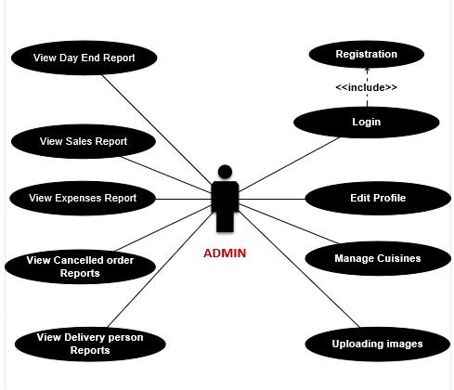

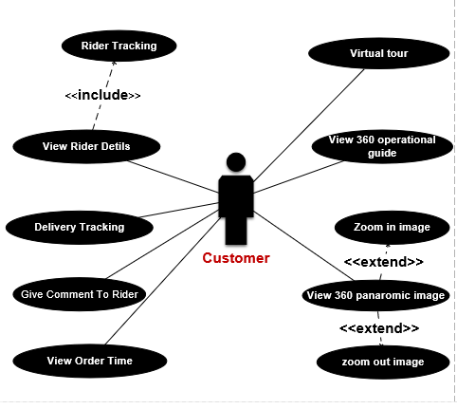

**Figure 3.1.2.2: Customer Use Case Diagram**

**Figure 3.1.2.3: Customer Use Case Diagram**

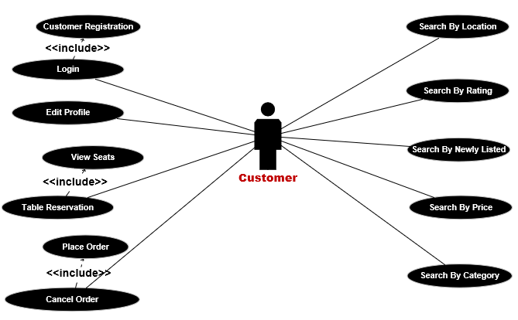

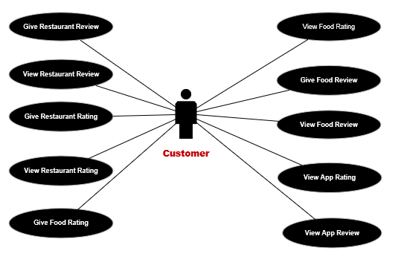

**Figure 3.1.2.4: Customer Use Case Diagram**

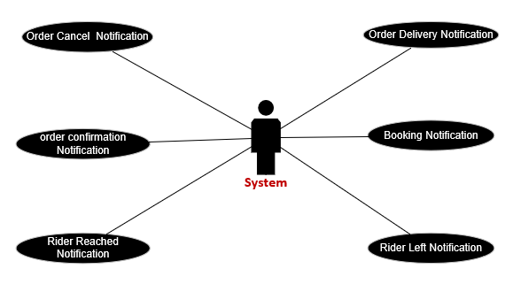

**Figure 3.1.3: System Use Case Diagram**

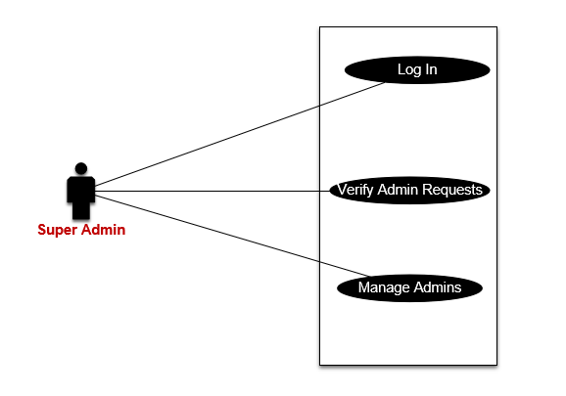

**Figure 3.1.4: Super Admin Use Case Diagram**

## Detailed Use Case

Below are the detailed use cases of Digital Bites:

## Module 1: Profile Management

Below are the uses cases for Module-1:

1. **Super Admin Login**

|  |  |
| --- | --- |
| **Use Case ID:** | UC-1.1 |
| **Use Case Name:** | Super Admin Login |
| **Actors:** | Primary: Super Admin |
| **Description:** | This use case for the company is essential so that only authorize personal can change or monitor the system. |
| **Level:** | Low |
| **Trigger:** | Super admin opens the URL |
| **Preconditions:** | N/A |
| **Includes:** | N/A |
| **Normal Flow:** | 1. System is accessed by the Super Admin via a URL 2. System displays login form 3. System ask to enter user ID and Password 4. Super Admin enters the credentials 5. Super Admin clicks Login |
| **Alternative Flows:** | N/A |
| **Exceptions:** | 5a. In step 5 of the normal flow, if the customer enters and invalid password   1. An error message is displayed 2. System prompts to enter correct credentials 3. Super admin enters correct credentials   Use Case resumes on step 6 of normal flow |
| **Postconditions:** | 1. Super Admin Login successfully 2. Super Admin now can manage the system |
| **Special Requirements:** | N/A |
| **Assumptions:** | N/A |
| **Notes and Issues:** | Internet connection is required |

1. **Admin Registration**

|  |  |
| --- | --- |
| **Use Case ID:** | UC-1.2 |
| **Use Case Name:** | Admin Registration |
| **Actors:** | Primary: Admin |
| **Description:** | This use case allows restaurant Admins to register in to the system. |
| **Level:** | High |
| **Trigger:** | Admin clicks on Signup |
| **Preconditions:** | 1. Admin has access to dashboard |
| **Includes:** | N/A |
| **Normal Flow:** | 1. The Admin clicks on signup 2. System will display registration form 3. Admin will enter email ID 4. Admin will then enter Full name 5. Admin will enter contact number 6. Admin will enter password 7. Admin will re-enter to confirm password 8. Admin submits the registration form |
| **Alternative Flows:** | N/A |
| **Exceptions:** | 8a. In step 8 of the normal flow, if the Admin missed any field   1. Admin will be prompted to fill the empty field |
| **Postconditions:** | 1. Admin is sent to be verified 2. Super Admin verifies the Admin |
| **Special Requirements:** | N/A |
| **Assumptions:** | N/A |
| **Notes and Issues:** | N/A |

1. **Admin Login**

|  |  |
| --- | --- |
| **Use Case ID:** | UC-1.3 |
| **Use Case Name:** | Admin Login |
| **Actors:** | Primary: Admin |
| **Description:** | This use case is for Admins to sign in to the Digital Bites system |
| **Level:** | Medium |
| **Trigger:** | Admin clicks on Log in |
| **Preconditions:** | 1. Admin is verified |
| **Includes:** | UC-1.2, UC-2.1 |
| **Normal Flow:** | 1. The Admin clicks on Log in from navigation bar 2. System will display login form 3. Admin enters the provided login id and password 4. Admin clicks on Log in |
| **Alternative Flows:** | N/A |
| **Exceptions:** | N/A |
| **Postconditions:** | Admin will now have access to dashboard |
| **Special Requirements:** | N/A |
| **Assumptions:** | N/A |
| **Notes and Issues:** | N/A |

1. **Change Password**

|  |  |
| --- | --- |
| **Use Case ID:** | UC-1.4 |
| **Use Case Name:** | Change Password |
| **Actors:** | Primary: user |
| **Description:** | This use case allows user to change password. |
| **Level:** | Medium |
| **Trigger:** | user clicks on Edit Password |
| **Preconditions:** | 1. User valid login |
| **Includes:** | UC-1.3 |
| **Normal Flow:** | 1. The User goes to his dashboard 2. User then clicks on profile 3. User then clicks on edit password 4. User enters new password 5. Admin saves the changes |
| **Alternative Flows:** | 4a. In step 4 of the normal flow, if User has entered weak password   1. User is prompted to enter a strong password 2. Use case resumes from 4 |
| **Exceptions:** | N/A |
| **Postconditions:** | User’s password is changed. |
| **Special Requirements:** | N/A |
| **Assumptions:** | N/A |
| **Notes and Issues:** | N/A |

1. **Customer Registration**

|  |  |
| --- | --- |
| **Use Case ID:** | UC-1.5 |
| **Use Case Name:** | Customer Registration |
| **Actors:** | Primary: Customer |
| **Description:** | This use case will allow customers to register to Digital Bite application |
| **Level:** | High |
| **Trigger:** | Customer clicks on Signup |
| **Preconditions:** | 1. Customer has downloaded the app |
| **Includes:** | N/A |
| **Normal Flow:** | 1. Customer tap on Signup 2. Customer enters the email 3. Customer enters the mobile number 4. Customer enters the password 5. Customer re-enters the password |
| **Alternative Flows:** | N/A |
| **Exceptions:** | 4a. In step 4 of the normal flow, if customer enters weak password   1. Customer will be prompted to enter a strong password 2. Use case resumes on 4 of the Normal Flow |
| **Postconditions:** | Customer can proceed to login |
| **Special Requirements:** | N/A |
| **Assumptions:** | 1. Customer entered correct mobile number 2. Customer entered correct email 3. Customer verified both mobile number and email |
| **Notes and Issues:** | N/A |

1. **Customer Login**

|  |  |
| --- | --- |
| **Use Case ID:** | UC-1.6 |
| **Use Case Name:** | Customer Login |
| **Actors:** | Primary: Customer |
| **Description:** | This use case will allow the customer to Login to Digital Bites application. |
| **Level:** | Medium |
| **Trigger:** | Customer clicks on Log in |
| **Preconditions:** | 1. Customer is Registered 2. Customer has verified email or mobile number |
| **Includes:** | UC-1.5 |
| **Normal Flow:** | 1. System will display the login form 2. Customer enters the email 3. Customer enters the password 4. Customer taps on login |
| **Alternative Flows:** | 2a. In step 2 of the normal flow, if customer wants to login with mobile number   1. Customer selects login with mobile number tab 2. Customer enters the number   Use case resumes from 3 of the Normal Flow |
| **Exceptions:** | 2a. In step 2 of the normal flow, if customer enters wrong email id or password.   1. System will prompt customer to enter correct email id or password |
| **Postconditions:** | Customer have now access Digital Bite application |
| **Special Requirements:** | N/A |
| **Assumptions:** | Customer is authorized |
| **Notes and Issues:** | N/A |

1. **Update Profile**

|  |  |
| --- | --- |
| **Use Case ID:** | UC-1.7 |
| **Use Case Name:** | Update Profile |
| **Actors:** | Primary: Customer |
| **Description:** | This use case allows the customers to change the password, address and contact number. |
| **Level:** | Medium |
| **Trigger:** | Customer clicks on Edit Profile |
| **Preconditions:** | 1. Customer is Login |
| **Includes:** | UC-1.6 |
| **Normal Flow:** | 1. Customer clicks on Update Profile 2. Customer adds the Address for order delivery 3. Customer click on Save |
| **Alternative Flows:** | 2a. In step 2 of the normal flow, if customer already entered the address   1. Customer clicks on edit address 2. Customer then enters new address.   Use case resumes from 3 of the Normal Flow  2b. In step 2 of the normal flow, if customer wants to change password   1. Customer clicks on edit password 2. System ask customer to enter old and new password 3. Customer enters old password 4. Customer enters new password 5. Customer re-enters new password   Use case resumes from 3 of the Normal Flow  2c. In step 2 of the normal flow, if customer wants to change preferred contact number   * + - 1. Customer clicks on edit number       2. Customer enters the contact number   Use case resumes from 3 of the Normal Flow |
| **Exceptions:** | 4a. In step 4 of the alternate flow 3a, if customer enters weak password   1. Customer will be prompted to enter a strong password   Use case resumes on 5 of the Alternate Flow 3a |
| **Postconditions:** | Customer’s profile is updated |
| **Special Requirements:** | N/A |
| **Assumptions:** | N/A |
| **Notes and Issues:** | N/A |

**Module 2: Admin Dashboard**

Below are the uses cases for Module-2:

* + - 1. **Verify Admin Request**

|  |  |
| --- | --- |
| **Use Case ID:** | UC-2.1 |
| **Use Case Name:** | Verify Admin Request |
| **Actors:** | Primary: Super Admin |
| **Description:** | This use case will allow Super admin to view the admins requests and can verify valid request or delete invalid requests. |
| **Level:** | Medium |
| **Trigger:** | Super admin clicks on view pending requests |
| **Preconditions:** | 1. Admin has registered. |
| **Includes:** | UC–1.1, UC-1.2 |
| **Normal Flow:** | 1. Super Admin view the pending request 2. Super admin will verify the Admin. 3. Super Admin adds the Requested Restaurant to the System. 4. Super Admin sends email verification message to Admin with login credentials. |
| **Alternative Flows:** | 3a. In step 3 of the normal flow, if the Admin request is not eligible or found to be fake   1. Super Admin Cancels the Request. |
| **Exceptions:** | N/A |
| **Postconditions:** | 1. Admin receives the verification email 2. Verified Admins can now access the system. |
| **Special Requirements:** | N/A |
| **Assumptions:** | N/A |
| **Notes and Issues:** | N/A |

* + - 1. **Remove Admin**

|  |  |
| --- | --- |
| **Use Case ID:** | UC-2.2 |
| **Use Case Name:** | Remove Admin |
| **Actors:** | Primary: Super Admin |
| **Description:** | This use case will allow super admin to delete those Admin who violates the terms and conditions of Digital Bites or who have many complaints from customers. |
| **Level:** | Medium |
| **Trigger:** | Super Admin clicks on delete Admin |
| **Preconditions:** | 1. Admin is already registered |
| **Includes:** | UC-1.1, UC-2.1 |
| **Normal Flow:** | 1. Super Admin clicks on view Admins 2. System will display registered Admins in a list view 3. Super Admin selects a particular Admin to remove 4. Super Admin clicks on delete Admin 5. System will prompt Super Admin for confirmation 6. Super Admin clicks confirm delete |
| **Alternative Flows:** | N/A |
| **Exceptions:** | N/A |
| **Postconditions:** | Admin is deleted from Digital Bites |
| **Special Requirements:** | N/A |
| **Assumptions:** | N/A |
| **Notes and Issues:** | N/A |

* + - 1. **Add Restaurant Details**

|  |  |
| --- | --- |
| **Use Case ID:** | UC-2.3 |
| **Use Case Name:** | Add Restaurant details |
| **Actors:** | Primary: Admin |
| **Description:** | This use case will allow admin to enter his registered restaurant complete information. |
| **Level:** | High |
| **Trigger:** | Admin clicks on add restaurant |
| **Preconditions:** | 1. Admin has access to dashboard |
| **Includes:** | UC-1.3, UC-2.1 |
| **Normal Flow:** | 1. Admin clicks on add restaurant 2. System will display the form to add all information regarding the restaurant 3. Admin will enter restaurant name 4. Admin will enter restaurant type 5. Admin will enter opening and closing hours 6. Admin will choose to enable or disable table reservation service 7. Admin will enter restaurant contact number 8. Admin will enter location of the restaurant 9. Admin will upload restaurant images |
| **Alternative Flows:** | N/A |
| **Exceptions:** | N/A |
| **Postconditions:** | Restaurant details are added successfully |
| **Special Requirements:** | N/A |
| **Assumptions:** | N/A |
| **Notes and Issues:** | N/A |

* + - 1. **View Restaurant details**

|  |  |
| --- | --- |
| **Use Case ID:** | UC-2.4 |
| **Use Case Name:** | View Restaurant details |
| **Actors:** | Primary: Admin |
| **Description:** | This use case will allow Admin to view the restaurant details |
| **Level:** | High |
| **Trigger:** | Admin clicks on view restaurant details |
| **Preconditions:** | 1. Admin has access to dashboard |
| **Includes:** | UC-2.3 |
| **Normal Flow:** | 1. Admin clicks on view restaurant details 2. System displays the restaurant details |
| **Alternative Flows:** | N/A |
| **Exceptions:** | N/A |
| **Postconditions:** | Restaurant details are displayed |
| **Special Requirements:** | N/A |
| **Assumptions:** | N/A |
| **Notes and Issues:** | N/A |

* + - 1. **Update Restaurant details**

|  |  |
| --- | --- |
| **Use Case ID:** | UC-2.5 |
| **Use Case Name:** | Update Restaurant details |
| **Actors:** | Primary: Admin |
| **Description:** | This use case will allow admin to edit or change the restaurant details. |
| **Level:** | Medium |
| **Trigger:** | Admin clicks on update restaurant details |
| **Preconditions:** | 1. Admin has added restaurant details |
| **Includes:** | UC-2.4 |
| **Normal Flow:** | 1. Admin clicks on update Restaurant details 2. System will display the form with all added details in a list view 3. Admin clicks on edit restaurant type 4. Admin changes the restaurant type 5. Admin saves the changes |
| **Alternative Flows:** | 3a. In step 3 of the normal flow, if admin wants to edit opening and closing hours.   1. Admin clicks on edit opening and closing hours 2. Admin enters opening and closing hours   Use case will resume on 5 of the Normal Flow  3b. In step 3 of the normal flow, if admin wants to edit order delivery timings   1. Admin clicks on edit order delivery timings 2. Admin enters order delivery timings   Use case will resume on 5 of the Normal Flow  3c. In step 3 of the normal flow, if admin wants to edit restaurant contact number   1. Admin clicks on edit contact number 2. Admin enters contact number   Use case will resume on 5 of the Normal Flow  3d. In step 3 of the normal flow, if admin wants to edit restaurant services   1. Admin clicks on edit restaurant services 2. Admin enters restaurant services   Use case will resume on 5 of the Normal Flow |
| **Exceptions:** | N/A |
| **Postconditions:** | Restaurant details are updated successfully |
| **Special Requirements:** | N/A |
| **Assumptions:** | N/A |
| **Notes and Issues:** | N/A |

* + - 1. **Remove Restaurant**

|  |  |
| --- | --- |
| **Use Case ID:** | UC-2.6 |
| **Use Case Name:** | Remove Restaurant |
| **Actors:** | Primary: Admin |
| **Description:** | This use case will allow the Admin to delete the restaurant |
| **Level:** | Medium |
| **Trigger:** | Admin clicks on delete restaurant |
| **Preconditions:** | Admin has added restaurant |
| **Includes:** | UC-2.3 |
| **Normal Flow:** | 1. Admin clicks on delete Restaurant 2. System will display delete warning 3. Admin clicks on confirm delete 4. Restaurant is deleted |
| **Alternative Flows:** | 2a. In step 2 of Normal Flow, if the admin doesn’t want to delete then   * 1. Admin clicks on cancel delete   2. The restaurant will not be deleted |
| **Exceptions:** | N/A |
| **Postconditions:** | Restaurant is deleted |
| **Special Requirements:** | N/A |
| **Assumptions:** | N/A |
| **Notes and Issues:** | N/A |

* + - 1. **Add Cuisine**

|  |  |
| --- | --- |
| **Use Case ID:** | UC-2.7 |
| **Use Case Name:** | Add Cuisine |
| **Actors:** | Primary: Admin |
| **Description:** | This use case will allow admin to add cuisines to the restaurant menu |
| **Level:** | Medium |
| **Trigger:** | Admin clicks on Add Cuisine |
| **Preconditions:** | 1. Admin has access to dashboard |
| **Includes:** | UC-2.3 |
| **Normal Flow:** | 1. Admin clicks on add a cuisine 2. System will display the form to add cuisine 3. Admin will enter cuisine type 4. Admin will enter food name 5. Admin will enter food price 6. Admin will upload food images 7. Admin will enter food serving |
| **Alternative Flows:** | N/A |
| **Exceptions:** | N/A |
| **Postconditions:** | Restaurant cuisine is added to Digital Bites |
| **Special Requirements:** | N/A |
| **Assumptions:** | N/A |
| **Notes and Issues:** | N/A |

* + - 1. **View Cuisine**

|  |  |
| --- | --- |
| **Use Case ID:** | UC-2.8 |
| **Use Case Name:** | View Cuisine |
| **Actors:** | Primary: Admin |
| **Description:** | This use case will allow Admin to view cuisines |
| **Level:** | Medium |
| **Trigger:** | Admin clicks on view Cuisine |
| **Preconditions:** | 1. Admin has access to dashboard |
| **Includes:** | UC-2.7 |
| **Normal Flow:** | 1. Admin clicks on view cuisine 2. System will display the cuisine along with all details |
| **Alternative Flows:** | N/A |
| **Exceptions:** | N/A |
| **Postconditions:** | Restaurant cuisine is displayed |
| **Special Requirements:** | N/A |
| **Assumptions:** | N/A |
| **Notes and Issues:** | N/A |

* + - 1. **Update Cuisine**

|  |  |
| --- | --- |
| **Use Case ID:** | UC-2.9 |
| **Use Case Name:** | Update Cuisine |
| **Actors:** | Primary: Admin |
| **Description:** | This use case will allow admin to update cuisines to the restaurant menu |
| **Level:** | Medium |
| **Trigger:** | Admin clicks on update cuisine |
| **Preconditions:** | 1. Admin has already added a cuisine |
| **Includes:** | UC-2.8 |
| **Normal Flow:** | 1. Admin clicks on update cuisine 2. System will display all the added cuisines in a list view 3. Admin clicks on edit cuisine type 4. Admin enters cuisine type 5. Admin saves the changes |
| **Alternative Flows:** | 3a. In step 3 of the normal flow, if admin wants to edit food name   1. Admin clicks on edit food name 2. Admin enters food name   Use case will resume on 5 of the Normal Flow  3b. In step 3 of the normal flow, if admin wants to edit food price   1. Admin clicks on edit food price 2. Admin enters food price   Use case will resume on 5 of the Normal Flow  3c. In step 3 of the normal flow, if admin wants to edit food serving   1. Admin clicks on edit food serving 2. Admin enters food serving   Use case will resume on 5 of the Normal Flow  3d. In step 3 of the normal flow, if admin wants to update food image   1. Admin clicks on update food image 2. Admin uploads food images   Use case will resume on 5 of the Normal Flow |
| **Exceptions:** | N/A |
| **Postconditions:** | Cuisines information are updated |
| **Special Requirements:** | N/A |
| **Assumptions:** | N/A |
| **Notes and Issues:** | N/A |

* + - 1. **Delete Cuisine**

|  |  |
| --- | --- |
| **Use Case ID:** | UC-2.10 |
| **Use Case Name:** | Delete Cuisine |
| **Actors:** | Primary: Admin |
| **Description:** | This use case will allow Admin to delete a cuisine |
| **Level:** | Medium |
| **Trigger:** | Admin clicks on delete cuisine |
| **Preconditions:** | 1. A cuisine is added |
| **Includes:** | UC-2.8 |
| **Normal Flow:** | 1. Admin clicks on view Cuisine 2. System will display all added cuisines in a list view 3. Admin selects a particular cuisine to remove 4. Admin clicks on delete cuisine 5. System will prompt Admin for confirmation 6. Admin clicks confirm delete |
| **Alternative Flows:** | N/A |
| **Exceptions:** | N/A |
| **Postconditions:** | Cuisine is deleted from Digital Bites |
| **Special Requirements:** | N/A |
| **Assumptions:** | N/A |
| **Notes and Issues:** | N/A |

* + - 1. **Order Response**

|  |  |
| --- | --- |
| **Use Case ID:** | UC-2.11 |
| **Use Case Name:** | Order Response |
| **Actors:** | Primary: Admin |
| **Description:** | This use case will allow Admin to confirm or cancel the pending order requests |
| **Level:** | Medium |
| **Trigger:** | Admin clicks on pending orders |
| **Preconditions:** | 1. Admin is logged in |
| **Includes:** | N/A |
| **Normal Flow:** | 1. Admin clicks on pending order 2. Admin clicks on confirm order 3. Order is confirmed |
| **Alternative Flows:** | 2a. In step 2 of the normal flow, if admin wants to cancel the order   1. Admin clicks on cancel order 2. Order is cancelled |
| **Exceptions:** | N/A |
| **Postconditions:** | Order response is recorded |
| **Special Requirements:** | N/A |
| **Assumptions:** | N/A |
| **Notes and Issues:** | N/A |

**Module 3: Search, Filter and Notification**

Below are the uses cases for Module-3

* + - 1. **Search By cuisine name**

|  |  |
| --- | --- |
| **Use Case ID:** | UC-3.1 |
| **Use Case Name:** | Search by cuisine name |
| **Actors:** | Primary: Customer |
| **Description:** | This use case allows Customer to search a particular cuisine. |
| **Level:** | Medium |
| **Trigger:** | Tap on Search Bar |
| **Preconditions:** | 1. User must log in to the Digital Bites mobile app |
| **Includes:** | N/A |
| **Normal Flow:** | 1. User tap on search bar 2. User enter a cuisine name 3. User tap on search icon |
| **Alternative Flows:** | N/A |
| **Exceptions:** | 3a. In step 3 of the normal flow, if the cuisine searched by user is not found  1. System will show the message that product is “N**ot found”** |
| **Postconditions:** | Restaurants containing those cuisines in their menu will be displayed. |
| **Special Requirements:** | N/A |
| **Assumptions:** | 1. The user has internet connection. |
| **Notes and Issues:** | N/A |

1. **Search by Restaurant Name**

|  |  |
| --- | --- |
| **Use Case ID:** | UC-3.2 |
| **Use Case Name:** | Search by Restaurant Name |
| **Actors:** | Primary: Customer |
| **Description:** | This use case will allow the user to search a particular restaurant by its name |
| **Level:** | Medium |
| **Trigger:** | User tap on Search bar |
| **Preconditions:** | 1. User must be logged in to Digital Bites application |
| **Includes:** | N/A |
| **Normal Flow:** | 1. User tap on search bar 2. User enter a restaurant name 3. User tap on search icon |
| **Alternative Flows:** | N/A |
| **Exceptions:** | 3a. in step 3 of the normal flow, if the restaurant that is searched is not found then,  1. System will show the message **“Not Found”** |
| **Postconditions:** | The searched restaurant is displayed |
| **Special Requirements:** | N/A |
| **Assumptions:** | N/A |
| **Notes and Issues:** | N/A |

1. **Sort by delivery time**

|  |  |
| --- | --- |
| **Use Case ID:** | UC-3.3 |
| **Use Case Name:** | Sort by delivery time |
| **Actors:** | Customer |
| **Description:** | This use case will allow the user to filter restaurants according to minimum delivery time |
| **Level:** | Medium |
| **Trigger:** | User taps on Filter icon |
| **Preconditions:** | 1. User must be logged in to app |
| **Includes:** | N/A |
| **Normal Flow:** | * + - 1. User taps on Filter icon       2. User then selects Filter by delivery time       3. User taps on Apply Filter |
| **Alternative Flows:** | N/A |
| **Exceptions:** | 3a. In step 3 of the normal flow, if the content related to search is not available  1. System will show the message that “**Location not found”** |
| **Postconditions:** | Restaurant satisfying the filters added by user will be displayed successfully |
| **Special Requirements:** | N/A |
| **Assumptions:** | N/A |
| **Notes and Issues:** | N/A |

1. **Sort by restaurant name**

|  |  |
| --- | --- |
| **Use Case ID:** | UC-3.4 |
| **Use Case Name:** | Sort by restaurant name |
| **Actors:** | User/customer |
| **Description:** | This use case will allow the user to sort the restaurants according to their first letter of their name |
| **Level:** | Medium |
| **Trigger:** | Tap on filters icon |
| **Preconditions:** | 1. User must log in to the app |
| **Includes:** | N/A |
| **Normal Flow:** | 1. User Tap on filters icon  2. User will tap on sort by restaurant name  3. User will press apply filter Button |
| **Alternative Flows:** | N/A |
| **Exceptions:** | N/A |
| **Postconditions:** | Restaurants sorted according to their rating will be displayed by the system |
| **Special Requirements:** | N/A |
| **Assumptions:** | N/A |
| **Notes and Issues:** | N/A |

1. **Sort by food name**

|  |  |
| --- | --- |
| **Use Case ID:** | UC-3.5 |
| **Use Case Name:** | Sort by food name |
| **Actors:** | Primary: Customer |
| **Description:** | This use case will allow the users to sort food items by the first letter of their name |
| **Level:** | Medium |
| **Trigger:** | Tap on filter icon |
| **Preconditions:** | 1. User must log in to the Digital bites |
| **Includes:** | N/A |
| **Normal Flow:** | 1. User taps on filters icon  2. User will tap on sort by name  3. User will tap on apply filter button |
| **Alternative Flows:** | N/A |
| **Exceptions:** | N/A |
| **Postconditions:** | System will display Recently added restaurants to the user. |
| **Special Requirements:** | N/A |
| **Assumptions:** | N/A |
| **Notes and Issues:** | The user has a strong internet connection. |

1. **Sort by food price**

|  |  |
| --- | --- |
| **Use Case ID:** | UC-3.6 |
| **Use Case Name:** | Sort by food price |
| **Actors:** | Primary: Customer |
| **Description:** | This use case will allow the users to sort food items by their prices |
| **Level:** | Medium |
| **Trigger:** | Tap on filter icon |
| **Preconditions:** | 1. User must log in to the Digital bites |
| **Includes:** | N/A |
| **Normal Flow:** | 1. User taps on filters icon  2. User will tap on sort by price  3. User will tap on apply filter button |
| **Alternative Flows:** | N/A |
| **Exceptions:** | N/A |
| **Postconditions:** | System will display Recently added restaurants to the user. |
| **Special Requirements:** | N/A |
| **Assumptions:** | N/A |
| **Notes and Issues:** | The user has a strong internet connection. |

1. **View Recommendation**

|  |  |
| --- | --- |
| **Use Case ID:** | UC-3.7 |
| **Use Case Name:** | View Recommendation |
| **Actors:** | Admin |
| **Description:** | This use case will allow user to view those restaurants that are recommended by the Digital Bites application in home page |
| **Level:** | Medium |
| **Trigger:** | Customer Login to the Digital bites |
| **Preconditions:** | 1. User is logged in |
| **Includes:** | N/A |
| **Normal Flow:** | 1. User logged in to the digital bite’s app  2. System recommended restaurants will be displayed to the user. |
| **Alternative Flows:** | N/A |
| **Exceptions:** | N/A |
| **Postconditions:** | The user will be able to view recommended restaurants from digital bites |
| **Special Requirements:** | N/A |
| **Assumptions:** | 1. N/A |
| **Notes and Issues:** | The user has internet connection |

1. **Order confirmation notification**

|  |  |
| --- | --- |
| **Use Case ID:** | UC-3.8 |
| **Use Case Name:** | Order confirmation notification |
| **Actors:** | System |
| **Description:** | This use case will allow the system to send order confirmation notification to the customers. |
| **Level:** | Medium |
| **Trigger:** | Clicks on Approve order |
| **Preconditions:** | 1. Admin must log in the portal  2. User should apply for the order in the restaurant |
| **Includes:** | N/A |
| **Normal Flow:** | 1. Admin logged in to their portal 2. Admin selects view pending order request 3. Admin sent order confirmation notification to the user by clicking send order confirmation 4. System will be notified the user about the confirmation of order |
| **Alternative Flows:** | N/A |
| **Exceptions:** | N/A |
| **Postconditions:** | User will be notified about the confirmation of order |
| **Special Requirements:** | N/A |
| **Assumptions:** | N/A |
| **Notes and Issues:** | N/A |

1. **Sort by food category**

|  |  |
| --- | --- |
| **Use Case ID:** | UC-3.9 |
| **Use Case Name:** | Sort by food category |
| **Actors:** | Primary: Customer |
| **Description:** | This use case will allow the users to sort food items by their category, e.g. fast food |
| **Level:** | Medium |
| **Trigger:** | Tap on filter icon |
| **Preconditions:** | 1. User must log in to the Digital bites |
| **Includes:** | N/A |
| **Normal Flow:** | 1. User taps on filters icon  2. User will tap on sort by category  3. User will tap on apply filter button |
| **Alternative Flows:** | N/A |
| **Exceptions:** | N/A |
| **Postconditions:** | System will display Recently added restaurants to the user. |
| **Special Requirements:** | N/A |
| **Assumptions:** | N/A |
| **Notes and Issues:** | The user has a strong internet connection. |

1. **Sort by order time**

|  |  |
| --- | --- |
| **Use Case ID:** | UC-3.10 |
| **Use Case Name:** | Sort by order time |
| **Actors:** | Primary: Customer |
| **Description:** | This use case will allow the users to sort food items by their order time |
| **Level:** | Medium |
| **Trigger:** | Tap on filter icon |
| **Preconditions:** | 1. User must log in to the Digital bites |
| **Includes:** | N/A |
| **Normal Flow:** | 1. User taps on filters icon  2. User will tap on sort by order time  3. User will tap on apply filter button |
| **Alternative Flows:** | N/A |
| **Exceptions:** | N/A |
| **Postconditions:** | System will display Recently added restaurants to the user. |
| **Special Requirements:** | N/A |
| **Assumptions:** | N/A |
| **Notes and Issues:** | The user has a strong internet connection. |

1. **Sort by food serving**

|  |  |
| --- | --- |
| **Use Case ID:** | UC-3.11 |
| **Use Case Name:** | Sort by food serving |
| **Actors:** | Primary: Customer |
| **Description:** | This use case will allow the users to sort food items by their servings |
| **Level:** | Medium |
| **Trigger:** | Tap on filter icon |
| **Preconditions:** | 1. User must log in to the Digital bites |
| **Includes:** | N/A |
| **Normal Flow:** | 1. User taps on filters icon  2. User will tap on sort by servings  3. User will tap on apply filter button |
| **Alternative Flows:** | N/A |
| **Exceptions:** | N/A |
| **Postconditions:** | System will display Recently added restaurants to the user. |
| **Special Requirements:** | N/A |
| **Assumptions:** | N/A |
| **Notes and Issues:** | The user has a strong internet connection. |

1. **Order cancel notification**

|  |  |
| --- | --- |
| **Use Case ID:** | UC-3.12 |
| **Use Case Name:** | Order cancel notification |
| **Actors:** | System |
| **Description:** | This use case will allow the admin to send order cancel notification to the customers |
| **Level:** | Medium |
| **Trigger:** | Clicks on Cancel order |
| **Preconditions:** | 1. Admin must log in the portal  2. User should apply for the order in the restaurant |
| **Includes:** |  |
| **Normal Flow:** | 1. Admin logged in to their portal 2. Admin can view pending order request 3. Admin will click on order cancel. 4. System will be notified the user about the cancellation of order |
| **Alternative Flows:** | N/A |
| **Exceptions:** | N/A |
| **Postconditions:** | Order cancellation notification will be sent to the users |
| **Special Requirements:** | N/A |
| **Assumptions:** | 1. The admin has internet connection to send notification. |
| **Notes and Issues:** | N/A |

1. **Table reservation notification**

|  |  |
| --- | --- |
| **Use Case ID:** | UC-3.13 |
| **Use Case Name:** | Table reservation notification |
| **Actors:** | System |
| **Description:** | This use case will allow the admin to send table reservation notification to the customers |
| **Level:** | Medium |
| **Trigger:** | Admin clicks on confirm table reservation |
| **Preconditions:** | 1.Admin must log in the portal  2. User should apply for the reservation in the restaurant |
| **Includes:** | N/A |
| **Normal Flow:** | 1. Admin logged in to their portal 2. Admin can view table reservation pending requests 3. Admin will click on confirm reservation 4. System will change the status from pending to confirmed 5. System will send notification of confirmation |
| **Alternative Flows:** | N/A |
| **Exceptions:** | N/A |
| **Postconditions:** | Customer receives the confirmation request |
| **Special Requirements:** | N/A |
| **Assumptions:** | 1. The user has applied for reservation 2. The admin has ha internet connection to send notification. |
| **Notes and Issues:** | N/A |

1. **Order left notification**

|  |  |
| --- | --- |
| **Use Case ID:** | UC-3.14 |
| **Use Case Name:** | Order left notification |
| **Actors:** | System |
| **Description:** | This use case will allow the system to send notification to the customers about the departure of order |
| **Level:** | Medium |
| **Trigger:** | Admin clicks on order left |
| **Preconditions:** | 1. Order is approved and ready to be delivered |
| **Includes:** | N/A |
| **Normal Flow:** | 1. Admin will select the order 2. Admin will click on order left button 3. System will notify user about the departure of order |
| **Alternative Flows:** | N/A |
| **Exceptions:** | N/A |
| **Postconditions:** | User will receive order left notification |
| **Special Requirements:** | N/A |
| **Assumptions:** | 1. User must be login. |
| **Notes and Issues:** | The admin has internet connection to send notification. |

**Module 4: AR Menu**

Below are the uses cases for Module-4:

1. **Model Placement**

|  |  |
| --- | --- |
| **Use Case ID:** | UC-4.1 |
| **Use Case Name:** | Model Placement |
| **Actors:** | Customer |
| **Description:** | In this use case, the user shall be able to place the selected food item and augment it into the specified area. |
| **Level:** | Medium |
| **Trigger:** | User selects a food item. |
| **Preconditions:** | 1. The customer must be registered and logged in. 2. The application must have access to the rear camera. |
| **Normal Flow:** | 1. The user launches the application in his/her smartphone. 2. Application displays the main menu. 3. The user then selects a restaurant. 4. The corresponding menu for that restaurant is displayed. 5. The user then selects a food item. 6. The 3D model is then placed on the surface. |
| **Alternative Flows:** | NA |
| **Exceptions:** | NA |
| **Postconditions:** | The customer will be able to place the food model on the surface. |
| **Assumptions:** | 1. The smartphone must have a rear camera. |
| **Notes and Issues:** | N/A |

1. **View Food Items**

|  |  |
| --- | --- |
| **Use Case ID:** | UC-4.2 |
| **Use Case Name:** | View Food Items |
| **Actors:** | Customer |
| **Description:** | In this use case, the user shall be able to view food items of a selected restaurant. |
| **Level:** | Medium |
| **Trigger:** | User selects a particular restaurant. |
| **Preconditions:** | The customer must be registered and logged in. |
| **Normal Flow:** | 1. The user launches the application in his/her smartphone. 2. Application displays the main menu. 3. The user then selects a restaurant. 4. The corresponding food items of that restaurant are displayed. |
| **Alternative Flows:** | N/A |
| **Exceptions:** | N/A |
| **Postconditions:** | The customer will be able to view the list of food items of the selected restaurant. |
| **Assumptions:** | N/A |
| **Notes and Issues:** | N/A |

1. **Rotate**

|  |  |
| --- | --- |
| **Use Case ID:** | UC-4.3 |
| **Use Case Name:** | Rotate |
| **Actors:** | Customer |
| **Description:** | In this use case, the user shall be able to interact with the augmented 3D models by rotating. |
| **Level:** | High |
| **Trigger:** | User selects a particular food item from the displayed list. |
| **Preconditions:** | 1. The customer must be registered and logged in. 2. The application must have access to the back camera of the smartphone. |
| **Normal Flow:** | 1. The user launches the application in his/her smartphone. 2. Application displays the main menu. 3. The user then selects a restaurant. 4. The corresponding food items of that restaurant are displayed. 5. The user then selects a food item from that particular restaurant. 6. The lifelike 3D model of that food item is then augmented. 7. The user can then interact with the 3D model by rotating it. |
| **Alternative Flows:** | NA |
| **Exceptions:** | NA |
| **Postconditions:** | The customer will be able to view and rotate the augmented 3D food model. |
| **Assumptions:** | 1. The smartphone must have a rear camera. |
| **Notes and Issues:** | N/A |

1. **View 3D AR Food**

|  |  |
| --- | --- |
| **Use Case ID:** | UC-4.4 |
| **Use Case Name:** | View 3D AR Food |
| **Actors:** | Customer |
| **Description:** | In this use case, the user shall be able to interact with the augmented 3D models by |
| **Level:** | Medium |
| **Trigger:** | User selects a particular food item from the displayed list. |
| **Preconditions:** | 1. The customer must be registered and logged in. 2. The application must have access to the rear camera of the smartphone. |
| **Normal Flow:** | 1. The user launches the application in his/her smartphone. 2. Application displays the main menu. 3. The user then selects a restaurant. 4. The corresponding menu for that restaurant is displayed. 5. The user then selects a food item. 6. The 3D augmented view of the selected food item is then displayed. |
| **Alternative Flows:** | N/A |
| **Exceptions:** | N/A |
| **Postconditions:** | The customer will be able to view the augmented 3D model of the food item. |
| **Assumptions:** | 1. The smartphone must have a rear camera. |
| **Notes and Issues:** | N/A |

1. **View User Help**

|  |  |
| --- | --- |
| **Use Case ID:** | UC-4.5 |
| **Use Case Name:** | View user help |
| **Actors:** | Customer |
| **Description:** | In this use case, the user shall be able to view the help menu designed specially to assist the customers on their AR journey |
| **Level:** | Medium |
| **Trigger:** | User clicks on the “View User Help” button |
| **Preconditions:** | The user must be registered and logged in. |
| **Normal Flow:** | 1. The user launches the application in his/her smartphone. 2. Application displays the main menu. 3. The user clicks on the “View User Help” button. 4. The application displays the step by step tutorial in order to guide the customers. |
| **Alternative Flows:** | N/A |
| **Exceptions:** | N/A |
| **Postconditions:** | The user will be able to view the User Help Guide. |
| **Assumptions:** | N/A |
| **Notes and Issues:** | N/A |

**Module 5: Booking, Reservation and Rider tracking**

Below are the uses cases for Module-5:

1. **Place Order**

|  |  |
| --- | --- |
| **Use Case ID:** | UC-5.1 |
| **Use Case Name:** | Place Order |
| **Actors:** | Primary: Customer |
| **Description:** | This use case will allow customers to place an order. |
| **Level:** | Medium |
| **Trigger:** | Customer tap on place order |
| **Preconditions:** | 1. Customer must be registered. 2. Customer must have provided his address |
| **Includes:** | N/A |
| **Normal Flow:** | 1. Customer selects a food item 2. Customer adds the food item to cart 3. Customer then tap on place order 4. Customer then review the cart 5. Customer then review the address and contact details 6. Customer then tap on checkout |
| **Alternative Flows:** | N/A |
| **Exceptions:** | 4a. In step 4 of the normal flow, if the customer had to change the order   1. Customer taps on edit cart 2. Customer Adds or deletes an item   Use Case resumes on step 3 of normal flow  5a. In step 5 of the normal flow, if the customer had to change the delivery and contact details   1. Customer clicks on edit 2. Customer update respective details   Use Case resumes on step 5 of normal flow |
| **Postconditions:** | 1. Customer receives a notification of order placement |
| **Special Requirements:** | N/A |
| **Assumptions:** | N/A |
| **Notes and Issues:** | User Order must be equal or greater than the minimum order price allowed. |

1. **Table Reservation**

|  |  |
| --- | --- |
| **Use Case ID:** | UC-5.2 |
| **Use Case Name:** | Table Reservation |
| **Actors:** | Primary: Customer |
| **Description:** | This use case customer can reserve the table in a restraint for ease |
| **Level:** | Medium |
| **Trigger:** | Customer tap on table reservation |
| **Preconditions:** | Customer tap on the restaurant |
| **Includes:** | N/A |
| **Normal Flow:** | 1. Customer tap on table reservation 2. Customer selects the available table 3. Customer then make reservation 4. Customer review his table 5. Customer then confirms Reservation |
| **Alternative Flows:** | N/A |
| **Exceptions:** | 4a. In step 4 of the normal flow, if the customer has to change the table   1. Customer tap on edit table 2. Customer selects the available table   Use Case resumes on step 3 of normal flow |
| **Postconditions:** | 1. Customer receives reservation notification |
| **Special Requirements:** | N/A |
| **Assumptions:** | N/A |
| **Notes and Issues:** | Customer should have active and stable internet connection |

1. **Pre Order**

|  |  |
| --- | --- |
| **Use Case ID:** | UC-5.3 |
| **Use Case Name:** | Pre Order |
| **Actors:** | Primary: Customer |
| **Description:** | This use case is for the customer to pre order the food items so that when customer will arrive, they don’t have to wait |
| **Level:** | Medium |
| **Trigger:** | Customer tap on pre order |
| **Preconditions:** | 1. Customer has made table reservation |
| **Includes:** | UC-5.2 |
| **Normal Flow:** | 1. Customer tap on Pre order 2. Customer search for the food items 3. Customer selects the food items 4. Customer add selected food item to cart 5. Customer tap on move to checkout 6. Customer reviews the ordered items 7. Customer tap on checkout |
| **Alternative Flows:** | N/A |
| **Exceptions:** | 6a. In step 6 of the normal flow, if the customer had to change the order   1. Customer tap on edit order 2. Customer selects food items   Use Case resumes on step 4 of normal flow |
| **Postconditions:** | 1. Customer receives the notification 2. Customer order is confirmed |
| **Special Requirements:** | N/A |
| **Assumptions:** | N/A |
| **Notes and Issues:** | Customer should have active and stable internet connection |

1. **Order History**

|  |  |
| --- | --- |
| **Use Case ID:** | UC-5.4 |
| **Use Case Name:** | Order History |
| **Actors:** | Primary: Customer |
| **Description:** | Customer can view the order history |
| **Level:** | Low |
| **Trigger:** | Customer tap the history tab |
| **Preconditions:** | N/A |
| **Includes:** | N/A |
| **Normal Flow:** | 1. Customer go to history tab 2. Customer selects order history 3. Customer views the list of past orders |
| **Alternative Flows:** | N/A |
| **Exceptions:** | N/A |
| **Postconditions:** | Customer will be able to view the details of past order |
| **Special Requirements:** | N/A |
| **Assumptions:** | N/A |
| **Notes and Issues:** | N/A |

1. **Restaurant reservation History**

|  |  |
| --- | --- |
| **Use Case ID:** | UC-5.5 |
| **Use Case Name:** | Restaurant Reservation History |
| **Actors:** | Primary: Customer |
| **Description:** | Customer can view the restaurant reservation history. |
| **Level:** | Low |
| **Trigger:** | Customer taps the history tab |
| **Preconditions:** | N/A |
| **Includes:** | N/A |
| **Normal Flow:** | 1. Customer go to history tab 2. Customer selects restaurant reservation history 3. Customer views the list of past table reservations |
| **Alternative Flows:** | N/A |
| **Exceptions:** | N/A |
| **Postconditions:** | Customer view the table reservation history in detail |
| **Special Requirements:** | N/A |
| **Assumptions:** | N/A |
| **Notes and Issues:** | N/A |

1. **Add Rider Details**

|  |  |
| --- | --- |
| **Use Case ID:** | UC-5.6 |
| **Use Case Name:** | Add Rider Details |
| **Actors:** | Primary: Admin |
| **Description:** | This use case will allow admin to add a new rider |
| **Level:** | High |
| **Trigger:** | Admin clicks on “Add Rider” |
| **Preconditions:** | Admin has access to dashboard |
| **Includes:** | UC-1.3, UC-2.1 |
| **Normal Flow:** | 1. Admin clicks on “Add Rider”. 2. System will display the form to add all information regarding the rider. 3. Admin will enter rider’s name. 4. Admin will enter rider’s email. 5. Admin will enter rider’s contact number. 6. Admin will enter rider’s password. 7. Admin will enter the password again to confirm it. 8. Admin will choose whether the rider has a driving license or not. 9. Admin will choose whether the rider has his own transport or not. 10. Admin will enter rider’s address. 11. Admin will then click on the Submit button. |
| **Alternative Flows:** | N/A |
| **Exceptions:** | N/A |
| **Postconditions:** | Rider details are added successfully |
| **Special Requirements:** | N/A |
| **Assumptions:** | N/A |
| **Notes and Issues:** | N/A |

1. **View Rider details**

|  |  |
| --- | --- |
| **Use Case ID:** | UC-5.7 |
| **Use Case Name:** | View Rider details |
| **Actors:** | Primary: Admin |
| **Description:** | This use case will allow Admin to view the details of a rider |
| **Level:** | High |
| **Trigger:** | Admin clicks on “View Rider Details” |
| **Preconditions:** | Admin has access to dashboard |
| **Includes:** | UC-2.3 |
| **Normal Flow:** | 1. Admin clicks on “View Rider Details”. 2. System displays the rider details |
| **Alternative Flows:** | N/A |
| **Exceptions:** | N/A |
| **Postconditions:** | Rider details are displayed |
| **Special Requirements:** | N/A |
| **Assumptions:** | N/A |
| **Notes and Issues:** | N/A |

1. **Update Rider details**

|  |  |
| --- | --- |
| **Use Case ID:** | UC-5.8 |
| **Use Case Name:** | Update Rider details |
| **Actors:** | Primary: Admin |
| **Description:** | This use case will allow admin to edit or change the details of a rider |
| **Level:** | Medium |
| **Trigger:** | Admin clicks on “Update Rider Details” |
| **Preconditions:** | 1. Admin has added rider details |
| **Includes:** |  |
| **Normal Flow:** | 1. Admin clicks on “Update Rider Details”. 2. System will display the form with all added details in a list view. 3. Admin clicks on edit transport. 4. Admin changes the transport information of a rider. 5. Admin saves the changes by clicking on the Save button. |
| **Alternative Flows:** | 3a. In step 3 of the normal flow, if admin wants to edit the address of a rider.   1. Admin clicks on edit address. 2. Admin enters new address.   Use case will resume on 5 of the Normal Flow  3b. In step 3 of the normal flow, if admin wants to edit the contact number of a rider.   1. Admin clicks on edit contact number. 2. Admin enters the new contact number.   Use case will resume on 5 of the Normal Flow  3c. In step 3 of the normal flow, if admin wants to edit email of a rider.   1. Admin clicks on edit email. 2. Admin enters new email address.   Use case will resume on 5 of the Normal Flow |
| **Exceptions:** | N/A |
| **Postconditions:** | Rider details are updated successfully |
| **Special Requirements:** | N/A |
| **Assumptions:** | N/A |
| **Notes and Issues:** | N/A |

1. **Remove Rider**

|  |  |
| --- | --- |
| **Use Case ID:** | UC-5.9 |
| **Use Case Name:** | Remove Rider |
| **Actors:** | Primary: Admin |
| **Description:** | This use case will allow the Admin to delete a rider |
| **Level:** | Medium |
| **Trigger:** | Admin clicks on “Delete Rider” |
| **Preconditions:** | 1. Admin has added rider |
| **Includes:** |  |
| **Normal Flow:** | 1. Admin clicks on “Delete Rider”. 2. System will display delete warning. 3. Admin clicks on confirm delete.   Rider is deleted. |
| **Alternative Flows:** | 2a. In step 2 of Normal Flow, if the admin doesn’t want to delete then   * 1. Admin clicks on cancel delete   The rider will not be deleted |
| **Exceptions:** | N/A |
| **Postconditions:** | Rider is deleted |
| **Special Requirements:** | N/A |
| **Assumptions:** | N/A |
| **Notes and Issues:** | N/A |

1. **Rider Tracking**

|  |  |
| --- | --- |
| **Use Case ID:** | UC-5.10 |
| **Use Case Name:** | Rider Tracking |
| **Actors:** | Customer |
| **Description:** | In this use case, the user shall be able to track the food delivery rider. |
| **Level:** | Medium |
| **Trigger:** | User clicks on the “Track Rider” button |
| **Preconditions:** | 1. The customer must be registered and logged in. 2. The customer must have placed a valid food delivery order. |
| **Normal Flow:** | 1. The user launches the application in his/her smartphone. 2. The Customer homepage is displayed. 3. Click on the “My Orders” button. 4. Select the order whose status customer want to check. 5. Click on the “Track Rider” button. 6. The map showing the progress of the rider is then displayed. |
| **Alternative Flows:** | N/A |
| **Exceptions:** | N/A |
| **Postconditions:** | The customer will be able to track the location of the rider fulfilling their food delivery. |
| **Assumptions:** | 1. The user has a valid username and password. 2. The user has order(s) placed. 3. The user has location services enabled. |
| **Notes and Issues:** | N/A |

**Module 6: Restaurant 360 View**

Below are the uses cases for Module-6:

**1. View 360 panoramic image**

|  |  |
| --- | --- |
| **Use Case ID:** | UC-6.1 |
| **Use Case Name:** | 360 panoramic images |
| **Actors:** | Customer |
| **Description:** | This use case will allow the user to view restaurant in 360 panoramic view. |
| **Level:** | Medium |
| **Trigger:** | View Restaurant |
| **Preconditions:** | 1. User is logged in.  2. User tap on restaurant to view restaurant details |
| **Includes:** | N/A |
| **Normal Flow:** | 1. User tap on view restaurant 2. System will display different options to view restaurant 3. User will than press view in 360 to view restaurant in full rotation |
| **Alternative Flows:** | N/A |
| **Exceptions:** | 3a. In step 3 of the normal flow, if the restaurants pics are provided by the admin then   * + - 1. The system will notify user that 360 view for this restaurant is not provided. |
| **Postconditions:** | User will be able to view the Restaurant in 360 rotation and restaurant can be viewed from every perspective |
| **Special Requirements:** | N/A |
| **Assumptions:** | 1. Restaurants pics are provided by the restaurant |
| **Notes and Issues:** | User has a strong internet connection |

**2. 360 operational guides**

|  |  |
| --- | --- |
| **Use Case ID:** | UC-6.2 |
| **Use Case Name:** | 360 operational guides |
| **Actors:** | Customer |
| **Description:** | This use case will help and guide the user how he can view restaurant in 360 |
| **Level:** | Medium |
| **Trigger:** | View Restaurant |
| **Preconditions:** | 1. User is logged in.  2. User tap on restaurant to view restaurant details |
| **Includes:** | N/A |
| **Normal Flow:** | 1. User tap on view restaurant 2. System will display different options to view restaurant 3. User will than press view 360 operational guide to get an idea how he can view restaurant in 360 view |
| **Alternative Flows:** | N/A |
| **Exceptions:** | N/A |
| **Postconditions:** | Users will be able to know how they can use this feature and can see restaurants in 360 |
| **Special Requirements:** | N/A |
| **Assumptions:** | 1. User has a internet connection |
| **Notes and Issues:** | N/A |

**3. Virtual tour**

|  |  |
| --- | --- |
| **Use Case ID:** | UC-6.3 |
| **Use Case Name:** | Virtual tour |
| **Actors:** | Customer |
| **Description:** | This use case will allow the user to view virtual tour of the restaurant. |
| **Level:** | Medium |
| **Trigger:** | View Restaurant |
| **Preconditions:** | 1. User is logged in.  2. User tap on restaurant to view restaurant details |
| **Includes:** | N/A |
| **Normal Flow:** | 1. User tap on view restaurant option 2. System will display different options to view restaurant 3. User will than press view virtual tour to view restaurant in virtual reality 4. User will be able to take a virtual tour of the restaurant |
| **Alternative Flows:** | N/A |
| **Exceptions:** | 3a.   * + - 1. In step 3 of the normal flow, if the restaurants pics are provided by the admin than the system will be notify user that virtual tour for this restaurant is not provided. |
| **Postconditions:** | User will be able to take virtual tour of the restaurant and can view restaurant can be viewed from every perspective |
| **Special Requirements:** | N/A |
| **Assumptions:** | N/A |
| **Notes and Issues:** | VR headset is required |

|  |  |
| --- | --- |
| **Postconditions:** | User will be able to zoom out the 360 images |
| **Special Requirements:** | N/A |
| **Assumptions:** | N/A |
| **Notes and Issues:** | N/A |

**Module 7: Help and Support**

Below are the uses cases for Module-7:

1. **FAQ for Admin**

|  |  |
| --- | --- |
| **Use Case ID:** | UC-7.1 |
| **Use Case Name:** | FAQ for Admin |
| **Actors:** | Admin |
| **Description:** | In this use case, the admin shall be able to access the FAQs (Frequently Asked Questions). |
| **Level:** | Low |
| **Trigger:** | Admin clicks on the “FAQ” button |
| **Preconditions:** | The admin must be registered and logged in. |
| **Normal Flow:** | 1. The Admin dashboard will be displayed. 2. Admin will Click on the FAQ link. 3. The Frequently Asked Questions will be displayed to the admin. |
| **Alternative Flows:** | NA |
| **Exceptions:** | NA |
| **Postconditions:** | The admin will be able to read the FAQs. |
| **Assumptions:** | The user can read and understand English language. |
| **Notes and Issues:** | N/A |

1. **FAQ for Customers**

|  |  |
| --- | --- |
| **Use Case ID:** | UC-7.2 |
| **Use Case Name:** | FAQ for Customers |
| **Actors:** | Customer |
| **Description:** | In this use case, the customer shall be able to access the FAQs (Frequently Asked Questions). |
| **Level:** | Low |
| **Trigger:** | Customer clicks on the “FAQ” button |
| **Preconditions:** | The customer must be registered and logged in. |
| **Normal Flow:** | 1. The customer launches the Digital Bites application. 2. The Customer dashboard is displayed. 3. Click on the menu tab. 4. Select the FAQ button. 5. The Frequently Asked Questions will be displayed to the customer. |
| **Alternative Flows:** | N/A |
| **Exceptions:** | N/A |
| **Postconditions:** | The customer will be able to read the FAQs. |
| **Assumptions:** | The user can read and understand English language. |
| **Notes and Issues:** | N/A |

1. **Contact Us for Admin**

|  |  |
| --- | --- |
| **Use Case ID:** | UC-7.3 |
| **Use Case Name:** | Contact Us for Admin |
| **Actors:** | Admin |
| **Description:** | In this use case, the admin shall be able to access the Contact Us section of the website. |
| **Level:** | Low |
| **Trigger:** | Admin clicks on the “Contact Us” button |
| **Preconditions:** | The admin must be registered and logged in. |
| **Normal Flow:** | 1. The admin will enter the site using Google or by directly entering url in the browser address bar. 2. The Admin dashboard will be displayed. 3. Click on the Contact Us button displayed on the website’s header. 4. The Contact Us page will be displayed. 5. The admin can then contact the development team by entering their name, email, restaurant name, contact number and their corresponding message. |
| **Alternative Flows:** | N/A |
| **Exceptions:** | N/A |
| **Postconditions:** | The admin will be able to contact the team regarding any help or query. |
| **Assumptions:** | The user has the basic level of English skills to communicate with agent. |
| **Notes and Issues:** | N/A |

1. **Contact Restaurant**

|  |  |
| --- | --- |
| **Use Case ID:** | UC-7.4 |
| **Use Case Name:** | Contact Restaurant |
| **Actors:** | Customer |
| **Description:** | In this use case, the customer shall be able to contact the restaurant. |
| **Level:** | Low |
| **Trigger:** | Customer clicks on a restaurant |
| **Preconditions:** | The customer must be registered and logged in. |
| **Normal Flow:** | 1. The customer launches the Digital Bites application on his/her smartphone. 2. The Customer dashboard is displayed. 3. The customer selects a restaurant whom he/she wants to contact. 4. The selected restaurant’s information menu is displayed to the customer. 5. The customer can then contact the restaurant by clicking on the provided contact number. 6. The dialer is then displayed. |
| **Alternative Flows:** | N/A |
| **Exceptions:** | N/A |
| **Postconditions:** | The customer will be able to contact the restaurant. |
| **Assumptions:** | N/A |
| **Notes and Issues:** | N/A |

1. **Send Feedback**

|  |  |
| --- | --- |
| **Use Case ID:** | UC-7.5 |
| **Use Case Name:** | Send Feedback |
| **Actors:** | Customer |
| **Description:** | In this use case, the customer shall be able to provide feedback to the restaurant. |
| **Level:** | Low |
| **Trigger:** | Customer clicks on the “Send Feedback” button |
| **Preconditions:** | The customer must be registered and logged in. |
| **Normal Flow:** | 1. The customer launches the Digital Bites application on his/her smartphone. 2. The Customer dashboard is displayed. 3. The customer selects a restaurant whom he/she wants to send feedback to. 4. The selected restaurant’s information menu is displayed to the customer. 5. Click on the Send Feedback option. 6. A text menu is displayed where the customer can type in their feedback. |
| **Alternative Flows:** | N/A |
| **Exceptions:** | NA |
| **Postconditions:** | The customer will be able to provide feedback to the restaurant. |
| **Assumptions:** | 1. The customer has the basic level of English skills to communicate with agent. 2. The customer has a valid log-in. |
| **Notes and Issues:** | N/A |

**6. About Us for Admin**

|  |  |
| --- | --- |
| **Use Case ID:** | UC-7.6 |
| **Use Case Name:** | About Us for Admin |
| **Actors:** | Admin |
| **Description:** | In this use case, the admin shall be able to access the About Us section of the website. |
| **Level:** | Low |
| **Trigger:** | Admin clicks on the “About Us” button |
| **Preconditions:** | The admin must be registered and logged in. |
| **Normal Flow:** | 1. The admin will enter the site using Google or by directly entering url in the browser address bar. 2. The Admin dashboard will be displayed. 3. Click on the About Us button displayed on the website’s header. 4. The About Us page will be displayed. |
| **Alternative Flows:** | N/A |
| **Exceptions:** | N/A |
| **Postconditions:** | The admin will be able to read information regarding Digital Bites. |
| **Assumptions:** | The user has the basic level of English skills. |
| **Notes and Issues:** | N/A |

**Module 8: Ratings and Reviews**

Below are the uses cases for Module-8:

1. **Give Restaurant Review**

|  |  |
| --- | --- |
| **Use Case ID:** | UC-8.1 |
| **Use Case Name:** | Give Restaurant Review |
| **Actors:** | Primary: Customer |
| **Description:** | Customer can review a restaurant regarding his/her experience |
| **Level:** | Low |
| **Trigger:** | Customer has visited or ordered the respective restaurant |
| **Preconditions:** | 1. Customer has already visited the restaurant |
| **Includes:** | N/A |
| **Normal Flow:** | 1. Customer goes to history 2. Customer then selects Restaurant Reservation tab 3. Customer then selects the restaurant from his history 4. Customer then click on write a review 5. Customer writes in the review box 6. Customer then post the review |
| **Alternative Flows:** | N/A |
| **Exceptions:** | N/A |
| **Postconditions:** | Customer review is recorded |
| **Special Requirements:** | N/A |
| **Assumptions:** | Customer has experienced the Food or Environment of the restaurant. |
| **Notes and Issues:** | N/A |

1. **View Restaurant Review**

|  |  |
| --- | --- |
| **Use Case ID:** | UC-8.2 |
| **Use Case Name:** | View Restaurant Review |
| **Actors:** | Primary: Customer |
| **Description:** | Customer can view review of a restaurant regarding other’s experience |
| **Level:** | Low |
| **Trigger:** | Customer selects a restaurant |
| **Preconditions:** | N/A |
| **Includes:** | N/A |
| **Normal Flow:** | 1. Customer search a restaurant 2. Customer then selects a restaurant 3. Customer then view the reviews |
| **Alternative Flows:** | N/A |
| **Exceptions:** | A message will be displayed to the customer as “**No reviews yet**” |
| **Postconditions:** | Customer can see and judge according to reviews |
| **Special Requirements:** | N/A |
| **Assumptions:** | Reviews are not fake or false |
| **Notes and Issues:** | N/A |

1. **Give Restaurant Rating**

|  |  |
| --- | --- |
| **Use Case ID:** | UC-8.3 |
| **Use Case Name:** | Give Restaurant Rating |
| **Actors:** | Primary: Customer |
| **Description:** | Customers can give rating to a restaurant according to their experience. |
| **Level:** | Low |
| **Trigger:** | Customer clicks on rate restaurant |
| **Preconditions:** | 1. Customer has already visited the restaurant |
| **Includes:** | N/A |
| **Normal Flow:** | 1. Customer goes to history 2. Customer then selects Restaurant Reservation tab 3. Customer then selects the restaurant from his history 4. Customer then click on rate Restaurant 5. Customer then selects stars on a 5 scale 6. Customer then post the rating |
| **Alternative Flows:** | N/A |
| **Exceptions:** | N/A |
| **Postconditions:** | Restaurant rating is recorded |
| **Special Requirements:** | N/A |
| **Assumptions:** | Customer has experienced the Food or Environment of the restaurant. |
| **Notes and Issues:** | N/A |

1. **View Restaurant Rating**

|  |  |
| --- | --- |
| **Use Case ID:** | UC-8.4 |
| **Use Case Name:** | View Restaurant Rating |
| **Actors:** | Primary: Customer |
| **Description:** | Customers can view rating to a restaurant according to other’s experience. |
| **Level:** | Low |
| **Trigger:** | Customer selects a restaurant |
| **Preconditions:** | N/A |
| **Includes:** | N/A |
| **Normal Flow:** | 1. Customer search a restaurant 2. Customer then selects a restaurant 3. Customer then view the ratings |
| **Alternative Flows:** | N/A |
| **Exceptions:** | Customer will be displayed as “**No ratings yet**” |
| **Postconditions:** | Customer views the ratings to determine a restaurant |
| **Special Requirements:** | N/A |
| **Assumptions:** | N/A |
| **Notes and Issues:** | N/A |

1. **Give Food Review**

|  |  |
| --- | --- |
| **Use Case ID:** | UC-8.5 |
| **Use Case Name:** | Give Food Review |
| **Actors:** | Primary: Customer |
| **Description:** | Customer can review a food item regarding his/her experience |
| **Level:** | Low |
| **Trigger:** | Customer has visited or ordered the respective restaurant |
| **Preconditions:** | 1. Customer’s ordered been delivered |
| **Includes:** | N/A |
| **Normal Flow:** | 1. Customer goes to history 2. Customer then selects order tab 3. Customer then selects the food from his history 4. Customer then click on write a review 5. Customer then writes in the review box 6. Customer then post the review |
| **Alternative Flows:** | N/A |
| **Exceptions:** | N/A |
| **Postconditions:** | Customer review is recorded |
| **Special Requirements:** | N/A |
| **Assumptions:** | Customer has experienced the Food or Environment of the restaurant. |
| **Notes and Issues:** | N/A |

1. **View Food Review**

|  |  |
| --- | --- |
| **Use Case ID:** | UC-8.6 |
| **Use Case Name:** | View Food Review |
| **Actors:** | Primary: Customer |
| **Description:** | Customer view review of a food item regarding other’s experience |
| **Level:** | Low |
| **Trigger:** | Customer selects the food |
| **Preconditions:** | N/A |
| **Includes:** | N/A |
| **Normal Flow:** | 1. Customer search a restaurant 2. Customer then selects the restaurant 3. Customer then selects the food item 4. Customer then view the reviews |
| **Alternative Flows:** | N/A |
| **Exceptions:** | A message will be displayed to Customer as “**No reviews yet**” |
| **Postconditions:** | Customer can read reviews of a food item |
| **Special Requirements:** | N/A |
| **Assumptions:** | N/A |
| **Notes and Issues:** | N/A |

1. **Give Food Ratings**

|  |  |
| --- | --- |
| **Use Case ID:** | UC-8.7 |
| **Use Case Name:** | Give Food Rating |
| **Actors:** | Primary: Customer |
| **Description:** | Customers can give rating to a food item according to their experience. |
| **Level:** | Low |
| **Trigger:** | Customer has visited or ordered the respective restaurant |
| **Preconditions:** | 1. Customer has already ordered the food |
| **Includes:** | N/A |
| **Normal Flow:** | 1. Customer goes to history 2. Customer then selects order tab 3. Customer then selects the food item from his history 4. Customer then click on rate food item 5. Customer then selects stars on a 5 scale 6. Customer then post the rating |
| **Alternative Flows:**  **[Alternative Flow 1 – Not in Network]** | 1. System prompts the customer to rate 2. Customer rates by selecting stars on a 5 scale 3. Customer then post the ratings |
| **Exceptions:** | N/A |
| **Postconditions:** | Order rating is recorded |
| **Special Requirements:** | N/A |
| **Assumptions:** | Customer has experienced the Food or Environment of the restaurant. |
| **Notes and Issues:** | N/A |

1. **View Food Ratings**

|  |  |
| --- | --- |
| **Use Case ID:** | UC-8.8 |
| **Use Case Name:** | View Food Rating |
| **Actors:** | Primary: Customer |
| **Description:** | Customers can give rating to a food item according to their experience. |
| **Level:** | Low |
| **Trigger:** | Customer selects the food |
| **Preconditions:** | N/A |
| **Includes:** | N/A |
| **Normal Flow:** | 1. Customer search a restaurant 2. Customer then selects the restaurant 3. Customer then selects the food item 4. Customer then view the ratings |
| **Alternative Flows:**  **[Alternative Flow 1 – Not in Network]** | 1. Customer search a food 2. Customer selects the food 3. Customer then view the ratings |
| **Exceptions:** | A message will be displayed to customer as “**No ratings yet**” |
| **Postconditions:** | Customer can view the ratings of a food. |
| **Special Requirements:** | N/A |
| **Assumptions:** | N/A |
| **Notes and Issues:** | N/A |

1. **Rate App**

|  |  |
| --- | --- |
| **Use Case ID:** | UC-8.9 |
| **Use Case Name:** | Rate App |
| **Actors:** | Primary: Customer |
| **Description:** | Customers can give rating to app according to their experience. |
| **Level:** | Low |
| **Trigger:** | Customer clicks on rate app |
| **Preconditions:** | Customer has used the app |
| **Includes:** | N/A |
| **Normal Flow:** | 1. Customer go to the side menu of app 2. Customer then clicks on rate app 3. Customer rates the app by selecting stars 4. Ratings are sent to Super Admin |
| **Alternative Flows:** | N/A |
| **Exceptions:** | N/A |
| **Postconditions:** | App rating is recorded |
| **Special Requirements:** | N/A |
| **Assumptions:** | Customer has experienced the App |
| **Notes and Issues:** | N/A |

**Module 9: Reports and Services**

Below are the uses cases for Module-9:

**1. View order report**

|  |  |
| --- | --- |
| **Use Case ID:** | UC-9.1 |
| **Use Case Name:** | View order report |
| **Actors:** | Admin |
| **Description:** | This use case will allow the admin to view the order reports of his restaurant in complete details |
| **Level:** | Medium |
| **Trigger:** | Clicks on View order reports |
| **Preconditions:** | 1. Admins must be accessed to their dashboard. |
| **Includes:** | N/A |
| **Normal Flow:** | 1. Admin clicks on Reports Section. 2. System will display summary reports to the admin 3. Admin than clicks on view order reports. 4. System will ask admin to select date range and order type. 5. Admin can select completed orders or cancelled orders in order type 6. Admin enter date and order type 7. Admin clicks on submit button 8. System will display order reports to the admin |
| **Alternative Flows:** | N/A |
| **Exceptions:** | 6a.   * + - 1. In step 6 of the normal flow, if the order report of that type does not exist, then system will notify the admin that **No items to display** |
| **Postconditions:** | Admin will be able to view sales report of his restaurant successfully |
| **Special Requirements:** | N/A |
| **Assumptions:** | 1. Admin has a strong internet connection |
| **Notes and Issues:** | N/A |

**2. View Cuisine Reports**

|  |  |
| --- | --- |
| **Use Case ID:** | UC-9.2 |
| **Use Case Name:** | View cuisine reports |
| **Actors:** | Super admin |
| **Description:** | This use case will allow admin to view cuisines report of the the restaurant |
| **Level:** | Medium |
| **Trigger:** | N/A |
| **Preconditions:** | Admins must be accessed to their dashboard. |
| **Includes:** | N/A |
| **Normal Flow:** | 1. Admin clicks on Reports section. 2. System will display summary reports to the admin 3. Admin than clicks on view Cuisines reports. 4. System will ask admin to select date range and cuisine type. 5. Admin enter date and cuisine type 6. Admin clicks on submit button 7. System will display cuisines reports to the admin |
| **Alternative Flows:** | N/A |
| **Exceptions:** | N/A |
| **Postconditions:** | Admin will be able to view cuisines reports of his restaurant successfully |
| **Special Requirements:** | N/A |
| **Assumptions:** | * + - 1. Admin has a strong internet connection |
| **Notes and Issues:** | N/A |

**3. View User complains**

|  |  |
| --- | --- |
| **Use Case ID:** | UC-9.3 |
| **Use Case Name:** | User complaints |
| **Actors:** | Admin |
| **Description:** | This use case will allow the admin to view the User complaints in complete details |
| **Level:** | Medium |
| **Trigger:** | View User complaints button |
| **Preconditions:** | Admins must be accessed to their dashboard. |
| **Includes:** | N/A |
| **Normal Flow:** | 1. Admin clicks on Reports section. 2. Admin than clicks on view user complaints. 3. System will display customer complaints to the admin |
| **Alternative Flows:** | N/A |
| **Exceptions:** | 3a.   * + - 1. In step 3 of the normal flow, if there are not any User complaints, then system will notify the admin that **there are not any User complaints** **related to your restaurant** |
| **Postconditions:** | Admin will be able to view user complaints |
| **Special Requirements:** | N/A |
| **Assumptions:** | 1.Admin has a strong internet connection |
| **Notes and Issues:** | Loss of internet connection |

**4. Send response**

|  |  |
| --- | --- |
| **Use Case ID:** | UC-9.4 |
| **Use Case Name:** | Send response |
| **Actors:** | Admin |
| **Description:** | This use case will allow the admin to send response to the user complains |
| **Level:** | Medium |
| **Trigger:** | Clicks on send response |
| **Preconditions:** | 1. Admins must be accessed to their dashboard. |
| **Includes:** | N/A |
| **Normal Flow:** | 1.Admin clicks on Reports section.  2.Admin than clicks on view user complains.  3.System will display customer complaints to the admin  4. Admin view complains and can respond to them  5.Admin enters a response and clicks on send response |
| **Alternative Flows:** | N/A |
| **Exceptions:** |  |
| **Postconditions:** | Admins response will be sent to the customer |
| **Special Requirements:** | N/A |
| **Assumptions:** | 1. Admin has a strong internet connection |
| **Notes and Issues:** | N/A |

## Functional Requirements

Below are the functional requirements of Digital Bites:

1. **Functional Requirement 1**

|  |  |
| --- | --- |
| Identifier | 1.1.1 |
| Title | Enter ID |
| Requirement | Super Admin need to enter a specific ID in a text field to access the system. |
| Source | Team Member (Areeb Siddiqui) |
| Rationale | ID is necessary for the verification and authorize access |
| Business Rule | N/A |
| Dependencies | N/A |
| Priority | High |

1. **Functional Requirement 2**

|  |  |
| --- | --- |
| Identifier | 1.1.2 |
| Title | Enter Password |
| Requirement | Super Admin need to enter a specific password in a text field to access the system. |
| Source | Team Member (Areeb Siddiqui) |
| Rationale | To verify authorize access or to prevent unauthorized access. |
| Business Rule | N/A |
| Dependencies | 1.1.1 |
| Priority | High |

1. **Functional Requirement 3**

|  |  |
| --- | --- |
| Identifier | 1.2.1 |
| Title | Enter First Name |
| Requirement | Admin have to enter the first name in a text field |
| Source | Team Member (Areeb Siddiqui) |
| Rationale | Admin enters the first name to authenticate himself |
| Business Rule | N/A |
| Dependencies | N/A |
| Priority | Medium |

1. **Functional Requirement 4**

|  |  |
| --- | --- |
| Identifier | 1.2.2 |
| Title | Enter First Name |
| Requirement | Admin have to enter the last name |
| Source | Team Member (Areeb Siddiqui) |
| Rationale | Admin enters the last name to authenticate him self |
| Business Rule | N/A |
| Dependencies | N/A |
| Priority | Medium |

1. **Functional Requirement 5**

|  |  |
| --- | --- |
| Identifier | 1.2.3 |
| Title | Enter Email id |
| Requirement | Admin will enter his email id in a text field |
| Source | Team Member (Areeb Siddiqui) |
| Rationale | Email id is used for later login to the Digital bite system for authentication |
| Business Rule | N/A |
| Dependencies | N/A |
| Priority | High |

1. **Functional Requirement 6**

|  |  |
| --- | --- |
| Identifier | 1.2.4 |
| Title | Enter Password |
| Requirement | Admin will enter a password in a text field to login to the Digital Bite system |
| Source | Team Member (Areeb Siddiqui) |
| Rationale | Password helps in authenticate an authorize access |
| Business Rule | N/A |
| Dependencies | N/A |
| Priority | High |

1. **Functional Requirement 7**

|  |  |
| --- | --- |
| Identifier | 1.2.5 |
| Title | Enter Contact number |
| Requirement | Admin will enter the contact number in a text field. |
| Source | Team Member (Areeb Siddiqui) |
| Rationale | Contact number will be used for verification purposes |
| Business Rule | N/A |
| Dependencies | N/A |
| Priority | High |

1. **Functional Requirement 8**

|  |  |
| --- | --- |
| Identifier | 1.3.1 |
| Title | Enter Email ID |
| Requirement | Admin will enter the registered email id in a text field to login |
| Source | Team Member (Areeb Siddiqui) |
| Rationale | The registered email id will be required to verify the Admin |
| Business Rule | N/A |
| Dependencies | N/A |
| Priority | Low |

1. **Functional Requirement 9**

|  |  |
| --- | --- |
| Identifier | 1.3.2 |
| Title | Enter Password |
| Requirement | Admin will have to enter password in a text field to login too the Digital Bites System |
| Source | Team Member (Areeb Siddiqui) |
| Rationale | Password ensures the authorized access |
| Business Rule | N/A |
| Dependencies | N/A |
| Priority | High |

1. **Functional Requirement 10**

|  |  |
| --- | --- |
| Identifier | 1.4.1 |
| Title | Enter old Password |
| Requirement | Admin can change the password by entering the old password in the text field. The password should match the previously used password |
| Source | Team Member (Areeb Siddiqui) |
| Rationale | This is to authenticate that the change is made by the authorized user |
| Business Rule | N/A |
| Dependencies | N/A |
| Priority | High |

1. **Functional Requirement 11**

|  |  |
| --- | --- |
| Identifier | 1.4.2 |
| Title | Enter new Password |
| Requirement | Admin can enter a new password. The password’s length must be greater than 8 and must be alphanumeric with symbols and lower and upper cases |
| Source | Team Member (Areeb Siddiqui) |
| Rationale | To ensure the strong password to prevent brute force attack |
| Business Rule | N/A |
| Dependencies | 1.4.1 |
| Priority | High |

1. **Functional Requirement 12**

|  |  |
| --- | --- |
| Identifier | 1.4.3 |
| Title | Re-enter new password |
| Requirement | Admin must re-enter the password to ensure authentication. Password should match the new password |
| Source | Team Member (Areeb Siddiqui) |
| Rationale | To ensure the password entered is authentic. |
| Business Rule | N/A |
| Dependencies | 1.4.2 |
| Priority | High |

1. **Functional Requirement 13**

|  |  |
| --- | --- |
| Identifier | 1.5.1 |
| Title | Enter First name |
| Requirement | Customer has to enter the first name in a text field. |
| Source | Team Member (Areeb Siddiqui) |
| Rationale | To recognize the user |
| Business Rule | Input must be in alphabet characters only |
| Dependencies | N/A |
| Priority | Medium |

1. **Functional Requirement 14**

|  |  |
| --- | --- |
| Identifier | 1.5.2 |
| Title | Enter Last name |
| Requirement | Customer has to enter the last name in a text field. |
| Source | Team Member (Areeb Siddiqui) |
| Rationale | To recognize the user |
| Business Rule | Input must be in alphabet characters only |
| Dependencies | N/A |
| Priority | Medium |

1. **Functional Requirement 15**

|  |  |
| --- | --- |
| Identifier | 1.5.3 |
| Title | Enter contact number |
| Requirement | Customer has to enter their contact number in a text field. |
| Source | Team Member (Areeb Siddiqui) |
| Rationale | To authenticate the customer |
| Business Rule | The input should be numeric only with no hyphens |
| Dependencies | N/A |
| Priority | High |

1. **Functional Requirement 16**

|  |  |
| --- | --- |
| Identifier | 1.5.4 |
| Title | Enter Email ID |
| Requirement | Customer has to enter the email address in a text field. The email id must contain @. |
| Source | Team Member (Areeb Siddiqui) |
| Rationale | To authenticate the user access |
| Business Rule | N/A |
| Dependencies | N/A |
| Priority | High |

1. **Functional Requirement 17**

|  |  |
| --- | --- |
| Identifier | 1.5.5 |
| Title | Enter password |
| Requirement | Customer must enter a password. The password must be alpha numeric and must contain symbols, upper and lower cases. |
| Source | Team Member (Areeb Siddiqui) |
| Rationale | To authenticate the user access |
| Business Rule | N/A |
| Dependencies | N/A |
| Priority | High |

1. **Functional Requirement 18**

|  |  |
| --- | --- |
| Identifier | 1.5.6 |
| Title | Re-enter password |
| Requirement | Customer has to re-enter the password. Both password field must match. |
| Source | Team Member (Areeb Siddiqui) |
| Rationale | To authenticate the password |
| Business Rule | N/A |
| Dependencies | 1.5.5 |
| Priority | High |

1. **Functional Requirement 19**

|  |  |
| --- | --- |
| Identifier | 1.6.1 |
| Title | Enter Email ID |
| Requirement | The customer must enter the registered email id |
| Source | Team Member (Areeb Siddiqui) |
| Rationale | To ensure the access is authorized |
| Business Rule | N/A |
| Dependencies | N/A |
| Priority | High |

1. **Functional Requirement 20**

|  |  |
| --- | --- |
| Identifier | 1.6.2 |
| Title | Enter Password |
| Requirement | Customer has to enter the password in order to access the app. |
| Source | Team Member (Areeb Siddiqui) |
| Rationale | To authenticate the user access |
| Business Rule | N/A |
| Dependencies | 1.6.1 |
| Priority | High |

1. **Functional Requirement 21**

|  |  |
| --- | --- |
| Identifier | 1.7.1 |
| Title | Enter address |
| Requirement | Customer can add address. Input must be alphanumeric |
| Source | Team Member (Areeb Siddiqui) |
| Rationale | To authenticate user location for delivery purposes. |
| Business Rule | N/A |
| Dependencies | N/A |
| Priority | High |

1. **Functional Requirement 22**

|  |  |
| --- | --- |
| Identifier | 1.7.2 |
| Title | Edit address |
| Requirement | Customer can edit address. Input must be alphanumeric |
| Source | Team Member (Areeb Siddiqui) |
| Rationale | To change the location for the delivery |
| Business Rule | N/A |
| Dependencies | 1.7.1 |
| Priority | High |

1. **Functional Requirement 23**

|  |  |
| --- | --- |
| Identifier | 1.7.3 |
| Title | Edit contact number |
| Requirement | Customer can edit contact number. Input must be in numeric |
| Source | Team Member (Areeb Siddiqui) |
| Rationale | To change the active contact number |
| Business Rule | N/A |
| Dependencies | 1.5.3 |
| Priority | High |

1. **Functional Requirement 24**

|  |  |
| --- | --- |
| Identifier | 1.7.4 |
| Title | Enter old Password |
| Requirement | Customer can change the password by entering the old password in the text field. The password should match the previously used |
| Source | Team Member (Areeb Siddiqui) |
| Rationale | This is to authenticate that the change is made by the authorized user |
| Business Rule | N/A |
| Dependencies | N/A |
| Priority | High |

1. **Functional Requirement 25**

|  |  |
| --- | --- |
| Identifier | 1.7.5 |
| Title | Enter new Password |
| Requirement | Customer can enter a new password. The password’s length must be greater than 8 and must be alphanumeric with symbols and lower and upper cases |
| Source | Team Member (Areeb Siddiqui) |
| Rationale | To ensure the strong password to prevent unauthorized access |
| Business Rule | N/A |
| Dependencies | 1.7.4 |
| Priority | High |

1. **Functional Requirement 26**

|  |  |
| --- | --- |
| Identifier | 1.7.6 |
| Title | Re-enter new password |
| Requirement | Customer must re-enter the password to ensure authentication. Password should match the new password |
| Source | Team Member (Areeb Siddiqui) |
| Rationale | To ensure the password entered is authentic. |
| Business Rule | N/A |
| Dependencies | 1.7.5 |
| Priority | High |

1. **Functional Requirement 27**

|  |  |
| --- | --- |
| Identifier | 2.1.1 |
| Title | View request |
| Requirement | Super Admin can view the pending requests of the Admin. |
| Source | Team Member (Areeb Siddiqui) |
| Rationale | To view all the requests made by restaurants admins. Super admin can confirm or remove these requests |
| Business Rule | N/A |
| Dependencies | N/A |
| Priority | Medium |

1. **Functional Requirement 28**

|  |  |
| --- | --- |
| Identifier | 2.1.2 |
| Title | Select a request |
| Requirement | Super Admin selects a request to verify the Admin |
| Source | Team Member (Areeb Siddiqui) |
| Rationale | To select the pending request to view Admin’s information |
| Business Rule | N/A |
| Dependencies | 2.1.1 |
| Priority | Medium |

1. **Functional Requirement 29**

|  |  |
| --- | --- |
| Identifier | 2.1.3 |
| Title | Contact Admin |
| Requirement | Super Admin can contact Admin to confirm their identity |
| Source | Team Member (Areeb Siddiqui) |
| Rationale | To verify the registration of the Admins |
| Business Rule | N/A |
| Dependencies | 2.1.2 |
| Priority | High |

1. **Functional Requirement 30**

|  |  |
| --- | --- |
| Identifier | 2.1.4 |
| Title | Confirm Admin request |
| Requirement | Super Admin confirm Admin’s request after verification |
| Source | Team Member (Areeb Siddiqui) |
| Rationale | To grant Admins to access the Digital Bite System and now they can have access to their dashboard |
| Business Rule | N/A |
| Dependencies | 2.1.3 |
| Priority | High |

1. **Functional Requirement 31**

|  |  |
| --- | --- |
| Identifier | 2.1.5 |
| Title | Cancel Request |
| Requirement | Super Admin can cancel a request if Admins fails to verify themselves |
| Source | Team Member (Areeb Siddiqui) |
| Rationale | To ensure that the verified Admins with a restaurant get access. |
| Business Rule | N/A |
| Dependencies | 2.1.3 |
| Priority | High |

1. **Functional Requirement 32**

|  |  |
| --- | --- |
| Identifier | 2.2.1 |
| Title | View Admins |
| Requirement | Super Admin can view all Admins |
| Source | Team Member (Areeb Siddiqui) |
| Rationale | To view all the registered admins of the Digital Bites System |
| Business Rule | N/A |
| Dependencies | N/A |
| Priority | Medium |

1. **Functional Requirement 33**

|  |  |
| --- | --- |
| Identifier | 2.2.2 |
| Title | Select a Admin |
| Requirement | Super Admin can select a Admin to view the information |
| Source | Team Member (Areeb Siddiqui) |
| Rationale | To select a Admin to see the details or perform an action(delete) |
| Business Rule | N/A |
| Dependencies | 2.2.1 |
| Priority | Medium |

1. **Functional Requirement 34**

|  |  |
| --- | --- |
| Identifier | 2.2.3 |
| Title | Delete a Admin |
| Requirement | Super Admin can delete a Admin if terms and conditions are violated. |
| Source | Team Member (Areeb Siddiqui) |
| Rationale | To prevent the Admin from accessing the Digital Bite System. |
| Business Rule | N/A |
| Dependencies | 2.2.2 |
| Priority | High |

1. **Functional Requirement 35**

|  |  |
| --- | --- |
| Identifier | 2.3.1 |
| Title | Enter Restaurant name |
| Requirement | Admin will provide the restaurant name which is to be registered. Input must be in alphanumeric. |
| Source | Team Member (Areeb Siddiqui) |
| Rationale | To get Restaurant name |
| Business Rule | N/A |
| Dependencies | N/A |
| Priority | Medium |

1. **Functional Requirement 36**

|  |  |
| --- | --- |
| Identifier | 2.3.2 |
| Title | Select restaurant type |
| Requirement | Admin will select the restaurant type from the given options. The options will be in a dropdown from which Admin will select. |
| Source | Team Member (Areeb Siddiqui) |
| Rationale | To specify the type of cuisine available in the restaurant |
| Business Rule | N/A |
| Dependencies | 2.3.1 |
| Priority | Medium |

1. **Functional Requirement 37**

|  |  |
| --- | --- |
| Identifier | 2.3.3 |
| Title | Enter Restaurant address |
| Requirement | Admin will enter the complete restaurant address. Input must be in alphanumeric |
| Source | Team Member (Areeb Siddiqui) |
| Rationale | To specify the location of the restaurant for the customers |
| Business Rule | N/A |
| Dependencies | 2.3.2 |
| Priority | Medium |

1. **Functional Requirement 38**

|  |  |
| --- | --- |
| Identifier | 2.3.4 |
| Title | Table reservation service |
| Requirement | Admin can choose to allow the table reservation service for the customers. The input is from the radio button. |
| Source | Team Member (Areeb Siddiqui) |
| Rationale | Table reservation allows customer to pre book a table before they arrive |
| Business Rule | N/A |
| Dependencies | 2.3.3 |
| Priority | Medium |

1. **Functional Requirement 39**

|  |  |
| --- | --- |
| Identifier | 2.3.5 |
| Title | Select restaurant timings |
| Requirement | Admin will select restaurant timings. Timings are provided in a dropdown with a 24-hour format. Admin must choose from the dropdown. |
| Source | Team Member (Areeb Siddiqui) |
| Rationale | To specify the closing and opening hours of the restaurant. |
| Business Rule | N/A |
| Dependencies | 2.3.4 |
| Priority | Medium |

1. **Functional Requirement 40**

|  |  |
| --- | --- |
| Identifier | 2.3.6 |
| Title | Enter contact number |
| Requirement | Admin will enter restaurant’s contact number. The input must be in numeric. |
| Source | Team Member (Areeb Siddiqui) |
| Rationale | To have customer contact restaurant when required. |
| Business Rule | N/A |
| Dependencies | 2.3.5 |
| Priority | Medium |

1. **Functional Requirement 41**

|  |  |
| --- | --- |
| Identifier | 2.3.7 |
| Title | Upload restaurant images |
| Requirement | Admin will upload the restaurant images. Images must be taken from every angle. |
| Source | Team Member (Areeb Siddiqui) |
| Rationale | To convert the images in to the 360-degree rotational image for the customer’s virtual experience. |
| Business Rule | Minimum of 8 images can be upload |
| Dependencies | 2.3.6 |
| Priority | Medium |

1. **Functional Requirement 42**

|  |  |
| --- | --- |
| Identifier | 2.4.1 |
| Title | View Restaurant details |
| Requirement | Admin can view the added restaurant details |
| Source | Team Member (Areeb Siddiqui) |
| Rationale | To view complete information about the restaurants |
| Business Rule | N/A |
| Dependencies | N/A |
| Priority | Medium |

1. **Functional Requirement 43**

|  |  |
| --- | --- |
| Identifier | 2.5.1 |
| Title | View Restaurant details |
| Requirement | Admin can view the added restaurant details |
| Source | Team Member (Areeb Siddiqui) |
| Rationale | To view complete information about the restaurants and then can edit these information’s |
| Business Rule | N/A |
| Dependencies | N/A |
| Priority | Medium |

1. **Functional Requirement 44**

|  |  |
| --- | --- |
| Identifier | 2.5.2 |
| Title | Edit Restaurant Name |
| Requirement | Admin can select to edit restaurant name. the input must be alpha numeric |
| Source | Team Member (Areeb Siddiqui) |
| Rationale | To help user identify the business |
| Business Rule | N/A |
| Dependencies | 2.5.1 |
| Priority | Medium |

1. **Functional Requirement 45**

|  |  |
| --- | --- |
| Identifier | 2.5.3 |
| Title | Edit Address |
| Requirement | Admin can edit address. The input must be in alphanumeric |
| Source | Team Member (Areeb Siddiqui) |
| Rationale | To allow user to specify the location if the restaurant is relocated |
| Business Rule | N/A |
| Dependencies | 2.5.1 |
| Priority | Medium |

1. **Functional Requirement 46**

|  |  |
| --- | --- |
| Identifier | 2.5.4 |
| Title | Edit table reservation service |
| Requirement | Admin can enable or disable the table reservation service. The input is taken in radio button |
| Source | Team Member (Areeb Siddiqui) |
| Rationale | To enable or disable if the restaurant starts offering or ends this service respectively |
| Business Rule | N/A |
| Dependencies | 2.5.1 |
| Priority | Medium |

1. **Functional Requirement 47**

|  |  |
| --- | --- |
| Identifier | 2.5.5 |
| Title | Edit restaurant timings |
| Requirement | Admin can change restaurant timings. Timings are provided in a dropdown with a 24-hour format. Admin must select the respective timings from the dropdown. |
| Source | Team Member (Areeb Siddiqui) |
| Rationale | To Login after registration and for security |
| Business Rule | N/A |
| Dependencies | 2.5.1 |
| Priority | Medium |

1. **Functional Requirement 48**

|  |  |
| --- | --- |
| Identifier | 2.5.6 |
| Title | Edit contact number |
| Requirement | Admin can edit the contact number. The input must be in alpha numeric |
| Source | Team Member (Areeb Siddiqui) |
| Rationale | To change the contact number if non active. |
| Business Rule | N/A |
| Dependencies | 2.5.1 |
| Priority | Medium |

1. **Functional Requirement 49**

|  |  |
| --- | --- |
| Identifier | 2.5.7 |
| Title | Update restaurant images |
| Requirement | Admin will upload new updated restaurant images. Images must be taken from every angle. Minimum of 8 images can be upload |
| Source | Team Member (Areeb Siddiqui) |
| Rationale | To convert the images in to the 360-degree rotational image for the customer’s virtual experience. |
| Business Rule | N/A |
| Dependencies | 2.5.1 |
| Priority | Medium |

1. **Functional Requirement 50**

|  |  |
| --- | --- |
| Identifier | 2.6.1 |
| Title | Delete restaurant |
| Requirement | Admin can delete a restaurant |
| Source | Team Member (Areeb Siddiqui) |
| Rationale | To delete the restaurant if the restaurant is in-active |
| Business Rule | N/A |
| Dependencies | N/A |
| Priority | Medium |

1. **Functional Requirement 51**

|  |  |
| --- | --- |
| Identifier | 2.7.1 |
| Title | Add food name |
| Requirement | Admin specify the name of the food item. Input must be in characters. |
| Source | Team Member (Areeb Siddiqui) |
| Rationale | To identify the food item |
| Business Rule | N/A |
| Dependencies | N/A |
| Priority | Medium |

1. **Functional Requirement 52**

|  |  |
| --- | --- |
| Identifier | 2.7.2 |
| Title | Select cuisine type |
| Requirement | Admin can select a cuisine type from the given list. Selection must be performed by the dropdown. |
| Source | Team Member (Areeb Siddiqui) |
| Rationale | To specify which food category, it belongs to |
| Business Rule | N/A |
| Dependencies | 2.6.1 |
| Priority | Medium |

1. **Functional Requirement 53**

|  |  |
| --- | --- |
| Identifier | 2.7.3 |
| Title | Enter Food price |
| Requirement | Admin will enter the food price for that item. The input must be in numeric with decimal. The price will be in Rupees |
| Source | Team Member |
| Rationale | To specify the item price |
| Business Rule | N/A |
| Dependencies | 2.6.2 |
| Priority | Medium |

1. **Functional Requirement 54**

|  |  |
| --- | --- |
| Identifier | 2.7.4 |
| Title | Add Food images |
| Requirement | Admin will add food images to generate the AR view. Image shall be upload from every direction |
| Source | Team Member (Areeb Siddiqui) |
| Rationale | To generate the AR view of the food for the customer to view |
| Business Rule | N/A |
| Dependencies | 2.6.3 |
| Priority | Medium |

1. **Functional Requirement 55**

|  |  |
| --- | --- |
| Identifier | 2.8.1 |
| Title | View Food items |
| Requirement | Admin can view all the food items added |
| Source | Team Member (Areeb Siddiqui) |
| Rationale | Admin can view food items to check they are up to date |
| Business Rule | N/A |
| Dependencies | N/A |
| Priority | Medium |

1. **Functional Requirement 56**

|  |  |
| --- | --- |
| Identifier | 2.8.2 |
| Title | Select Food items |
| Requirement | Admin can select a food item |
| Source | Team Member (Areeb Siddiqui) |
| Rationale | To perform action on a food item |
| Business Rule | N/A |
| Dependencies | 2.8.1 |
| Priority | Medium |

1. **Functional Requirement 57**

|  |  |
| --- | --- |
| Identifier | 2.8.3 |
| Title | Edit food name |
| Requirement | Admin can change the name of the food item. Input must be in characters. |
| Source | Team Member (Areeb Siddiqui) |
| Rationale | To identify the food item |
| Business Rule | N/A |
| Dependencies | 2.8.2 |
| Priority | Medium |

1. **Functional Requirement 58**

|  |  |
| --- | --- |
| Identifier | 2.8.4 |
| Title | Edit cuisine type |
| Requirement | Admin can select to change a cuisine type from the given list. Selection must be performed by the dropdown. |
| Source | Team Member (Areeb Siddiqui) |
| Rationale | To specify which food category, it belongs to |
| Business Rule | N/A |
| Dependencies | 2.8.2 |
| Priority | Medium |

1. **Functional Requirement 59**

|  |  |
| --- | --- |
| Identifier | 2.8.5 |
| Title | Edit Food price |
| Requirement | Admin will edit the food price for that item. The input must be in numeric with decimal. The price will be in Rupees |
| Source | Team Member (Areeb Siddiqui) |
| Rationale | To specify the item price |
| Business Rule | N/A |
| Dependencies | 2.8.2 |
| Priority | Medium |

1. **Functional Requirement 60**

|  |  |
| --- | --- |
| Identifier | 2.8.6 |
| Title | Change Food images |
| Requirement | Admin will add new food images to generate the AR view. Image shall be upload from every direction |
| Source | Team Member (Areeb Siddiqui) |
| Rationale | To generate new updated AR view of the food for the customer to view |
| Business Rule | N/A |
| Dependencies | 2.8.2 |
| Priority | Medium |

1. **Functional Requirement 61**

|  |  |
| --- | --- |
| Identifier | 2.9.1 |
| Title | View Food items |
| Requirement | Admin can view all the food items added |
| Source | Team Member (Areeb Siddiqui) |
| Rationale | To ensure that Admins added correct food items |
| Business Rule | N/A |
| Dependencies | N/A |
| Priority | Medium |

1. **Functional Requirement 62**

|  |  |
| --- | --- |
| Identifier | 2.9.2 |
| Title | Select Food items |
| Requirement | Admin can select a food item |
| Source | Team Member (Areeb Siddiqui) |
| Rationale | To perform action on a food item |
| Business Rule | N/A |
| Dependencies | 2.9.1 |
| Priority | Medium |

1. **Functional Requirement 63**

|  |  |
| --- | --- |
| Identifier | 2.9.3 |
| Title | Delete Food items |
| Requirement | Admin can delete a food item |
| Source | Team Member (Areeb Siddiqui) |
| Rationale | To delete a food item |
| Business Rule | N/A |
| Dependencies | 2.9.2 |
| Priority | Medium |

1. **Functional Requirement 64**

|  |  |
| --- | --- |
| Identifier | 2.10.1 |
| Title | View orders |
| Requirement | Admin can view all the orders |
| Source | Team Member (Areeb Siddiqui) |
| Rationale | To view order details |
| Business Rule | N/A |
| Dependencies | N/A |
| Priority | Medium |

1. **Functional Requirement 65**

|  |  |
| --- | --- |
| Identifier | 2.10.2 |
| Title | Select an order |
| Requirement | Admin can select an order |
| Source | Team Member (Areeb Siddiqui) |
| Rationale | To perform action on an order |
| Business Rule | N/A |
| Dependencies | 2.10.1 |
| Priority | Medium |

1. **Functional Requirement 66**

|  |  |
| --- | --- |
| Identifier | 2.10.3 |
| Title | Confirm an order |
| Requirement | Admin can confirm an order |
| Source | Team Member (Areeb Siddiqui) |
| Rationale | To confirm the order |
| Business Rule | N/A |
| Dependencies | 2.10.2 |
| Priority | Medium |

1. **Functional Requirement 67**

|  |  |
| --- | --- |
| Identifier | 2.10.4 |
| Title | Cancel an order |
| Requirement | Admin can cancel an order |
| Source | Team Member (Areeb Siddiqui) |
| Rationale | To cancel the order |
| Business Rule | N/A |
| Dependencies | 2.10.3 |
| Priority | Medium |

1. **Functional Requirement 68**

|  |  |
| --- | --- |
| Identifier | 2.11.1 |
| Title | View pending order |
| Requirement | Admin can view the pending orders |
| Source | Team Member (Areeb Siddiqui) |
| Rationale | To view all the pending orders |
| Business Rule | N/A |
| Dependencies | N/A |
| Priority | High |

1. **Functional Requirement 69**

|  |  |
| --- | --- |
| Identifier | 2.11.2 |
| Title | Select a pending order |
| Requirement | Admin can select a pending order |
| Source | Team Member (Areeb Siddiqui) |
| Rationale | To select an order to perform an action |
| Business Rule | N/A |
| Dependencies | 2.11.1 |
| Priority | High |

1. **Functional Requirement 70**

|  |  |
| --- | --- |
| Identifier | 2.11.3 |
| Title | Confirm the order |
| Requirement | Admin confirms the pending order |
| Source | Team Member (Areeb Siddiqui) |
| Rationale | To notify the customer that the order is placed |
| Business Rule | N/A |
| Dependencies | 2.11.2 |
| Priority | High |

1. **Functional Requirement 71**

|  |  |
| --- | --- |
| Identifier | 2.11.4 |
| Title | Cancel the order |
| Requirement | Admin cancels the pending order |
| Source | Team Member (Areeb Siddiqui) |
| Rationale | To notify the customer for cancellation |
| Business Rule | N/A |
| Dependencies | 2.11.3 |
| Priority | High |

1. **Functional Requirement 72**

|  |  |
| --- | --- |
| Identifier | 3.1.1 |
| Title | Enter cuisine name |
| Requirement | This will allow the user to enter the name of a cuisine in a text field |
| Source | Team Member (Taha jamil) |
| Rationale | To allow the user to enter the name of the cuisine of their choice |
| Business Rule | Cuisine name should be in a String |
| Dependencies | N/A |
| Priority | High |

1. **Functional Requirement 73**

|  |  |
| --- | --- |
| Identifier | 3.1.2 |
| Title | Display cuisines |
| Requirement | This will allow the system to display the resulting cuisines fulfilling the customer’s enter cuisine name |
| Source | Team Member (Taha jamil) |
| Rationale | To allow the system to display the cuisines that were entered by the customer |
| Business Rule | N/A |
| Dependencies | 3.1.1 |
| Priority | High |

1. **Functional Requirement 74**

|  |  |
| --- | --- |
| Identifier | 3.2.1 |
| Title | Enter restaurant name |
| Requirement | This will allow the user to enter the name of a restaurant |
| Source | Team Member (Taha jamil) |
| Rationale | To allow the user to enter the name of the restaurant of their choice |
| Business Rule | Name should not contain any numeric characters |
| Dependencies | N/A |
| Priority | High |

1. **Functional Requirement 75**

|  |  |
| --- | --- |
| Identifier | 3.2.2 |
| Title | Display resulting restaurants |
| Requirement | This will allow the system to display the resulting restaurants fulfilling the customer’s enter restaurant name |
| Source | Team Member (Taha Jamil) |
| Rationale | To allow the system to display the restaurant that were entered by the customer |
| Business Rule | N/A |
| Dependencies | 3.2.1 |
| Priority | High |

1. **Functional Requirement 76**

|  |  |
| --- | --- |
| Identifier | 3.3.1 |
| Title | Select Sort by delivery time filter |
| Requirement | This will allow the customer to view the restaurants by their delivery time |
| Source | Team Member (Taha jamil) |
| Rationale | To allow the customers to view sorted restaurants by their delivery time in ascending order |
| Business Rule | N/A |
| Dependencies | N/A |
| Priority | Medium |

1. **Functional Requirement 77**

|  |  |
| --- | --- |
| Identifier | 3.4.1 |
| Title | Select Sort by name filter |
| Requirement | This will allow the customer to view the restaurants by their names |
| Source | Team Member (Taha jamil) |
| Rationale | To allow the customers to view sorted restaurants by their names in ascending order |
| Business Rule | N/A |
| Dependencies | N/A |
| Priority | Medium |

1. **Functional Requirement 78**

|  |  |
| --- | --- |
| Identifier | 3.5.1 |
| Title | Select Sort by food name filter |
| Requirement | This will allow the customer to view the menu by their names |
| Source | Team Member (Taha jamil) |
| Rationale | To allow the customers to view sorted food items by their names in ascending order |
| Business Rule | N/A |
| Dependencies | N/A |
| Priority | Medium |

1. **Functional Requirement 79**

|  |  |
| --- | --- |
| Identifier | 3.6.1 |
| Title | Select Sort by food price filter |
| Requirement | This will allow the customer to view the menu by their prices |
| Source | Team Member (Taha jamil) |
| Rationale | To allow the customers to view sorted food items by their prices in ascending order |
| Business Rule | N/A |
| Dependencies | N/A |
| Priority | Medium |

1. **Functional Requirement 80**

|  |  |
| --- | --- |
| Identifier | 3.7.1 |
| Title | View newly listed restaurants by ascending order |
| Requirement | This will allow the customer to view the newly listed restaurants in ascending order |
| Source | Team Member (Taha jamil) |
| Rationale | To view newly added restaurants in the Digital Bites application in ascending order by applying filter |
| Business Rule | N/A |
| Dependencies | N/A |
| Priority | Medium |

1. **Functional Requirement 81**

|  |  |
| --- | --- |
| Identifier | 3.7.2 |
| Title | View newly listed by descending order |
| Requirement | This will allow the customer to view the newly listed restaurants in descending order by applying filter |
| Source | Team Member (Taha jamil) |
| Rationale | To view newly added restaurants in the Digital Bites application in descending order |
| Business Rule | N/A |
| Dependencies | N/A |
| Priority | Medium |

1. **Functional Requirement 82**

|  |  |
| --- | --- |
| Identifier | 3.8.1 |
| Title | View system recommended restaurant |
| Requirement | This will allow the user to view the restaurants recommended by the Digital Bites system |
| Source | Team Member (Taha jamil) |
| Rationale | To enable customer to view the newly restaurants opening in his area |
| Business Rule | N/A |
| Dependencies | N/A |
| Priority | High |

1. **Functional Requirement 83**

|  |  |
| --- | --- |
| Identifier | 3.9.1 |
| Title | Select Sort by food category filter |
| Requirement | This will allow the customer to view the menu by their category |
| Source | Team Member (Taha jamil) |
| Rationale | To allow the customers to view sorted food items by their category in ascending order |
| Business Rule | N/A |
| Dependencies | N/A |
| Priority | Medium |

1. **Functional Requirement 84**

|  |  |
| --- | --- |
| Identifier | 3.10.1 |
| Title | Select Sort by food order time filter |
| Requirement | This will allow the customer to view the menu by their order time |
| Source | Team Member (Taha jamil) |
| Rationale | To allow the customers to view sorted food items by their order time in ascending order |
| Business Rule | N/A |
| Dependencies | N/A |
| Priority | Medium |

1. **Functional Requirement 85**

|  |  |
| --- | --- |
| Identifier | 3.11.1 |
| Title | Select Sort by food serving filter |
| Requirement | This will allow the customer to view the menu by their servings |
| Source | Team Member (Taha jamil) |
| Rationale | To allow the customers to view sorted food items by their servings in ascending order |
| Business Rule | N/A |
| Dependencies | N/A |
| Priority | Medium |

1. **Functional Requirement 86**

|  |  |
| --- | --- |
| Identifier | 3.12.1 |
| Title | View order confirmation notification |
| Requirement | This allow the customer to view the notification that order has been placed successfully when admin clicks on order confirmation |
| Source | Team Member (Taha jamil) |
| Rationale | To notify customer about confirmation of order |
| Business Rule | N/A |
| Dependencies | N/A |
| Priority | High |

1. **Functional Requirement 87**

|  |  |
| --- | --- |
| Identifier | 3.13.1 |
| Title | View Order cancel notification |
| Requirement | This allow the customer to view the notification that order has been cancelled due to particular reason when admin clicks on cancel order |
| Source | Team Member (Taha Jamil) |
| Rationale | To notify customer about the cancellation of order |
| Business Rule | N/A |
| Dependencies | N/A |
| Priority | Medium |

1. **Functional Requirement 88**

|  |  |
| --- | --- |
| Identifier | 3.14.1 |
| Title | View table reservation notification |
| Requirement | This allow the customer to view notification about the updated delivery status of his/her order |
| Source | Team Member (Taha jamil) |
| Rationale | To stay updated about the delivery status |
| Business Rule | N/A |
| Dependencies | N/A |
| Priority | Medium |

1. **Functional Requirement 89**

|  |  |
| --- | --- |
| Identifier | 3.15.1 |
| Title | View order left notification |
| Requirement | This allow the customer to view notification that the delivery order has left |
| Source | Team Member (Taha jamil) |
| Rationale | To informed customer about order delivery status |
| Business Rule | N/A |
| Dependencies | N/A |
| Priority | Medium |

1. **Functional Requirement 90**

|  |  |
| --- | --- |
| Identifier | 4.1.1 |
| Title | Select Restaurant |
| Requirement | Users will be able to select a restaurant of their choice |
| Source | Team member 1 (Nida Shahid) |
| Rationale | So that the users can select a restaurant in order to view the list of food items they have to offer |
| Business Rule | N/A |
| Dependencies | N/A |
| Priority | Medium |

1. **Functional Requirement 91**

|  |  |
| --- | --- |
| Identifier | 4.1.2 |
| Title | Select Food Item |
| Requirement | Users will be able to select food items of their choice |
| Source | Team member 1 (Nida Shahid) |
| Rationale | So that the users can select the food item whose 3D models they’d like to augment on the surface |
| Business Rule | N/A |
| Dependencies | 4.1.1 |
| Priority | Medium |

1. **Functional Requirement 92**

|  |  |
| --- | --- |
| Identifier | 4.1.3 |
| Title | Food Placement |
| Requirement | Users will require to select a place for the model to be placed |
| Source | Team member 1 (Nida Shahid) |
| Rationale | The user can place a food model in a place of their ease. |
| Business Rule | N/A |
| Dependencies | 4.1.2 |
| Priority | Medium |

1. **Functional Requirement 93**

|  |  |
| --- | --- |
| Identifier | 4.2.1 |
| Title | Select Restaurant |
| Requirement | Users will be able to select a restaurant of their choice |
| Source | Team member 1 (Nida Shahid) |
| Rationale | So that the users can select a restaurant in order to view the list of food items they have to offer |
| Business Rule | N/A |
| Dependencies | N/A |
| Priority | Medium |

1. **Functional Requirement 94**

|  |  |
| --- | --- |
| Identifier | 4.3.1 |
| Title | Select Restaurant |
| Requirement | Users will be able to select a restaurant of their choice |
| Source | Team member 1 (Nida Shahid) |
| Rationale | So that the users can select a restaurant in order to view the list of food items they have to offer |
| Business Rule | N/A |
| Dependencies | N/A |
| Priority | Medium |

1. **Functional Requirement 95**

|  |  |
| --- | --- |
| Identifier | 4.3.2 |
| Title | Select Food Item |
| Requirement | Users will be able to select food items of their choice |
| Source | Team member 1 (Nida Shahid) |
| Rationale | So that the users can select the food item whose 3D models they’d like to augment on the surface |
| Business Rule | N/A |
| Dependencies | 4.3.1 |
| Priority | Medium |

1. **Functional Requirement 96**

|  |  |
| --- | --- |
| Identifier | 4.3.3 |
| Title | Rotate Food Item |
| Requirement | Users will be able to rotate the displayed item |
| Source | Team member 1 (Nida Shahid) |
| Rationale | So that the users can observe the food from every side |
| Business Rule | N/A |
| Dependencies | 4.3.2 |
| Priority | Medium |

1. **Functional Requirement 97**

|  |  |
| --- | --- |
| Identifier | 4.4.1 |
| Title | Select Restaurant |
| Requirement | Users will be able to select a restaurant of their choice |
| Source | Team member 1 (Nida Shahid) |
| Rationale | So that the users can select a restaurant in order to view the list of food items they have to offer |
| Business Rule | N/A |
| Dependencies | N/A |
| Priority | Medium |

1. **Functional Requirement 98**

|  |  |
| --- | --- |
| Identifier | 4.4.2 |
| Title | Select Food Item |
| Requirement | Users will be able to select food items of their choice |
| Source | Team member 1 (Nida Shahid) |
| Rationale | So that the users can select the food item whose 3D models they’d like to augment on the surface |
| Business Rule | N/A |
| Dependencies | 4.4.1 |
| Priority | Medium |

1. **Functional Requirement 99**

|  |  |
| --- | --- |
| Identifier | 4.4.3 |
| Title | Augment Food Item |
| Requirement | Users will be able to augment the selected food item onto the specified area |
| Source | Team member 1 (Nida Shahid) |
| Rationale | So that the users can view the selected food item in 3D and interact with it either by zooming in/out or by rotating the 3D model |
| Business Rule | N/A |
| Dependencies | 4.4.2 |
| Priority | Medium |

1. **Functional Requirement 100**

|  |  |
| --- | --- |
| Identifier | 4.5.1 |
| Title | Select Restaurant |
| Requirement | Users will be able to select a restaurant of their choice |
| Source | Team member 1 (Nida Shahid) |
| Rationale | So that the users can select a restaurant in order to view the list of food items they have to offer |
| Business Rule | N/A |
| Dependencies | N/A |
| Priority | Medium |

1. **Functional Requirement 101**

|  |  |
| --- | --- |
| Identifier | 4.5.2 |
| Title | Select Food Item |
| Requirement | Users will be able to select food items of their choice |
| Source | Team member 1 (Nida Shahid) |
| Rationale | So that the users can select the food item whose 3D models they’d like to augment on the surface |
| Business Rule | N/A |
| Dependencies | 4.5.1 |
| Priority | Medium |

1. **Functional Requirement 102**

|  |  |
| --- | --- |
| Identifier | 4.5.3 |
| Title | Select User guide |
| Requirement | Customers will be provided a step-by-step help guide |
| Source | Team member 1 (Nida Shahid) |
| Rationale | So that the customers can have a help guide in order to enhance their AR experience |
| Business Rule | None |
| Dependencies | 4.5.2 |
| Priority | Medium |

1. **Functional Requirement 103**

|  |  |
| --- | --- |
| Identifier | 5.1.1 |
| Title | Select Food item |
| Requirement | The user has to select some food item in order to place an order |
| Source | Group Member 2 (Areeb Siddiqui) |
| Rationale | In order to buy the food, an item must be selected. |
| Business Rule | N/A |
| Dependencies | N/A |
| Priority | Medium |

1. **Functional Requirement 104**

|  |  |
| --- | --- |
| Identifier | 5.1.2 |
| Title | Add to cart |
| Requirement | The user has to select some food item in order to add to cart. |
| Source | Group Member 2 (Areeb Siddiqui) |
| Rationale | So that multiple items can be added and ordered at the same time. |
| Business Rule | N/A |
| Dependencies | N/A |
| Priority | Medium |

1. **Functional Requirement 105**

|  |  |
| --- | --- |
| Identifier | 5.1.3 |
| Title | Edit order |
| Requirement | If the customer wants to change his order before confirming it, he/she can go back to select and unselect items. |
| Source | Group Member 2 (Areeb Siddiqui) |
| Rationale | The customer doesn’t want the order or wants some addition in it. |
| Business Rule | N/A |
| Dependencies | N/A |
| Priority | Medium |

1. **Functional Requirement 106**

|  |  |
| --- | --- |
| Identifier | 5.1.4 |
| Title | Edit Customer Details |
| Requirement | If the customer wants to change his details, he/she can go to edit details to change them. |
| Source | Group Member 2 (Areeb Siddiqui) |
| Rationale | Customer wants the food to be delivered elsewhere. |
| Business Rule | N/A |
| Dependencies | N/A |
| Priority | Medium |

1. **Functional Requirement 107**

|  |  |
| --- | --- |
| Identifier | 5.1.2 |
| Title | Confirm Order |
| Requirement | The user must confirm the order by reviewing the food items. |
| Source | Group Member 2 (Areeb Siddiqui) |
| Rationale | Confirmation is required if the items are final to be prepared or there is some change in the order |
| Business Rule | N/A |
| Dependencies | N/A |
| Priority | High |

1. **Functional Requirement 108**

|  |  |
| --- | --- |
| Identifier | 5.2.1 |
| Title | Select Table |
| Requirement | Customer has to select the table from the ones available in order to reserve them. |
| Source | Group Member 2 (Areeb Siddiqui) |
| Rationale | Preferred table must be selected to proceed reservation. |
| Business Rule | N/A |
| Dependencies | N/A |
| Priority | Medium |

1. **Functional Requirement 109**

|  |  |
| --- | --- |
| Identifier | 5.2.2 |
| Title | Change Table |
| Requirement | Customer can change Table by going back to selection of table |
| Source | Group Member 2 (Areeb Siddiqui) |
| Rationale | Change seats if customer want to add or subtract the number of booking by judging his or her company. |
| Business Rule | N/A |
| Dependencies | N/A |
| Priority | Medium |

1. **Functional Requirement 110**

|  |  |
| --- | --- |
| Identifier | 5.2.3 |
| Title | Confirm Reservation |
| Requirement | Customer has to confirm the reservation by reviewing the seats |
| Source | Group Member 2 (Areeb Siddiqui) |
| Rationale | Confirmation is required to ensure the reservation of preferred seats |
| Business Rule | N/A |
| Dependencies | N/A |
| Priority | Low |

1. **Functional Requirement 110**

|  |  |
| --- | --- |
| Identifier | 5.3.1 |
| Title | Select Food item |
| Requirement | The user has to select some food item in order to place an order |
| Source | Group Member 2 (Areeb Siddiqui) |
| Rationale | In order to buy the food, an item must be selected. |
| Business Rule | N/A |
| Dependencies | N/A |
| Priority | Low |

1. **Functional Requirement 111**

|  |  |
| --- | --- |
| Identifier | 5.3.2 |
| Title | Add to cart |
| Requirement | The user has to select some food item in order to add to cart. |
| Source | Group Member 2 (Areeb Siddiqui) |
| Rationale | So that multiple items can be added and ordered at the same time. |
| Business Rule | N/A |
| Dependencies | N/A |
| Priority | Medium |

1. **Functional Requirement 112**

|  |  |
| --- | --- |
| Identifier | 5.3.3 |
| Title | Edit order |
| Requirement | If the customer wants to change his order before confirming it, he/she can go back to select and unselect items. |
| Source | Group Member 2 (Areeb Siddiqui) |
| Rationale | The customer doesn’t want the order or wants some addition in it. |
| Business Rule | N/A |
| Dependencies | N/A |
| Priority | Medium |

1. **Functional Requirement 113**

|  |  |
| --- | --- |
| Identifier | 5.3.4 |
| Title | Edit Customer Details |
| Requirement | If the customer wants to change his details, he/she can go to edit details to change them. |
| Source | Group Member 2 (Areeb Siddiqui) |
| Rationale | Customer wants the food to be delivered elsewhere. |
| Business Rule | N/A |
| Dependencies | N/A |
| Priority | Medium |

1. **Functional Requirement 114**

|  |  |
| --- | --- |
| Identifier | 5.3.2 |
| Title | Confirm Order |
| Requirement | The user must confirm the order by reviewing the food items. |
| Source | Group Member 2 (Areeb Siddiqui) |
| Rationale | Confirmation is required if the items are final to be prepared or there is some change in the order |
| Business Rule | N/A |
| Dependencies | N/A |
| Priority | Low |

1. **Functional Requirement 115**

|  |  |
| --- | --- |
| Identifier | 5.4.1 |
| Title | Cancel Order |
| Requirement | Customer can cancel the order |
| Source | Group Member 2 (Areeb Siddiqui) |
| Rationale | Customer doesn’t want the order |
| Business Rule | N/A |
| Dependencies | 3.1.2 |
| Priority | Medium |

1. **Functional Requirement 116**

|  |  |
| --- | --- |
| Identifier | 5.4.2 |
| Title | Confirm to cancel |
| Requirement | Customer have to confirm to cancel the order. |
| Source | Group Member 2 (Areeb Siddiqui) |
| Rationale | Confirmation must be done to ensure the cancellation |
| Business Rule | N/A |
| Dependencies | 3.4.1 |
| Priority | Medium |

1. **Functional Requirement 117**

|  |  |
| --- | --- |
| Identifier | 5.5.1 |
| Title | Cancel Restaurant Reservation |
| Requirement | Customer can cancel the reservation |
| Source | Group Member 2 (Areeb Siddiqui) |
| Rationale | Customer doesn’t want reserved seats |
| Business Rule | N/A |
| Dependencies | 3.2.2 |
| Priority | Medium |

1. **Functional Requirement 118**

|  |  |
| --- | --- |
| Identifier | 5.5.2 |
| Title | Confirm Cancel Reservation |
| Requirement | Customer have to confirm to cancel the already reserved seats |
| Source | Group Member 2 (Areeb Siddiqui) |
| Rationale | Confirmation must be done to ensure the cancellation |
| Business Rule | N/A |
| Dependencies | 3.5.1 |
| Priority | Medium |

1. **Functional Requirement 119**

|  |  |
| --- | --- |
| Identifier | 5.6.1 |
| Title | Select Order History tab |
| Requirement | Customer can select to view history of their past orders |
| Source | Group Member 2 (Areeb Siddiqui) |
| Rationale | Customer can select to view the history of their past orders |
| Business Rule | N/A |
| Dependencies | N/A |
| Priority | Medium |

1. **Functional Requirement 120**

|  |  |
| --- | --- |
| Identifier | 5.6.2 |
| Title | Display Order History |
| Requirement | Customer can view history of their past orders |
| Source | Group Member 2 (Areeb Siddiqui) |
| Rationale | Customer can see the history of his or her orders |
| Business Rule | N/A |
| Dependencies | N/A |
| Priority | Medium |

1. **Functional Requirement 121**

|  |  |
| --- | --- |
| Identifier | 5.7.1 |
| Title | Select Order History tab |
| Requirement | Customer can select to view history of their past reserved tables |
| Source | Group Member 2 (Areeb Siddiqui) |
| Rationale | Customer can select to view the history of their past reserved tables |
| Business Rule | N/A |
| Dependencies | N/A |
| Priority | Medium |

1. **Functional Requirement 122**

|  |  |
| --- | --- |
| Identifier | 5.7.2 |
| Title | Display Restaurant Reservation History |
| Requirement | Customer can view history of reserved tables |
| Source | Group Member 2 (Areeb Siddiqui) |
| Rationale | Customer can see the history of his or her table reservations |
| Business Rule | N/A |
| Dependencies | N/A |
| Priority | Low |

1. **Functional Requirement 123**

|  |  |
| --- | --- |
| Identifier | 5.9.1 |
| Title | Table update |
| Requirement | Table allocation is updated by the system |
| Source | Group Member 2 (Areeb Siddiqui) |
| Rationale | Table allocation is updated so that reserved table (still in use) cannot be selected again. |
| Business Rule | N/A |
| Dependencies | 5.2.3 |
| Priority | Medium |

1. **Functional Requirement 124**

|  |  |
| --- | --- |
| Identifier | 5.6.1 |
| Title | Enter Rider’s name |
| Requirement | Admin will provide the rider’s name which is to be registered. Input must be in alphabets. |
| Source | Team Member (Nida Shahid) |
| Rationale | To get rider’s name |
| Business Rule | N/A |
| Dependencies | N/A |
| Priority | Medium |

1. **Functional Requirement 124**

|  |  |
| --- | --- |
| Identifier | 5.6.2 |
| Title | Enter Rider’s email |
| Requirement | Admin will provide the rider’s email. The email address must be valid. |
| Source | Team Member (Nida Shahid) |
| Rationale | To get rider’s email |
| Business Rule | N/A |
| Dependencies | N/A |
| Priority | Medium |

1. **Functional Requirement 124**

|  |  |
| --- | --- |
| Identifier | 5.6.3 |
| Title | Enter Rider’s contact number |
| Requirement | Admin will provide the rider’s contact number. The contact number must be valid. |
| Source | Team Member (Nida Shahid) |
| Rationale | To get rider’s contact number |
| Business Rule | N/A |
| Dependencies | N/A |
| Priority | Medium |

1. **Functional Requirement 124**

|  |  |
| --- | --- |
| Identifier | 5.6.4 |
| Title | Enter Rider’s password |
| Requirement | Admin will provide the rider’s password for authentication. The password must be longer than 6 characters. |
| Source | Team Member (Nida Shahid) |
| Rationale | For the authentication of the rider while logging into the system. |
| Business Rule | N/A |
| Dependencies | N/A |
| Priority | Medium |

1. **Functional Requirement 124**

|  |  |
| --- | --- |
| Identifier | 5.6.5 |
| Title | Enter the rider’s password again |
| Requirement | Admin will provide the rider’s password again for confirmation. The password must be the same as in the first field. |
| Source | Team Member (Nida Shahid) |
| Rationale | To confirm the rider’s password for authentication |
| Business Rule | N/A |
| Dependencies | N/A |
| Priority | Medium |

1. **Functional Requirement 124**

|  |  |
| --- | --- |
| Identifier | 5.6.6 |
| Title | Select transport |
| Requirement | Admin will select whether the rider has a transportation medium of his own. |
| Source | Team Member (Nida Shahid) |
| Rationale | To get rider’s transportation detail. |
| Business Rule | N/A |
| Dependencies | N/A |
| Priority | Medium |

1. **Functional Requirement 124**

|  |  |
| --- | --- |
| Identifier | 5.6.7 |
| Title | Select license |
| Requirement | Admin will select whether the rider has a driving license or not. |
| Source | Team Member (Nida Shahid) |
| Rationale | To get rider’s driving license detail. |
| Business Rule | N/A |
| Dependencies | N/A |
| Priority | Medium |

1. **Functional Requirement 124**

|  |  |
| --- | --- |
| Identifier | 5.6.8 |
| Title | Enter Rider’s address |
| Requirement | Admin will provide the rider’s address. Input must be in alphanumeric. |
| Source | Team Member (Nida Shahid) |
| Rationale | To get rider’s address |
| Business Rule | N/A |
| Dependencies | N/A |
| Priority | Medium |

1. **Functional Requirement 124**

|  |  |
| --- | --- |
| Identifier | 5.7.1 |
| Title | View Rider details |
| Requirement | Admin can view the details of registered riders |
| Source | Team Member (Nida Shahid) |
| Rationale | To view complete information about the riders |
| Business Rule | N/A |
| Dependencies | N/A |
| Priority | Medium |

1. **Functional Requirement 124**

|  |  |
| --- | --- |
| Identifier | 5.8.1 |
| Title | Edit Rider’s Name |
| Requirement | Admin can select to edit the rider’s name. Input must be alphabetical. |
| Source | Team Member (Nida Shahid) |
| Rationale | To edit the name of a rider |
| Business Rule | N/A |
| Dependencies |  |
| Priority | Medium |

1. **Functional Requirement 124**

|  |  |
| --- | --- |
| Identifier | 5.8.2 |
| Title | Edit rider’s email address |
| Requirement | Admin can select to edit the email address of the rider. Email address must be valid. |
| Source | Team Member (Areeb Siddiqui) |
| Rationale | To update the email address of a rider. |
| Business Rule | N/A |
| Dependencies |  |
| Priority | Medium |

1. **Functional Requirement 124**

|  |  |
| --- | --- |
| Identifier | 5.8.3 |
| Title | Edit Rider’s contact number |
| Requirement | Admin can select to edit the contact number of a rider. The contact number must be valid. |
| Source | Team Member (Nida Shahid) |
| Rationale | To update the contact number of a rider. |
| Business Rule | N/A |
| Dependencies |  |
| Priority | Medium |

1. **Functional Requirement 124**

|  |  |
| --- | --- |
| Identifier | 5.8.4 |
| Title | Edit Rider’s password |
| Requirement | Admin can select to change the password of a rider. The password must be longer than 6 characters. |
| Source | Team Member (Nida Shahid) |
| Rationale | To help change the password of a rider. |
| Business Rule | N/A |
| Dependencies |  |
| Priority | Medium |

1. **Functional Requirement 124**

|  |  |
| --- | --- |
| Identifier | 5.8.5 |
| Title | Edit Rider’s transport |
| Requirement | Admin can select to edit whether the rider has his own transport or not. |
| Source | Team Member (Nida Shahid) |
| Rationale | To help update the rider’s transport details. |
| Business Rule | N/A |
| Dependencies |  |
| Priority | Medium |

1. **Functional Requirement 124**

|  |  |
| --- | --- |
| Identifier | 5.8.6 |
| Title | Edit Rider’s license |
| Requirement | Admin can select to edit whether the rider has a driving license or not. |
| Source | Team Member (Nida Shahid) |
| Rationale | To help update the rider’s license details |
| Business Rule | N/A |
| Dependencies |  |
| Priority | Medium |

1. **Functional Requirement 124**

|  |  |
| --- | --- |
| Identifier | 5.8.7 |
| Title | Edit rider’s address |
| Requirement | Admin can select to edit the address of a rider. The input must be alphanumeric. |
| Source | Team Member (Nida Shahid) |
| Rationale | To help update the address of a rider. |
| Business Rule | N/A |
| Dependencies |  |
| Priority | Medium |

1. **Functional Requirement 124**

|  |  |
| --- | --- |
| Identifier | 5.9.1 |
| Title | Delete rider |
| Requirement | Admin can delete a rider |
| Source | Team Member (Nida Shahid) |
| Rationale | To delete a rider if he is no longer a working employee |
| Business Rule | N/A |
| Dependencies | N/A |
| Priority | Medium |

1. **Functional Requirement 124**

|  |  |
| --- | --- |
| Identifier | 6.1.1 |
| Title | View image from left and right |
| Requirement | This will help user to rotate the 360 panoramic images to ger every restaurant view from every perspective |
| Source | Team Member 3 (Taha Jamil) |
| Rationale | It allows them to look restaurant from left and right .it is like being in the moment that the photograph was captured |
| Business Rule | N/A |
| Dependencies | N/A |
| Priority | Medium |

1. **Functional Requirement 125**

|  |  |
| --- | --- |
| Identifier | 6.1.2 |
| Title | View image from up and down |
| Requirement | This will help user to rotate the 360 panoramic images to ger every restaurant view from every perspective |
| Source | Team Member 3 (Taha Jamil) |
| Rationale | It allows them to look restaurant from up and down.it is like being in the moment that the photograph was captured |
| Business Rule | N/A |
| Dependencies | N/A |
| Priority | Medium |

1. **Functional Requirement 126**

|  |  |
| --- | --- |
| Identifier | 6.2.1 |
| Title | Get started with 360 |
| Requirement | System will guide user how to get the virtual tour of restaurant and |
| Source | Team Member 3 (Taha Jamil) |
| Rationale | To provide user help and support by the system |
| Business Rule | N/A |
| Dependencies | N/A |
| Priority | Medium |

1. **Functional Requirement 127**

|  |  |
| --- | --- |
| Identifier | 6.2.2 |
| Title | View help guide |
| Requirement | This will allow customer to get complete details and assistance how he /she can get the perfect virtual tour of restaurant |
| Source | Team Member 3 (Taha Jamil) |
| Rationale | To increase understanding of user to enjoy virtual tour |
| Business Rule | N/A |
| Dependencies | N/A |
| Priority | Medium |

1. **Functional Requirement 128**

|  |  |
| --- | --- |
| Identifier | 6.3.1 |
| Title | View food setting |
| Requirement | This will allow customer to view the food arrangement and setting of the restaurant in virtual world |
| Source | Team Member 3 (Taha Jamil) |
| Rationale | To help customer to get more precise picture of the restaurant environment |
| Business Rule | N/A |
| Dependencies | N/A |
| Priority | Medium |

1. **Functional Requirement 129**

|  |  |
| --- | --- |
| Identifier | 6.3.2 |
| Title | View Design and Decoration |
| Requirement | This will allow customer to view the design and decoration of the restaurant in virtual world |
| Source | Team Member 3 (Taha Jamil) |
| Rationale | To help customer to get more precise picture of the restaurant environment and to take decision whether this restaurant is worth trying or not |
| Business Rule | N/A |
| Dependencies | N/A |
| Priority | Medium |

1. **Functional Requirement 130**

|  |  |
| --- | --- |
| Identifier | 6.3.3 |
| Title | View seating |
| Requirement | This will allow customer to view the sitting arrangement and sitting area of the restaurant in virtual world |
| Source | Team Member 3 (Taha Jamil) |
| Rationale | To help customer to get more precise picture of the restaurant sitting area |
| Business Rule | N/A |
| Dependencies | N/A |
| Priority | Medium |

1. **Functional Requirement 131**

|  |  |
| --- | --- |
| Identifier | 6.3.4 |
| Title | view restaurant ambiance |
| Requirement | This will allow customer to get the real atmosphere of the restaurant to |
| Source | Team Member 3 (Taha Jamil) |
| Rationale | To help customer to get more precise picture of the restaurant environment |
| Business Rule | N/A |
| Dependencies | N/A |
| Priority | Medium |

1. **Functional Requirement 132**

|  |  |
| --- | --- |
| Identifier | 6.4.1 |
| Title | View zoom in image |
| Requirement | This will allow customers to zoom in to 360 images to ger more precisely picture of the restaurant |
| Source | Team Member 3 (Taha Jamil) |
| Rationale | To help customer to look more closely |
| Business Rule | N/A |
| Dependencies | N/A |
| Priority | Medium |

1. **Functional Requirement 133**

|  |  |
| --- | --- |
| Identifier | 6.5.1 |
| Title | View zoom out image |
| Requirement | This will allow customers to zoom out of 360 images after zooming in |
| Source | Team Member 3 (Taha Jamil) |
| Rationale | To help customer to zoom out |
| Business Rule | N/A |
| Dependencies | 9.5.1 |
| Priority | Medium |

1. **Functional Requirement 134**

|  |  |
| --- | --- |
| Identifier | 7.1.1 |
| Title | View FAQs for Admin |
| Requirement | Admin will view most of the questions asked by other admins through the Contact Us section |
| Source | Team member 1 (Nida Shahid) |
| Rationale | To view answers of questions that have already been asked before by other admins |
| Business Rule | N/A |
| Dependencies | N/A |
| Priority | Low |

1. **Functional Requirement 135**

|  |  |
| --- | --- |
| Identifier | 7.1.2 |
| Title | Edit FAQs |
| Requirement | Super Admin will be able to edit the FAQs before uploading them onto the website for the admins to view |
| Source | Team member 1 (Nida Shahid) |
| Rationale | To edit the answers of questions that are frequently asked by the admins |
| Business Rule | N/A |
| Dependencies | N/A |
| Priority | Low |

1. **Functional Requirement 136**

|  |  |
| --- | --- |
| Identifier | 7.1.3 |
| Title | Upload FAQs |
| Requirement | Super Admin will be able to upload the FAQs onto the website for the admins to view |
| Source | Team member 1 (Nida Shahid) |
| Rationale | To upload the answers of questions that are frequently asked by the admins |
| Business Rule | N/A |
| Dependencies | N/A |
| Priority | Low |

1. **Functional Requirement 137**

|  |  |
| --- | --- |
| Identifier | 7.2.1 |
| Title | View FAQs for Customers |
| Requirement | Customer will view most of the questions asked by other customers |
| Source | Team member 1 (Nida Shahid) |
| Rationale | To view answers of questions that have already been asked before by other customers |
| Business Rule | N/A |
| Dependencies | N/A |
| Priority | Low |

1. **Functional Requirement 138**

|  |  |
| --- | --- |
| Identifier | 7.2.2 |
| Title | Edit FAQs |
| Requirement | Super Admin will be able to edit the FAQs before uploading them onto the website for the customers to view |
| Source | Team member 1 (Nida Shahid) |
| Rationale | To edit the answers of questions that are frequently asked by the customers |
| Business Rule | N/A |
| Dependencies | N/A |
| Priority | Low |

1. **Functional Requirement 139**

|  |  |
| --- | --- |
| Identifier | 7.2.3 |
| Title | Upload FAQs |
| Requirement | Super Admin will be able to upload the FAQs onto the website for the customers to view |
| Source | Team member 1 (Nida Shahid) |
| Rationale | To upload the answers of questions that are frequently asked by the customers |
| Business Rule | N/A |
| Dependencies | N/A |
| Priority | Low |

1. **Functional Requirement 140**

|  |  |
| --- | --- |
| Identifier | 7.3.1 |
| Title | Contact Developers |
| Requirement | The admins will be able to contact the developers of Digital Bites in the case of any query or feedback |
| Source | Team member 1 (Nida Shahid) |
| Rationale | To provide a platform for the admins to communicate with the development team |
| Business Rule | N/A |
| Dependencies | N/A |
| Priority | Low |

1. **Functional Requirement 141**

|  |  |
| --- | --- |
| Identifier | 7.3.2 |
| Title | Enter Name |
| Requirement | The admin will be able to enter their name on the provided text field in order to contact with the developers |
| Source | Team member 1 (Nida Shahid) |
| Rationale | To enter their name so as to fill in the Contact Us form |
| Business Rule | N/A |
| Dependencies | The name should be more than 4 characters long but less than 30 characters |
| Priority | Low |

1. **Functional Requirement 142**

|  |  |
| --- | --- |
| Identifier | 7.3.3 |
| Title | Enter Email |
| Requirement | The admin will be able to enter their email on the provided text field in order to contact with the developers |
| Source | Team member 1 (Nida Shahid) |
| Rationale | To enter their email so as to fill in the Contact Us form |
| Business Rule | N/A |
| Dependencies | The email should contain “@” and must be a valid email |
| Priority | Low |

1. **Functional Requirement 143**

|  |  |
| --- | --- |
| Identifier | 7.3.4 |
| Title | Enter Contact Number |
| Requirement | The admin will be able to enter their contact number on the provided text field in order to contact with the developers |
| Source | Team member 1 (Nida Shahid) |
| Rationale | To enter their contact number so as to fill in the Contact Us form |
| Business Rule | N/A |
| Dependencies | The contact number must be 12 characters long and must contain the country code |
| Priority | Low |

1. **Functional Requirement 144**

|  |  |
| --- | --- |
| Identifier | 7.3.5 |
| Title | Enter Restaurant Name |
| Requirement | The admin will be able to enter their restaurant name on the provided text field in order to contact with the developers |
| Source | Team member 1 (Nida Shahid) |
| Rationale | To enter their restaurant name so as to fill in the Contact Us form |
| Business Rule | N/A |
| Dependencies | N/A |
| Priority | Low |

1. **Functional Requirement 145**

|  |  |
| --- | --- |
| Identifier | 7.3.6 |
| Title | Enter Message |
| Requirement | The admin will be able to enter their message on the provided text area in order to contact with the developers |
| Source | Team member 1 (Nida Shahid) |
| Rationale | To enter their message so as to fill in the Contact Us form |
| Business Rule | N/A |
| Dependencies | N/A |
| Priority | Low |

1. **Functional Requirement 146**

|  |  |
| --- | --- |
| Identifier | 7.3.7 |
| Title | Send button |
| Requirement | The admin will be able to send their message to the development team by clicking on the Send button |
| Source | Team member 1 (Nida Shahid) |
| Rationale | To click on the Send button so as to send their query or feedback to the developers |
| Business Rule | N/A |
| Dependencies | N/A |
| Priority | Low |

1. **Functional Requirement 147**

|  |  |
| --- | --- |
| Identifier | 7.4.1 |
| Title | Contact Restaurant |
| Requirement | The customer will be able to contact the selected restaurant with the contact number provided |
| Source | Team member 1 (Nida Shahid) |
| Rationale | To provide a platform for the customers to communicate with the restaurant in the case of any query or complain |
| Business Rule | N/A |
| Dependencies | N/A |
| Priority | Low |

1. **Functional Requirement 148**

|  |  |
| --- | --- |
| Identifier | 7.5.1 |
| Title | Enter Feedback |
| Requirement | The customer will be able to write their message to the restaurant in the text area provided |
| Source | Team member 1 (Nida Shahid) |
| Rationale | To enter their feedback so as to communicate with the restaurant in the case of any question or complain |
| Business Rule | N/A |
| Dependencies | N/A |
| Priority | Low |

1. **Functional Requirement 149**

|  |  |
| --- | --- |
| Identifier | 7.5.2 |
| Title | Send button |
| Requirement | The customer will be able to send their feedback to the restaurant by clicking on the Send button |
| Source | Team member 1 (Nida Shahid) |
| Rationale | To click on the Send button so as to send their feedback to the restaurant |
| Business Rule | N/A |
| Dependencies | N/A |
| Priority | Low |

1. **Functional Requirement 150**

|  |  |
| --- | --- |
| Identifier | 7.6.1 |
| Title | About Us |
| Requirement | The admin will be able to read about Digital Bites by clicking on the About Us option |
| Source | Team member 1 (Nida Shahid) |
| Rationale | So that the admin can access the About Us section of the website which contains introductory information about Digital Bites |
| Business Rule | N/A |
| Dependencies | N/A |
| Priority | Low |

1. **Functional Requirement 151**

|  |  |
| --- | --- |
| Identifier | 8.1.1 |
| Title | Select Restaurant |
| Requirement | User selects a restaurant |
| Source | Team Member (Areeb Siddiqui) |
| Rationale | User selects a restaurant to write review about it |
| Business Rule | N/A |
| Dependencies | N/A |
| Priority | Low |

1. **Functional Requirement 152**

|  |  |
| --- | --- |
| Identifier | 8.1.2 |
| Title | Enter review |
| Requirement | User enter review for a restaurant |
| Source | Team Member (Areeb Siddiqui) |
| Rationale | To comment likes and dislikes |
| Business Rule | N/A |
| Dependencies | 8.1.1 |
| Priority | Low |

1. **Functional Requirement 153**

|  |  |
| --- | --- |
| Identifier | 8.2.1 |
| Title | Select Restaurant |
| Requirement | User selects a restaurant |
| Source | Team Member (Areeb Siddiqui) |
| Rationale | User selects the restaurant to view and read the reviews |
| Business Rule | N/A |
| Dependencies | N/A |
| Priority | Low |

1. **Functional Requirement 154**

|  |  |
| --- | --- |
| Identifier | 8.3.1 |
| Title | Select Restaurant |
| Requirement | User selects a restaurant |
| Source | Team Member (Areeb Siddiqui) |
| Rationale | User selects restaurant to give stars to restaurant |
| Business Rule | N/A |
| Dependencies | N/A |
| Priority | Low |

1. **Functional Requirement 155**

|  |  |
| --- | --- |
| Identifier | 8.3.2 |
| Title | Select stars |
| Requirement | User selects stars for restaurant ratings |
| Source | Team Member (Areeb Siddiqui) |
| Rationale | To rate and give score |
| Business Rule | N/A |
| Dependencies | 8.3.1 |
| Priority | Low |

1. **Functional Requirement 156**

|  |  |
| --- | --- |
| Identifier | 8.4.1 |
| Title | Select Restaurant |
| Requirement | User selects a restaurant |
| Source | Team Member (Areeb Siddiqui) |
| Rationale | User selects the restaurant to view its rating |
| Business Rule | N/A |
| Dependencies | N/A |
| Priority | Low |

1. **Functional Requirement 157**

|  |  |
| --- | --- |
| Identifier | 8.5.1 |
| Title | Select Food |
| Requirement | User selects a Food |
| Source | Team Member (Areeb Siddiqui) |
| Rationale | User selects a food item to write review about it |
| Business Rule | N/A |
| Dependencies | N/A |
| Priority | Low |

1. **Functional Requirement 158**

|  |  |
| --- | --- |
| Identifier | 8.5.2 |
| Title | Enter review |
| Requirement | User enter review for a Food item |
| Source | Team Member (Areeb Siddiqui) |
| Rationale | To comment likes and dislikes |
| Business Rule | N/A |
| Dependencies | 8.5.1 |
| Priority | Low |

1. **Functional Requirement 159**

|  |  |
| --- | --- |
| Identifier | 8.6.1 |
| Title | Select Food |
| Requirement | User selects a Food item |
| Source | Team Member (Areeb Siddiqui) |
| Rationale | User selects a food item to view and read review about it |
| Business Rule | N/A |
| Dependencies | N/A |
| Priority | Low |

1. **Functional Requirement 160**

|  |  |
| --- | --- |
| Identifier | 8.7.1 |
| Title | Select Food item |
| Requirement | User selects a food item |
| Source | Team Member (Areeb Siddiqui) |
| Rationale | User selects a food item to rate it |
| Business Rule | N/A |
| Dependencies | N/A |
| Priority | Low |

1. **Functional Requirement 161**

|  |  |
| --- | --- |
| Identifier | 8.7.2 |
| Title | Select stars |
| Requirement | User selects stars for food rating |
| Source | Team Member (Areeb Siddiqui) |
| Rationale | To rate and score the food |
| Business Rule | N/A |
| Dependencies | 8.6.1 |
| Priority | Low |

1. **Functional Requirement 162**

|  |  |
| --- | --- |
| Identifier | 8.8.1 |
| Title | Select Food item |
| Requirement | User selects a food item |
| Source | Team Member (Areeb Siddiqui) |
| Rationale | User selects a food item to view its rating |
| Business Rule | N/A |
| Dependencies | N/A |
| Priority | Low |

1. **Functional Requirement 163**

|  |  |
| --- | --- |
| Identifier | 8.9.1 |
| Title | Select Rate App |
| Requirement | User selects a rate app icon or link |
| Source | Team Member (Areeb Siddiqui) |
| Rationale | To allow customer to rate the user experience of the app |
| Business Rule | N/A |
| Dependencies | N/A |
| Priority | Low |

1. **Functional Requirement 164**

|  |  |
| --- | --- |
| Identifier | 8.9.2 |
| Title | Select stars |
| Requirement | User selects stars for rating App |
| Source | Team Member (Areeb Siddiqui) |
| Rationale | User can rate app according to their likes and dislikes |
| Business Rule | N/A |
| Dependencies | 8.9.1 |
| Priority | Low |

1. **Functional Requirement 165**

|  |  |
| --- | --- |
| Identifier | 9.1.1 |
| Title | Enter Date Range |
| Requirement | This will allow manger to enter particular date range in a text field for which manger wants to view the report. |
| Source | Team Member (Taha Jamil) |
| Rationale | To View order report of particular date |
| Business Rule | N/A |
| Dependencies | N/A |
| Priority | Medium |

1. **Functional Requirement 166**

|  |  |
| --- | --- |
| Identifier | 9.1.2 |
| Title | Enter order type |
| Requirement | Manger will be able to select order type from a drop-down menu to view report of that particular type. Order type can be completed orders or cancelled orders. |
| Source | Team Member (Taha Jamil) |
| Rationale | To view report of particular order type |
| Business Rule | N/A |
| Dependencies | N/A |
| Priority | Medium |

1. **Functional Requirement 167**

|  |  |
| --- | --- |
| Identifier | 9.1.3 |
| Title | Export order report |
| Requirement | Manger will be able to export report to pdf to save and print the report |
| Source | Team Member (Taha Jamil) |
| Rationale | To help manger to save report for later use. |
| Business Rule | N/A |
| Dependencies | N/A |
| Priority | Medium |

1. **Functional Requirement 168**

|  |  |
| --- | --- |
| Identifier | 9.2.1 |
| Title | Enter Date Range |
| Requirement | This will allow manger to enter particular date range in a text field for which manger wants to view the report. |
| Source | Team Member (Taha Jamil) |
| Rationale | To view reports of particular report |
| Business Rule | N/A |
| Dependencies | N/A |
| Priority | Medium |

1. **Functional Requirement 169**

|  |  |
| --- | --- |
| Identifier | 9.2.2 |
| Title | Enter delivery type |
| Requirement | Manger will be able to select delivery type from a drop-down menu to view report of that particular type. Delivery type can be completed deliveries or cancelled deliveries. |
| Source | Team Member (Taha Jamil) |
| Rationale | To View Report of particular delivery type |
| Business Rule | N/A |
| Dependencies | N/A |
| Priority | Medium |

1. **Functional Requirement 170**

|  |  |
| --- | --- |
| Identifier | 9.2.3 |
| Title | Export delivery report |
| Requirement | Manger will be able to export report to pdf to save and print the report |
| Source | Team Member (Taha Jamil) |
| Rationale | To save report for later use |
| Business Rule | N/A |
| Dependencies | N/A |
| Priority | Medium |

1. **Functional Requirement 171**

|  |  |
| --- | --- |
| Identifier | 9.3.1 |
| Title | Enter Date Range |
| Requirement | This will allow manger to enter particular date range in a text field for which manger wants to view the report. |
| Source | Team Member (Taha Jamil) |
| Rationale | To view Expenses report of that particular date range |
| Business Rule | N/A |
| Dependencies | N/A |
| Priority | Medium |

1. **Functional Requirement 172**

|  |  |
| --- | --- |
| Identifier | 9.3.2 |
| Title | Enter expense type |
| Requirement | Manger will be able to select expense type from a drop-down menu to view report of that particular type. |
| Source | Team Member (Taha Jamil) |
| Rationale | To view report of that particular expense type |
| Business Rule | N/A |
| Dependencies | N/A |
| Priority | Medium |

1. **3.3.173 Functional Requirement 173**

|  |  |
| --- | --- |
| Identifier | 9.3.3 |
| Title | Export expenses report |
| Requirement | Manger will be able to export report to pdf to save and print the report |
| Source | Team Member (Taha Jamil) |
| Rationale | To Save the report for later use |
| Business Rule | N/A |
| Dependencies | N/A |
| Priority | Medium |

1. **Functional Requirement 174**

|  |  |
| --- | --- |
| Identifier | 9.4.1 |
| Title | Enter Date Range |
| Requirement | This will allow manger to enter particular date range in a text field for which manger wants to view the report. |
| Source | Team Member (Taha Jamil) |
| Rationale | To view cuisines sales of that date range |
| Business Rule | N/A |
| Dependencies | N/A |
| Priority | Medium |

1. **Functional Requirement 175**

|  |  |
| --- | --- |
| Identifier | 9.4.2 |
| Title | Enter cuisine type |
| Requirement | Manger will be able to select Cuisine type from a drop-down menu to view report of that particular type. |
| Source | Team Member (Taha Jamil) |
| Rationale | To view sales of that particular cuisine type |
| Business Rule | N/A |
| Dependencies | N/A |
| Priority | High |

1. **Functional Requirement 176**

|  |  |
| --- | --- |
| Identifier | 9.4.3 |
| Title | Export category Report |
| Requirement | Manger will be able to export report to pdf to save and print the report |
| Source | Team Member (Taha Jamil) |
| Rationale | To Save report for later use |
| Business Rule | N/A |
| Dependencies | N/A |
| Priority | Medium |

1. **Functional Requirement 177**

|  |  |
| --- | --- |
| Identifier | 9.5.1 |
| Title | Enter Date Range |
| Requirement | This will allow manger to enter particular date range in a text field for which manger wants to view the report. |
| Source | Team Member (Taha Jamil) |
| Rationale | To View customer reports of that particular date range |
| Business Rule | N/A |
| Dependencies | N/A |
| Priority | Medium |

1. **Functional Requirement 178**

|  |  |
| --- | --- |
| Identifier | 9.5.2 |
| Title | Export customers Report |
| Requirement | Manger will be able to export report to pdf to save and print the report |
| Source | Team Member (Taha Jamil) |
| Rationale | To save report for later use |
| Business Rule | N/A |
| Dependencies | N/A |
| Priority | Medium |

1. **Functional Requirement 179**

|  |  |
| --- | --- |
| Identifier | 9.6.1 |
| Title | View user complains |
| Requirement | Admin should be able to view complains about the restaurants entered by the user |
| Source | Team Member (Taha Jamil) |
| Rationale | To view complains related to restaurant quality |
| Business Rule | N/A |
| Dependencies | N/A |
| Priority | High |

1. **Functional Requirement 180**

|  |  |
| --- | --- |
| Identifier | 9.7.1 |
| Title | Enter Response |
| Requirement | This will allow Admin to Enter response in a text box to send to the user regarding user complain |
| Source | Team Member (Taha Jamil) |
| Rationale | To write response for replying about user complains |
| Business Rule | N/A |
| Dependencies | N/A |
| Priority | Medium |

1. **Functional Requirement 181**

|  |  |
| --- | --- |
| Identifier | 9.7.2 |
| Title | Send response |
| Requirement | This will allow manger to send response to customer regrading complains by clicking send response button |
| Source | Team Member (Taha Jamil) |
| Rationale | To solve the customer’s, complain |
| Business Rule | N/A |
| Dependencies | N/A |
| Priority | High |

## Non-Functional Requirements

Below are the non-functional requirements of Digital Bites:

## 3.4.1 Usability

The web interface of Digital Bites is easy to understand and does not require the users to have any extended knowledge on how to use it. The GUI of the Digital Bites application is self-explanatory and interactive due to its Augmented Reality feature.

The Digital Bites application also contains a user help guide on how to correctly use the Augmented Reality feature of the application. There is also a provided user help guide for the Virtual Reality tour of a restaurant. The user help guides provide a step-by-step tutorial on how the users can make the most out of their Augmented Reality as well as Virtual Reality experiences on the application.

## 3.4.2 Performance

**PE-1:** For optimal performance, a minimum of 2 GB ram will be required for the customer to have the best experience out of the Digital Bites application. The application’s response time will be approximately 10ms.

**PE-2:** All of the web pages will be downloaded in a time interval of not more than 10 seconds over a connection speed of 40KBps.

## 3.4.3 Supportability

The Digital Bites website is supported in any web browser. As it is a web application you need an active internet connection. The Digital Bites application is supported for iOS 11 and above.

## 3.4.4 Reliability

Digital bites can handle 5000 users at a time and after that our app may get crashed.

## 3.4.5 Availability

The Digital Bites website will be available round the clock 24/7 except for when the website might need some maintenance which will be done on a periodic basis. The maintenance period will be scheduled beforehand and aimed to be short. The users of the website will be made aware of the maintenance period in advance.

## 3.4.6 Security

**SE-1:** The Digital Bites application will require a log-in for all kinds of operations.

**SE-2:** The Digital Bites system will only allow Admin to add and remove restaurants from the system.

**SE-3:** The Digital Bites system will allow each restaurant admin to be able to view solely their own information and not of other restaurant admins.

**SE-4:** The Digital Bites system will maintain the confidentiality of the user’s sensitive information from third parties.

# Design and Architecture

The following parts of Software Design Description (SDD) report should be included in this chapter.



## System Architecture

A **system architecture** is the conceptual model that defines the behavior, structure, and views of a **system**. An **architecture** description is a formal description and representation of a **system**, organized in a way that supports reasoning about the behaviors and structures of the **system.** **Digital Bites** will follow hybrid architecture. As **Digital Bites** application is based on heavy user interaction so we will use MVC design pattern at application level. Client architecture will have MVC (Model-View-Controller) pattern which will communicate with server. Server, Database will have N-tier architecture. Client (IOS Application) will basically send requests to read and write data on server. Server will retrieve and send data to database (MongoDB) through rest API. Furthermore, server will also communicate with hardware to send requests and get responses. Following diagram show the architectural design of the Digital Bites used to identify the interaction of components of system.

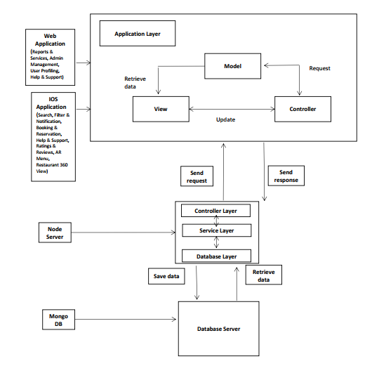

## Data Representation

The following is the ERD for the Digital Bites.

**ERD:**

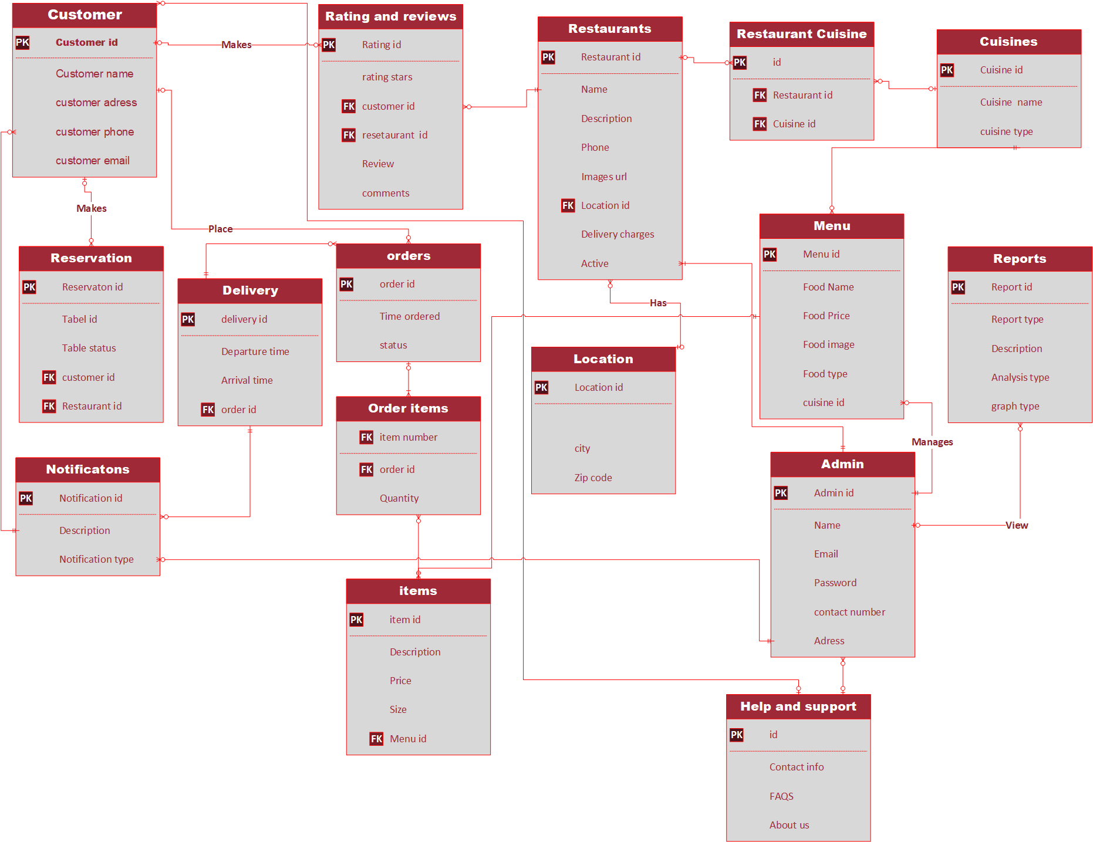

The following are the **JSON Schemas** for the Digital Bites

**User Schema:**

const mongoose = require('mongoose');

const bcrypt = require('bcryptjs')

const userSchema = new mongoose.Schema({

    name:{

        type:String,

    },

    email:{

        type:String,

        unique:true,

    },

    password:{

        type:String,

    },

    address:{

        type:String,

    }

    ,phone:{

        type:String,

    },

    role:{

     type:String

    }

})

userSchema.pre('save',function(next){

    const user = this;

    if(!user.isModified('password')){

        return next()

    }

    bcrypt.genSalt(10,(err,salt)=>{

        if(err){

            return next(err)

        }

     bcrypt.hash(user.password,salt,(err,hash)=>{

         if(err){

             return next(err)

         }

         user.password = hash;

         next()

     })

    })

})

userSchema.methods.comparePassword = function(candidatePassword) {

    const user = this;

    return new Promise((resolve,reject)=>{

        bcrypt.compare(candidatePassword,user.password,(err,isMatch)=>{

            if(err){

                return reject(err)

            }

            if (!isMatch){

                return reject(err)

            }

            resolve(true)

        })

    })

}

mongoose.model('User',userSchema);

**Orders Schema:**

const Orders = new mongoose. Schema({

    created By: {

        type: String,

    },

    items: {

        type: Array,

    },

    latitude: {

        type: String,

    },

    longitude: {

        type: String,

    },

    status: {

        type: String,

        default: "pending",

    },

    assigned: {

        type: String,

        default: "None",

    },

    created At: { type: Date, default: Date. Now },

});

module. Exports = mongoose. Model("Orders", Orders);

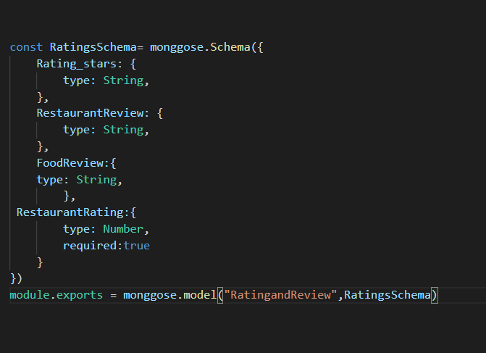**Rating and Review Schema:**

**Restaurant schema:**

const Restaurant = new mongoose.Schema({

    name: {

        type: String,

    },

    createdby: {

        type: String,

    },

    email: {

        type: String,

        required: true,

    },

    contactNumber: {

        type: String,

        required: true,

    },

    estimatedDeliveryTime: {

        type: String,

        required: true,

    },

    description: {

        type: String,

        required: true,

    },

    address: {

        type: String,

    },

    image: {

        type: String,

    },

    vrimage: {

        type: String,

    },

    latitude: {

        type: String,

    },

    longitude: {

        type: String,

    },

    status: {

        type: String,

        default: "pending",

    },

    createdAt: { type: Date, default: Date.now },

    Reviews: [

        {

            review: {

                type: mongoose.Schema.Types.ObjectId,

                ref: "Review",

            },

        },

    ],

    Menu: [

        {

            food: {

                type: mongoose.Schema.Types.ObjectId,

                ref: "Food",

            },

        },

    ],

    Orders: [

        {

            order: {

                type: mongoose.Schema.Types.ObjectId,

                ref: "Orders",

            },

        },

    ],

});

**Menu Schema:**

const Food = new mongoose.Schema({

  name: {

    required: true,

    type: String,

  },

  price: {

    type: Number,

    require: true,

  },

  description: {

    type: String,

  },

  category: {

    type: String,

  },

  image: {

    type: String,

  },

  Duration: {

    type: String,

  },

  Serving: {

    type: String,

  },

  createdBy: {

    type: String,

  },

  createdAt: { type: Date, default: Date.now },

  foodReviews: [

    {

      review: {

        type: mongoose.Schema.Types.ObjectId,

        ref: "foodreview",

      },

    },

  ],

});

**Rider Schema:**

onst Rider= new mongoose.Schema({

  name: {

    required: true,

    type: String,

  },

  email: {

    require: true,

    type: String,

  },

  password

  :{ type: String,

    require:true

  },

 Phonenumber:{

    type:String

  },

  transport:{

    type:String

  },

  Address:{

    type:String

  },

  createdBy: {

    type:String,

  },

  createdAt:

 {type: Date, default: Date.now},

  isavailabe:{

    type:String,

    default:"yes"

  }

,

rname:{

  type:String

},

  Orders:[{

    order: {

          type: mongoose.Schema.Types.ObjectId,

          ref: 'Orders',

        }

    }]

**Reservation Schema:**

const reserveSchema = new mongoose.Schema({

    status: {

        type: String,

        default: "pending",

    },

    name: {

        type: String,

        required: true,

    },

    Mobileno: {

        type: Number,

        min: 11,

    },

    Date: {

        type: Date,

    },

    Time: {

        type: String,

    },

    Tpeoples: {

        type: Number,

    },

    createdAt: { type: Date, default: Date.now },

    reserveBy: {

        type: String,

    },

});

## Process Flow/Representation

### Block Diagram:

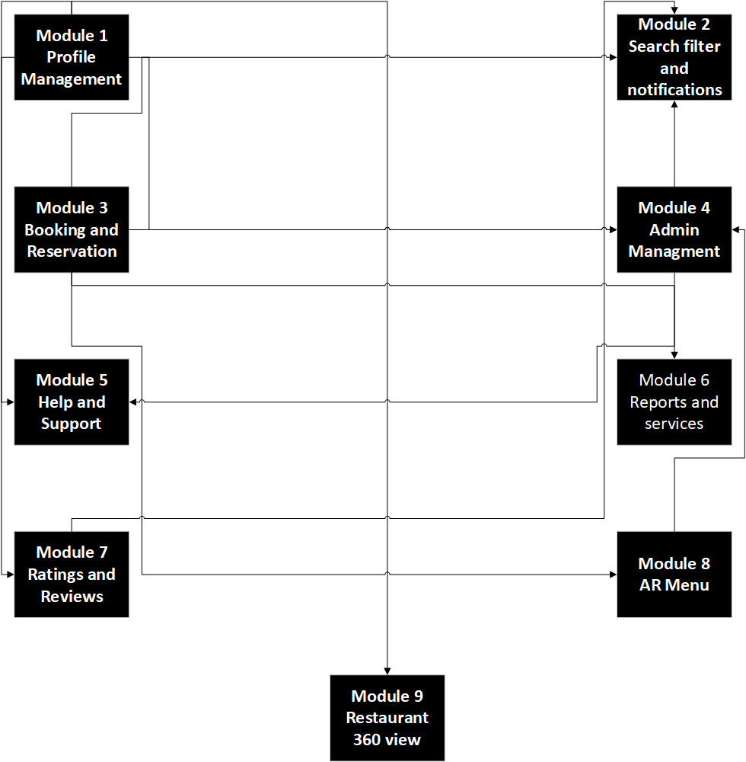

## Design Models

### Structural Diagrams

**The applicable models may include**:

#### Class diagram

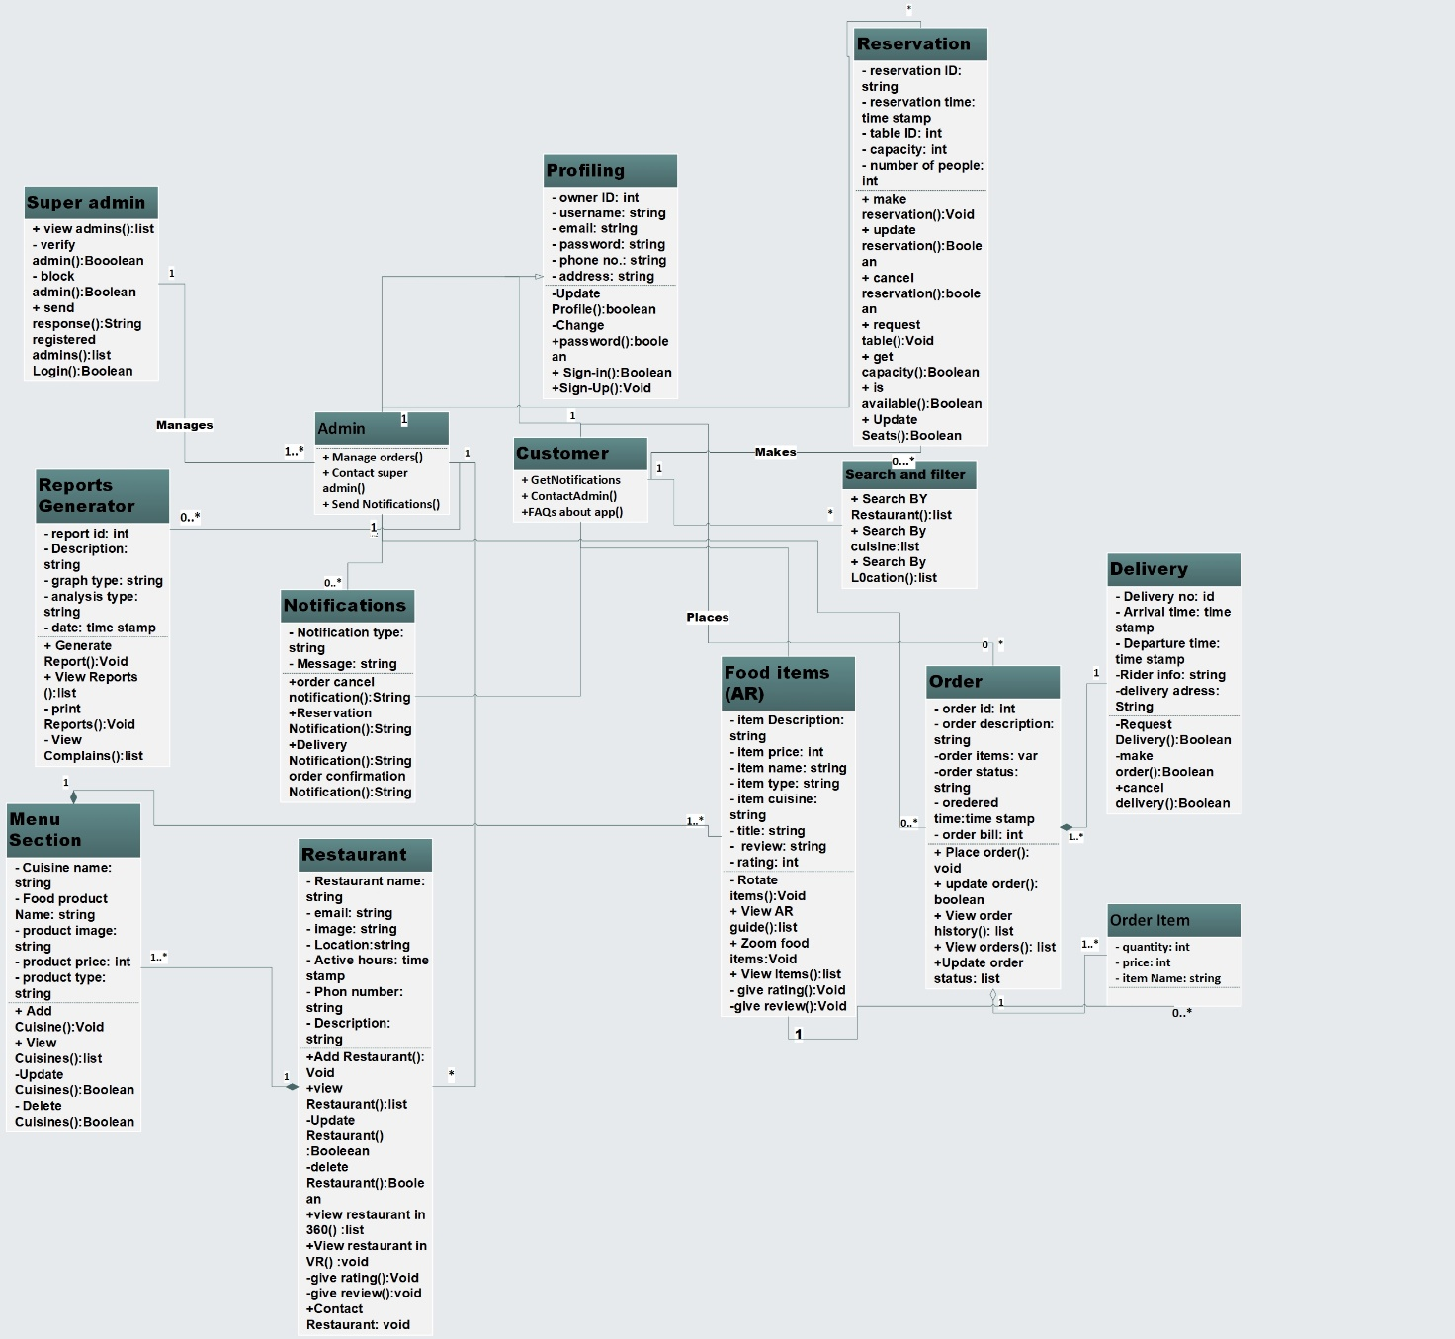

### Behavioral Diagrams

This section would present the behavior diagrams that show the dynamic behavior of the objects in a system, which can be described as a series of changes to the system over time.

#### Activity diagram

Activity diagrams defines the major process flow of the system. The following are the Process Flow Activity diagrams for the Digital Bites.

#### Admin Management Activity:

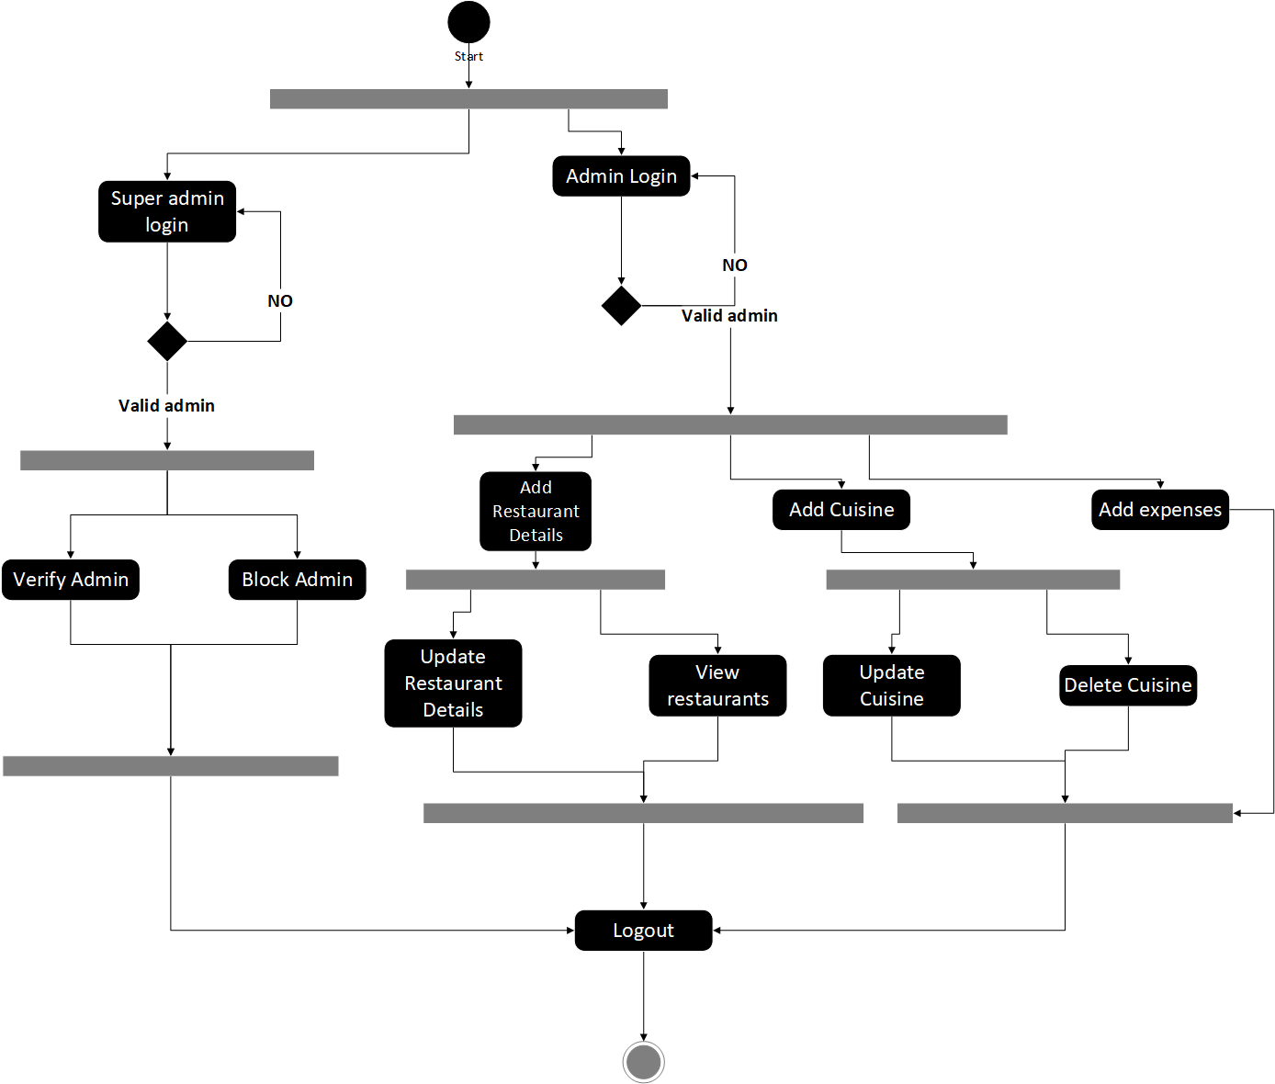The following diagram shows the main functionalities the Super Admin and Admins will perform after logging in. Super Admin can verify admins or block them. Admins can add restaurant details update them and view them. Admin can also add cuisines and update or delete them. Admin can also add expenses. To perform these activities, they are verified as registered users

#### Login Activity:

The following diagram shows the profiling for the users. Super Admin will sign in to manage Admins. Admins will login or signup if not registered and can edit his profile or change the login password. Customer can sign in or signup if not registered. Furthermore, he can edit his profile or change the password

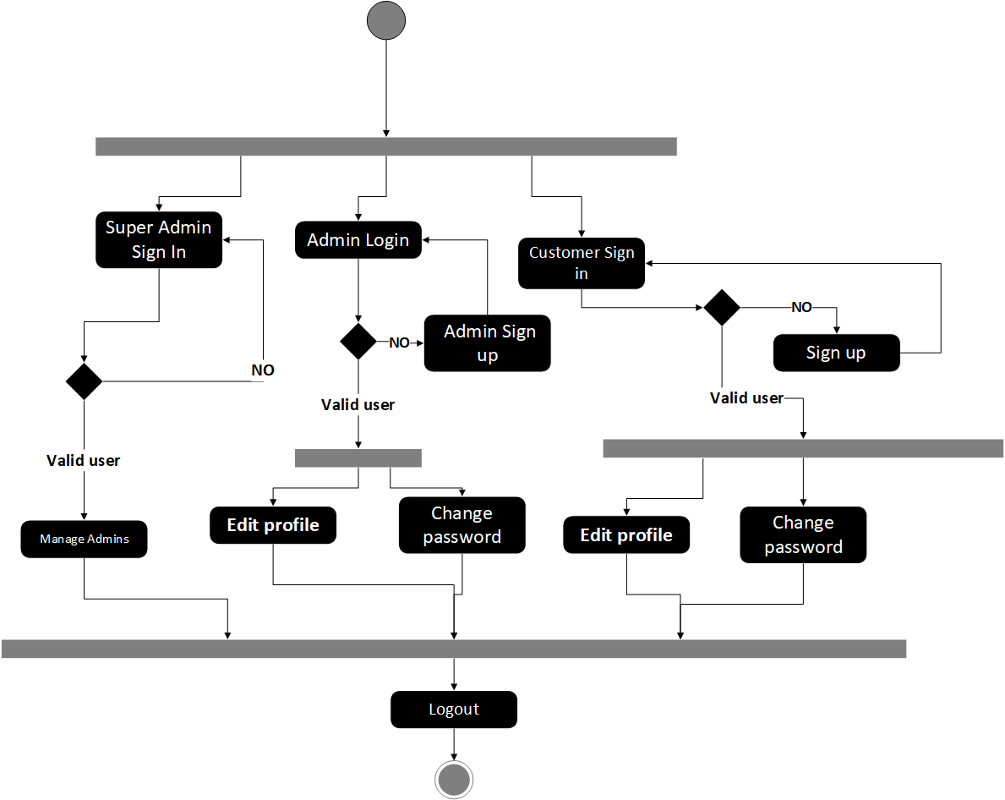

#### Search Activity:

The following diagram shows how the customer will interact with the system to search for restaurant or cuisine. Customer can search by different filters which will sort or refine the results.

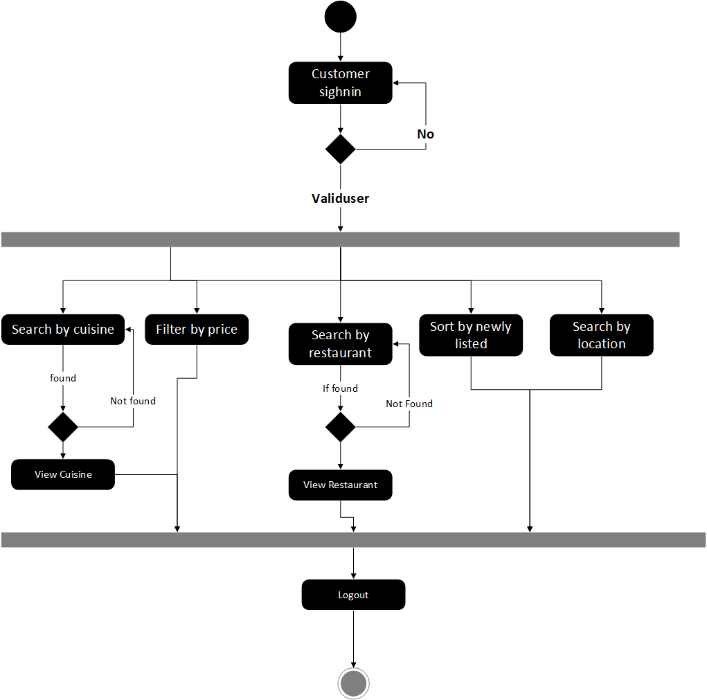

#### AR Activity:

The following diagram shows the interaction of the customer with AR functionality. The customer can view item in AR and can zoom in or out. Customer can also access user guide.

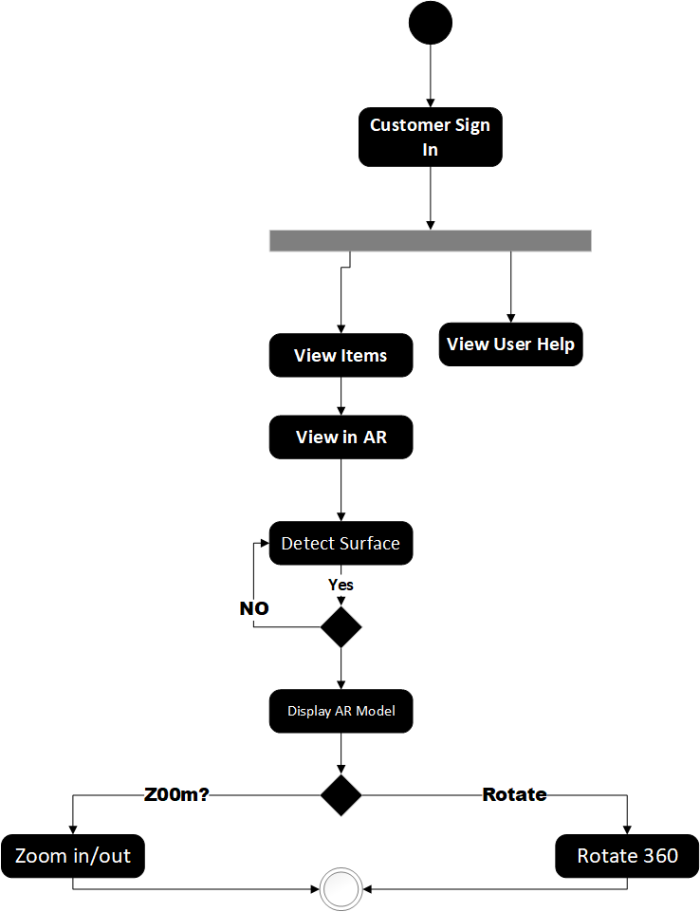

#### VR Activity:

The following diagram shows the customer’s interaction with VR functionality. Customer will select a restaurant and will select to view it in VR. This will allow the customer to view a 360 panoramic image or can select the 360 videos.

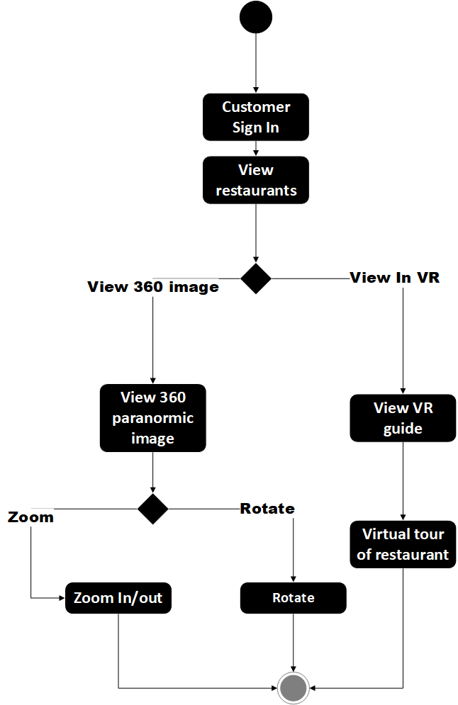

#### Reports Activity:

The following diagram shows the reports activity. Admins can view the reports of their sales, expenses, orders, delivery and customers.

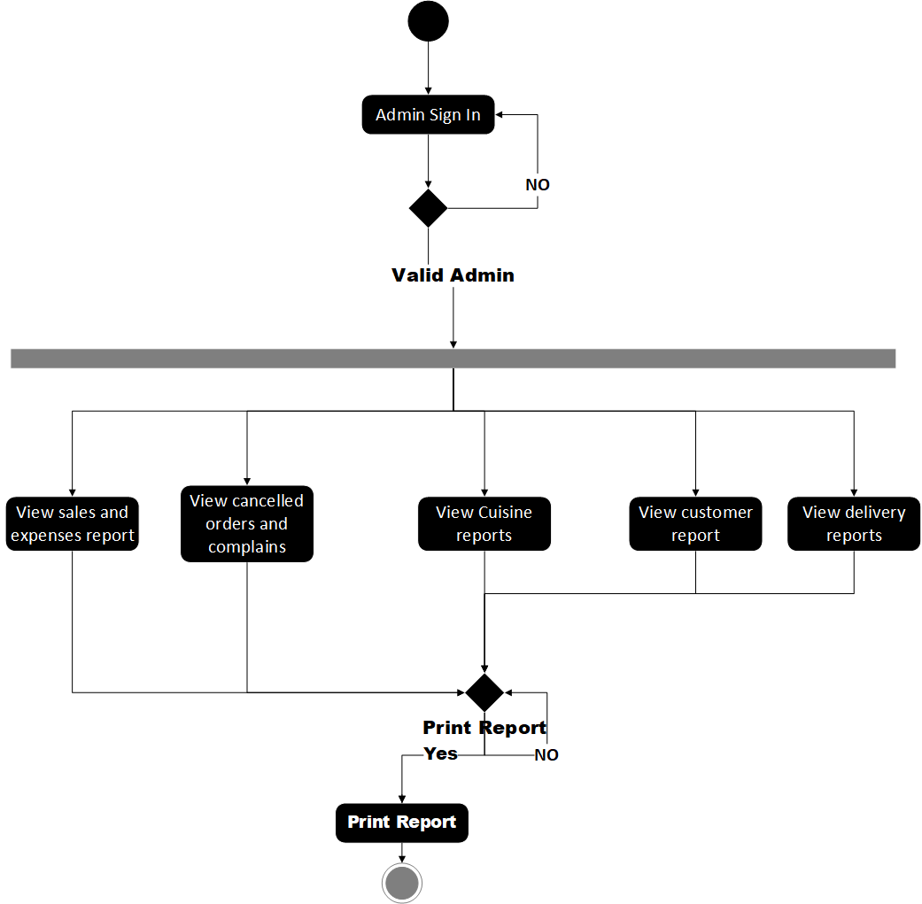

#### Help and Support Activity:

The following diagram shows the help and support activity. Customers and Admin can both view FAQ for the system. They can give feedback or can contact Super Admin.

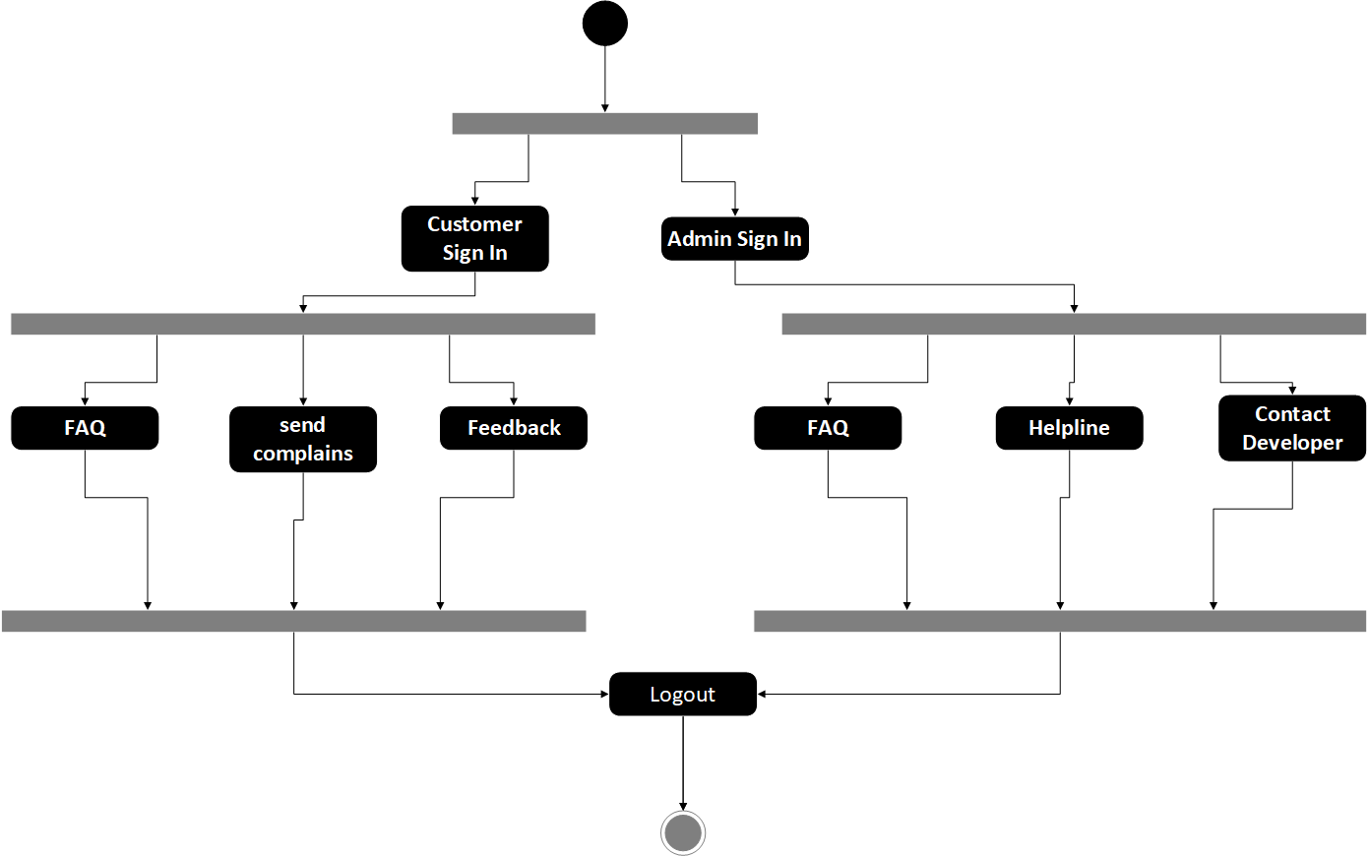

#### Reservation and Notification Activity:

The following diagram shows the reservation activity. Customers can order the food or reserve a table. Admin will manage the orders and notify the customers.

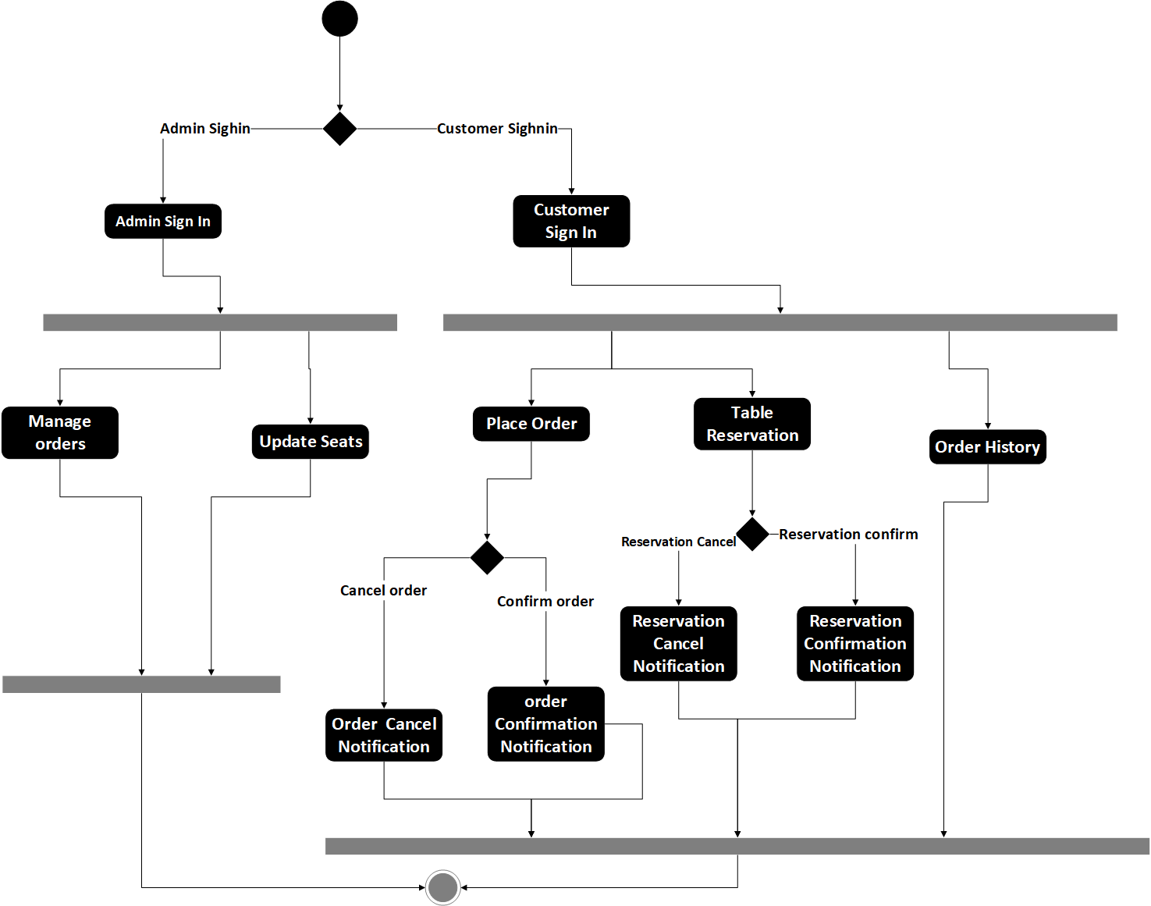

#### Ratings and Review Activity:

The following diagram shows the rating and review activity. Customer and rate or write a review for restaurants and food.

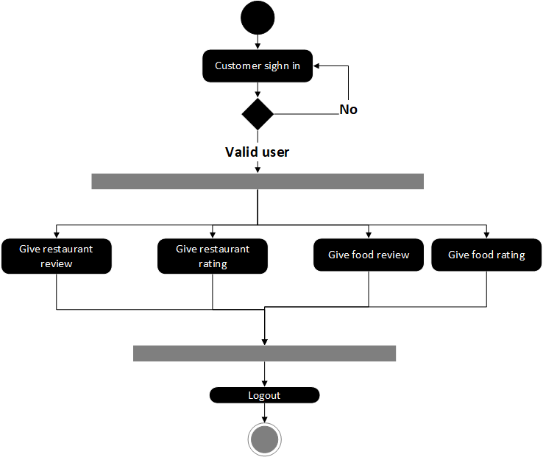

#### Sequence diagram

The Following are the Sequence diagram for the Digital Bites.

**Restaurants and Menu Selection:**

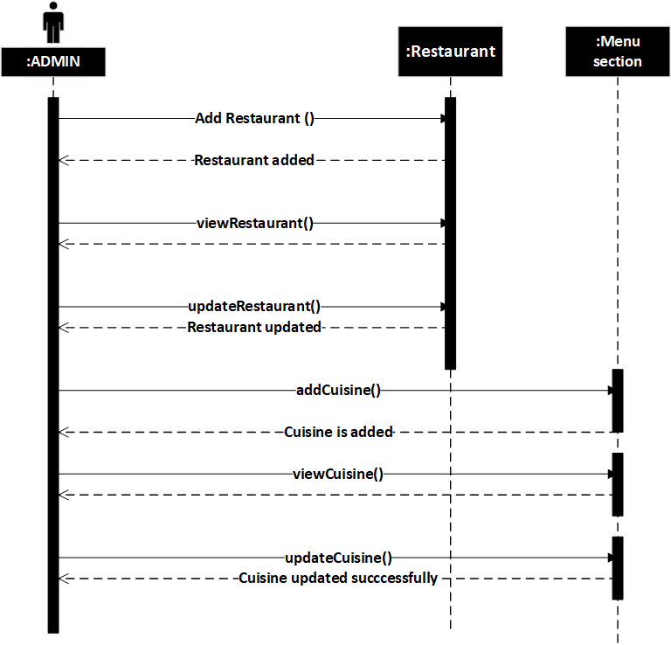

**Restaurant and Item Ratings:**

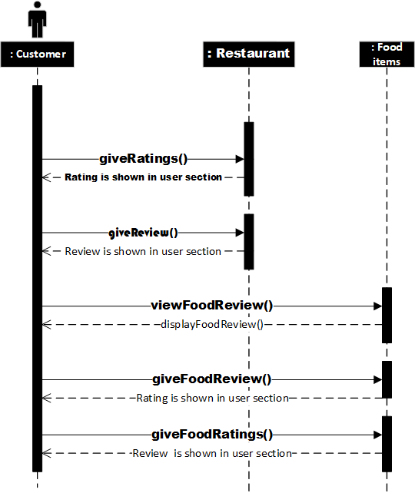

**AR and Restaurant View:**

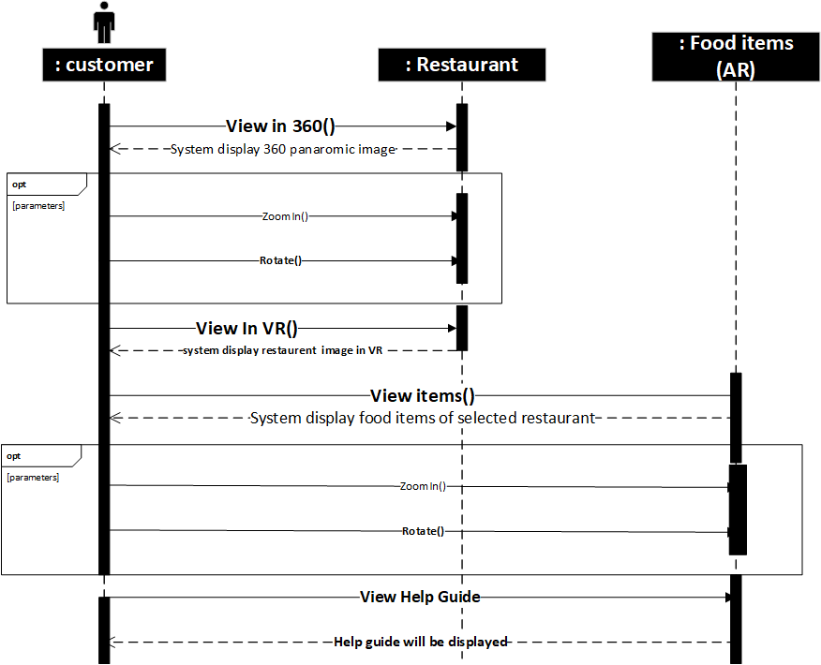

**Reports Generation:**

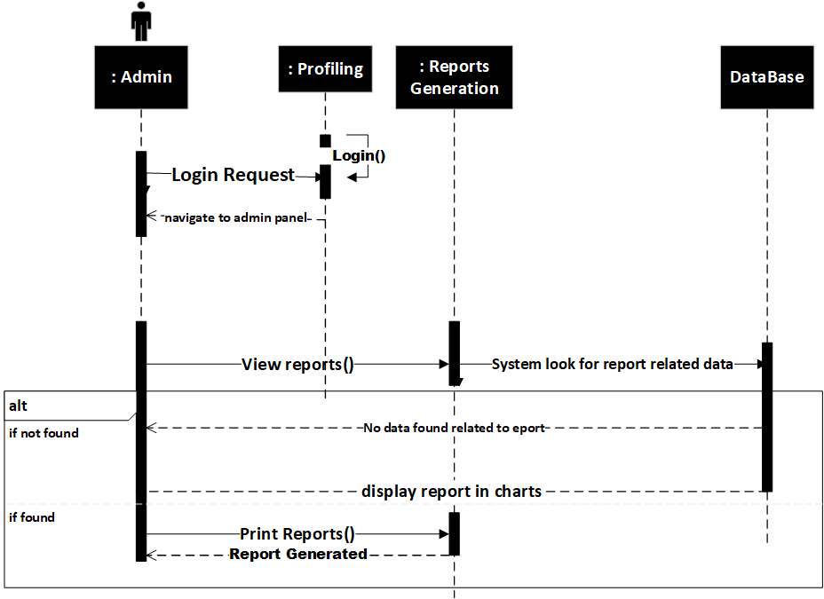

**Search and Filter:**

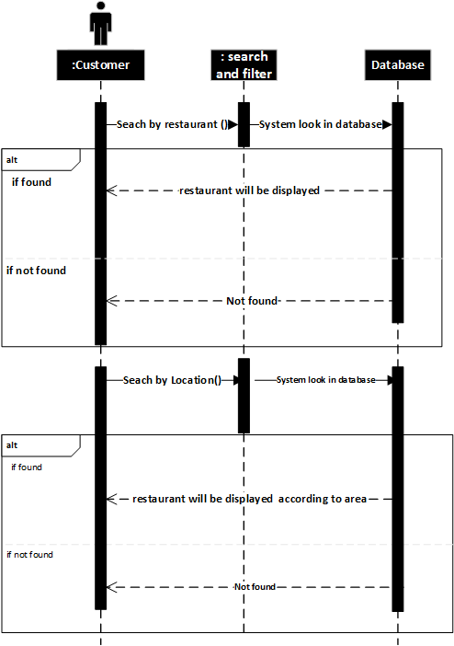

**Profiling:**

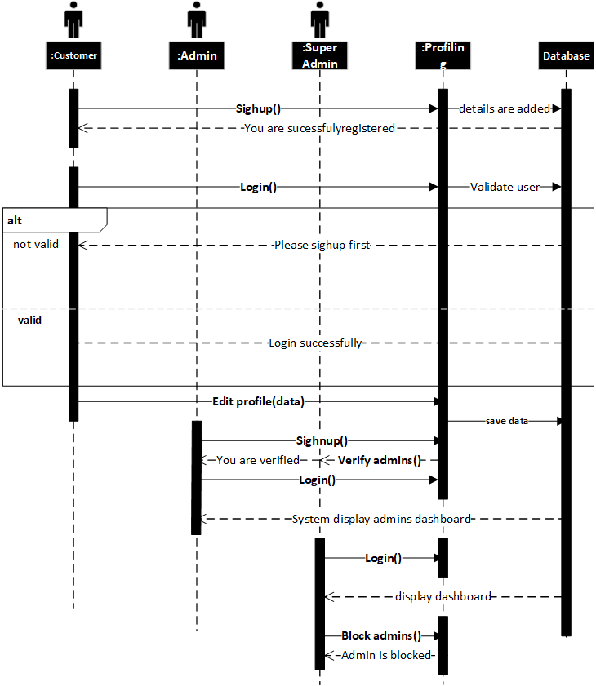

**Order Reservation and Notification:**

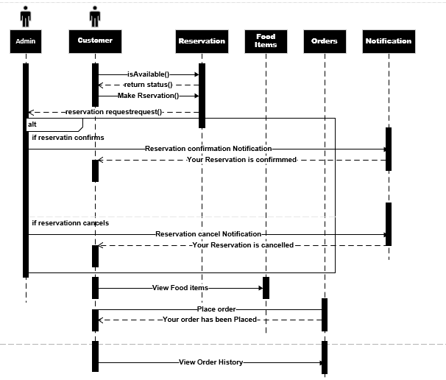

# Implementation



## Algorithm

### Admin Registration pseudo code:

Admin will enter the basic personal details Validate information on submit  
If data is invalid  
Show error message by focusing on the fields Else

User will be redirected to the next page user will fill the form and submit validate the form  
If data is invalid

Show error message by focusing on the fields  
Else  
Show message to the user "Successfully submitted for approval"  
Admin will see the Admin dashboard  
If account is approved  
Send an email to the user "Account successfully registered."  
Else  
Send an email to the user "Account not successfully registered. Please try again"

### Node mailer to send mails:

**Input:** We have to give From, to , subject of mail, and text.

**Output:** Node mailer send email to required user

async function main() {

let testAccount = await nodemailer.createTestAccount();

let transporter = nodemailer.createTransport({

host: "smtp.ethereal.email",

port: 587,

secure: false,

auth: {

user: testAccount.user,

pass: testAccount.pass

}

});

let info = await transporter.sendMail({

from: '"Fred Foo 👻" <foo@example.com>',

to: "bar@example.com, baz@example.com",

subject: "Hello ",

text: "Hello world?",

html: "<b>Hello world?</b>"

});

console.log("Message sent: %s", info.messageId);

console.log("Preview URL: %s", nodemailer.getTestMessageUrl(info));

main().catch(console.error);

## External APIs

**Table 5.1: Details of APIs used in the Project**

|  |  |  |  |
| --- | --- | --- | --- |
| **Name of API** | **Description of API** | **Purpose of Usage** | **List down the function/class name in which it is used** |
| **Google Maps API** | Google Maps API is used for location services | Digital Bites used this API to get or set users location , and set restaurant location | Restaurantdetails.js  Location.js  Tracker.js |
| **Nexmo** | Nexmo API is used to send messages | Digital Bites used this API to send message to users for order and reservation updates | **Orderdetails.js**  **Reservationdetails.js**  **Contactadmin.js** |
| **Node mailer** | Node mailer API is used to send mails | Digital Bites used this API to send mails to super admin | Contact superadmin.js |
| **Cloudinary** | Cloudinary API is used to store images online | Digital Bites used this API to store restaurant and food images online | Restaurant.js  Food.js |
| **Pub Nub** | Pub Nub | Digital Bites used this API to send rider location updated to customer | Tracker.js  Order.js |

## User Interface

### Mobile Application interface:

**Home Screen**

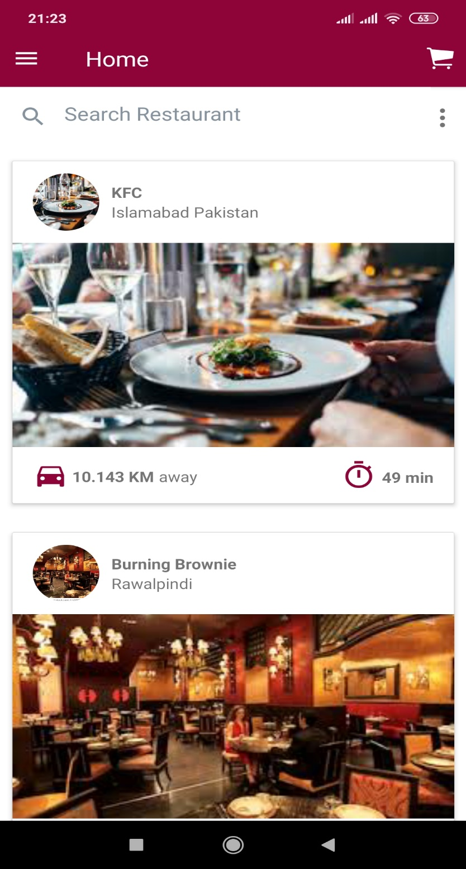

**Restaurant Screen**

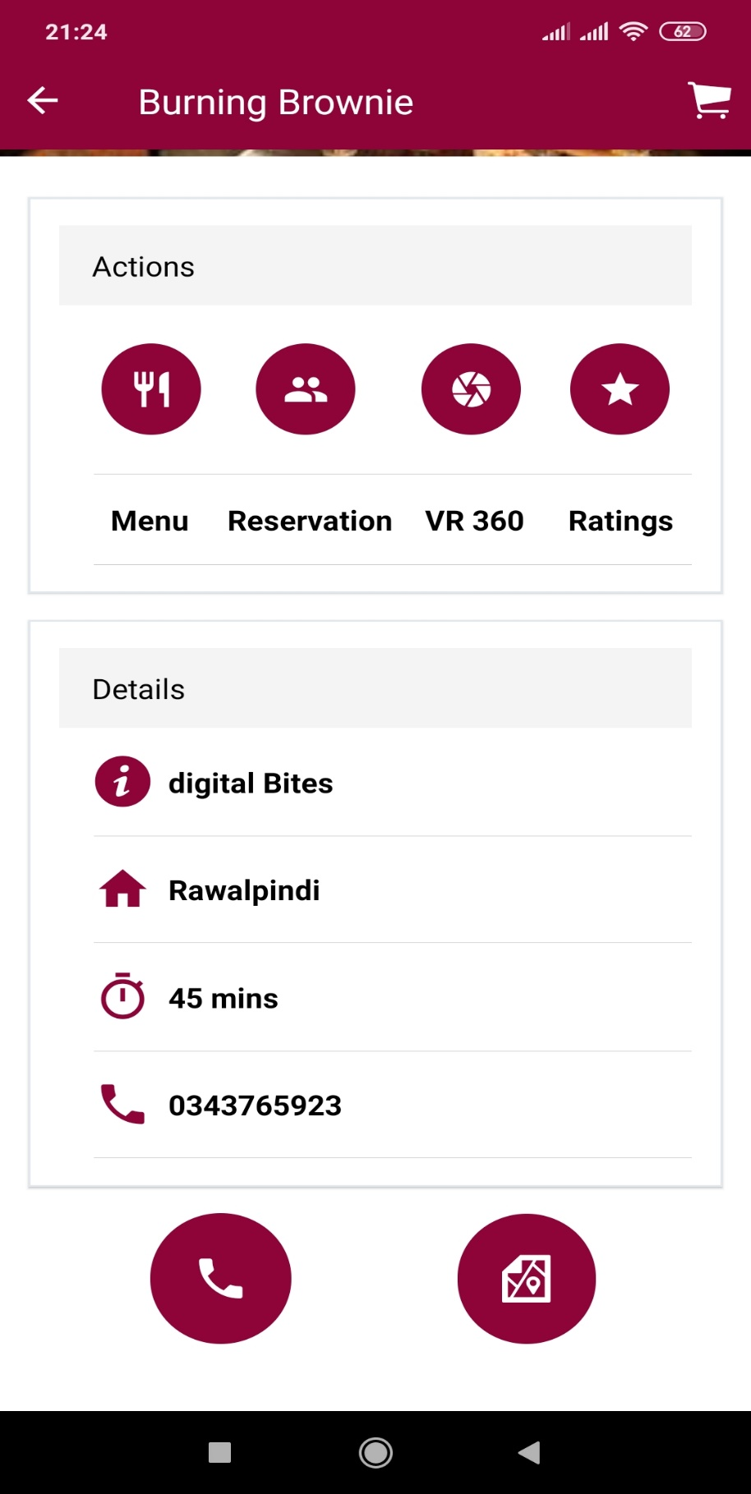

**Reservation Screen**

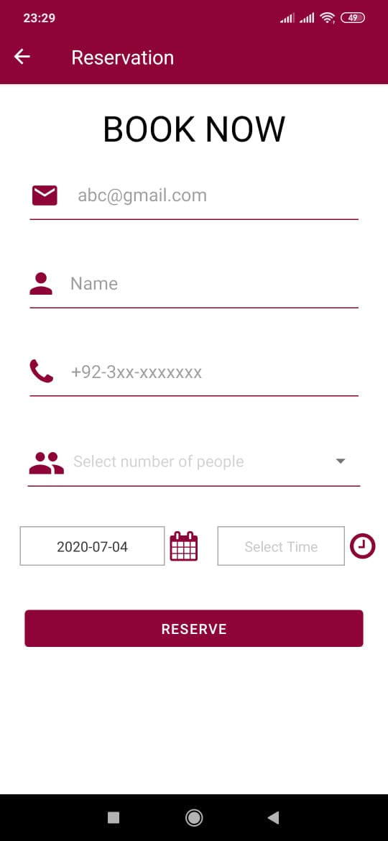

**VR Screen**

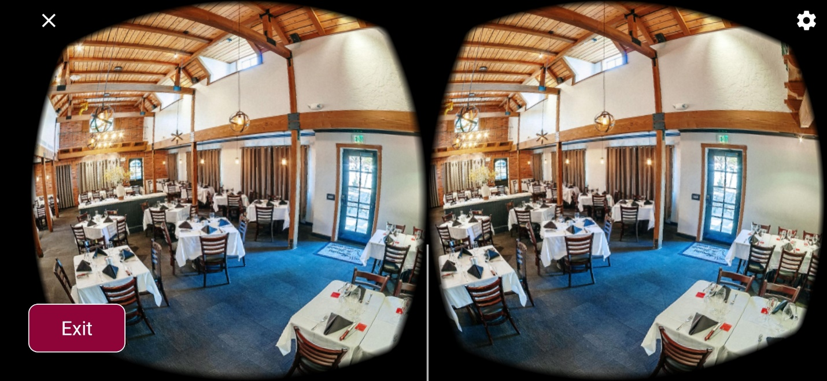

**Ratings Screen**

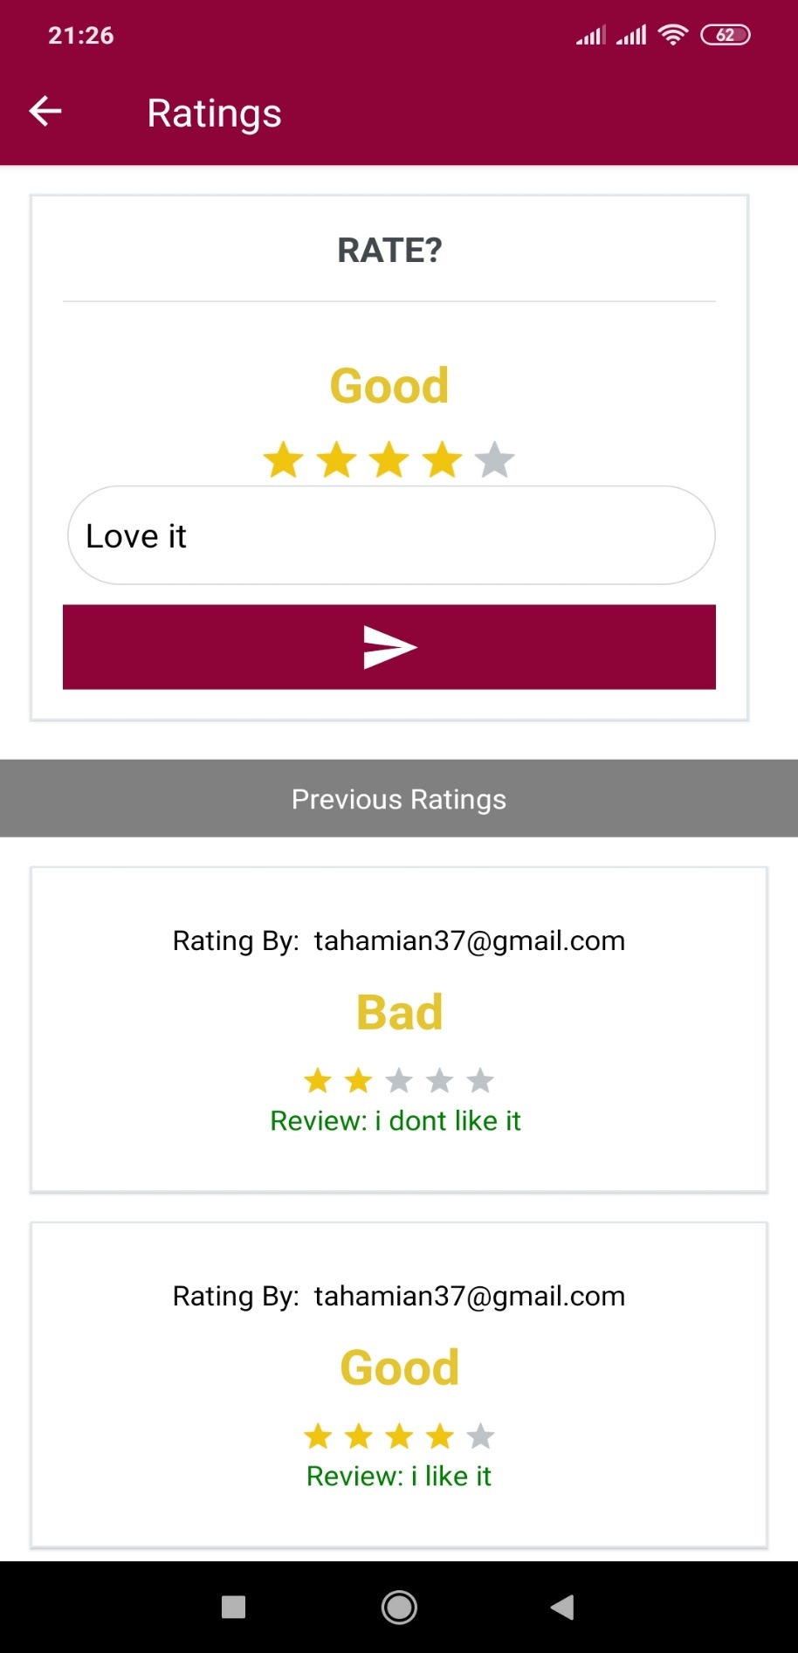

**Menu Screen**

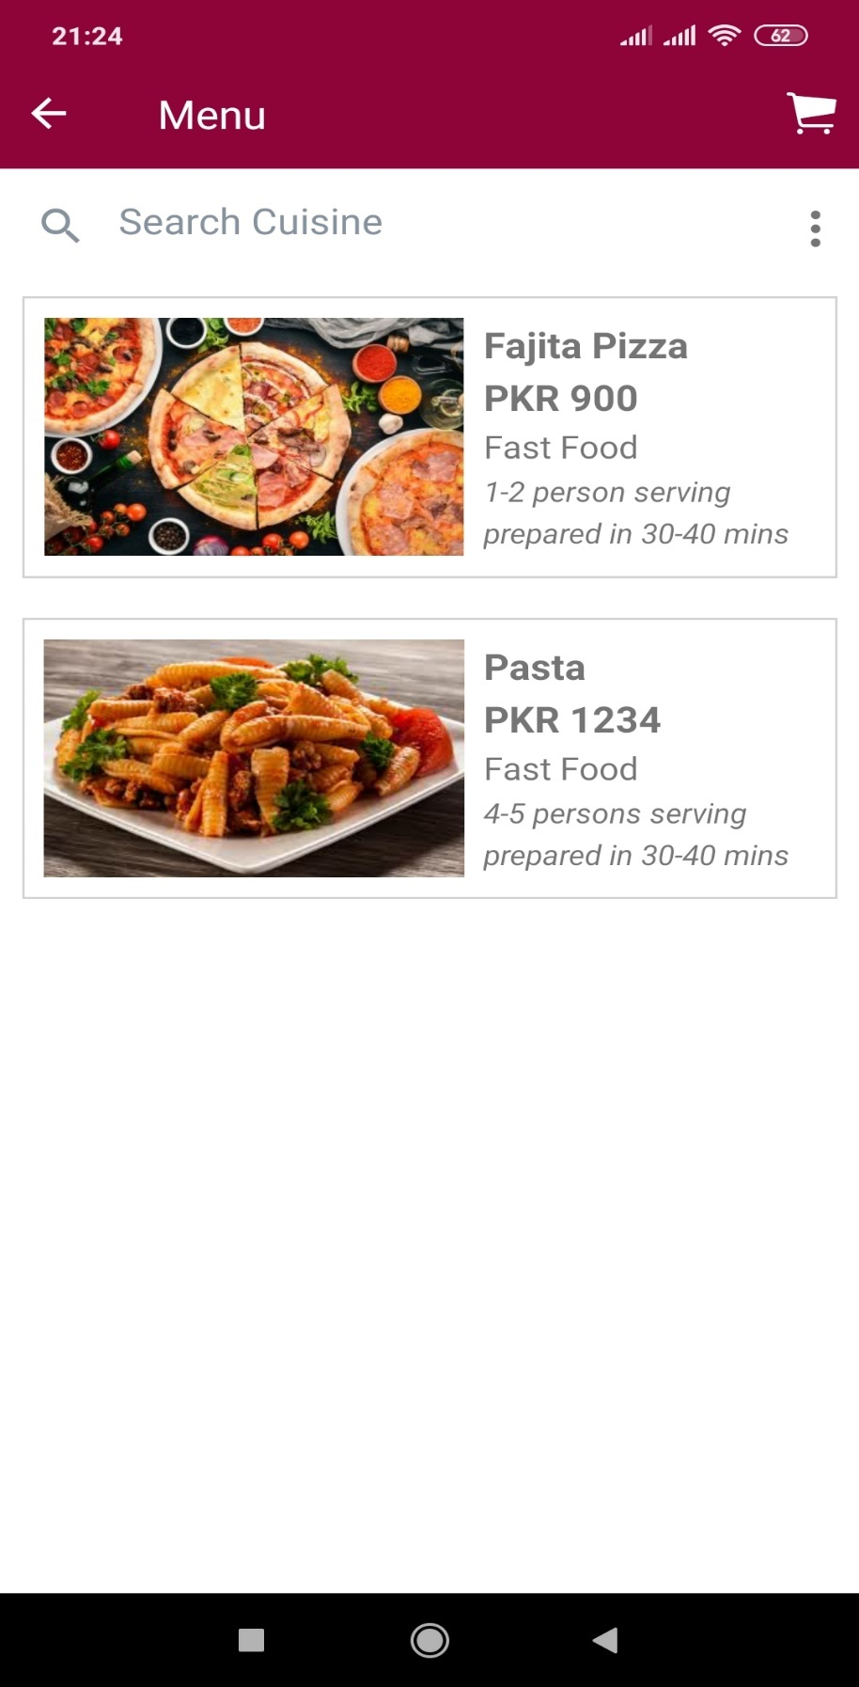

**Menu Item Screen**

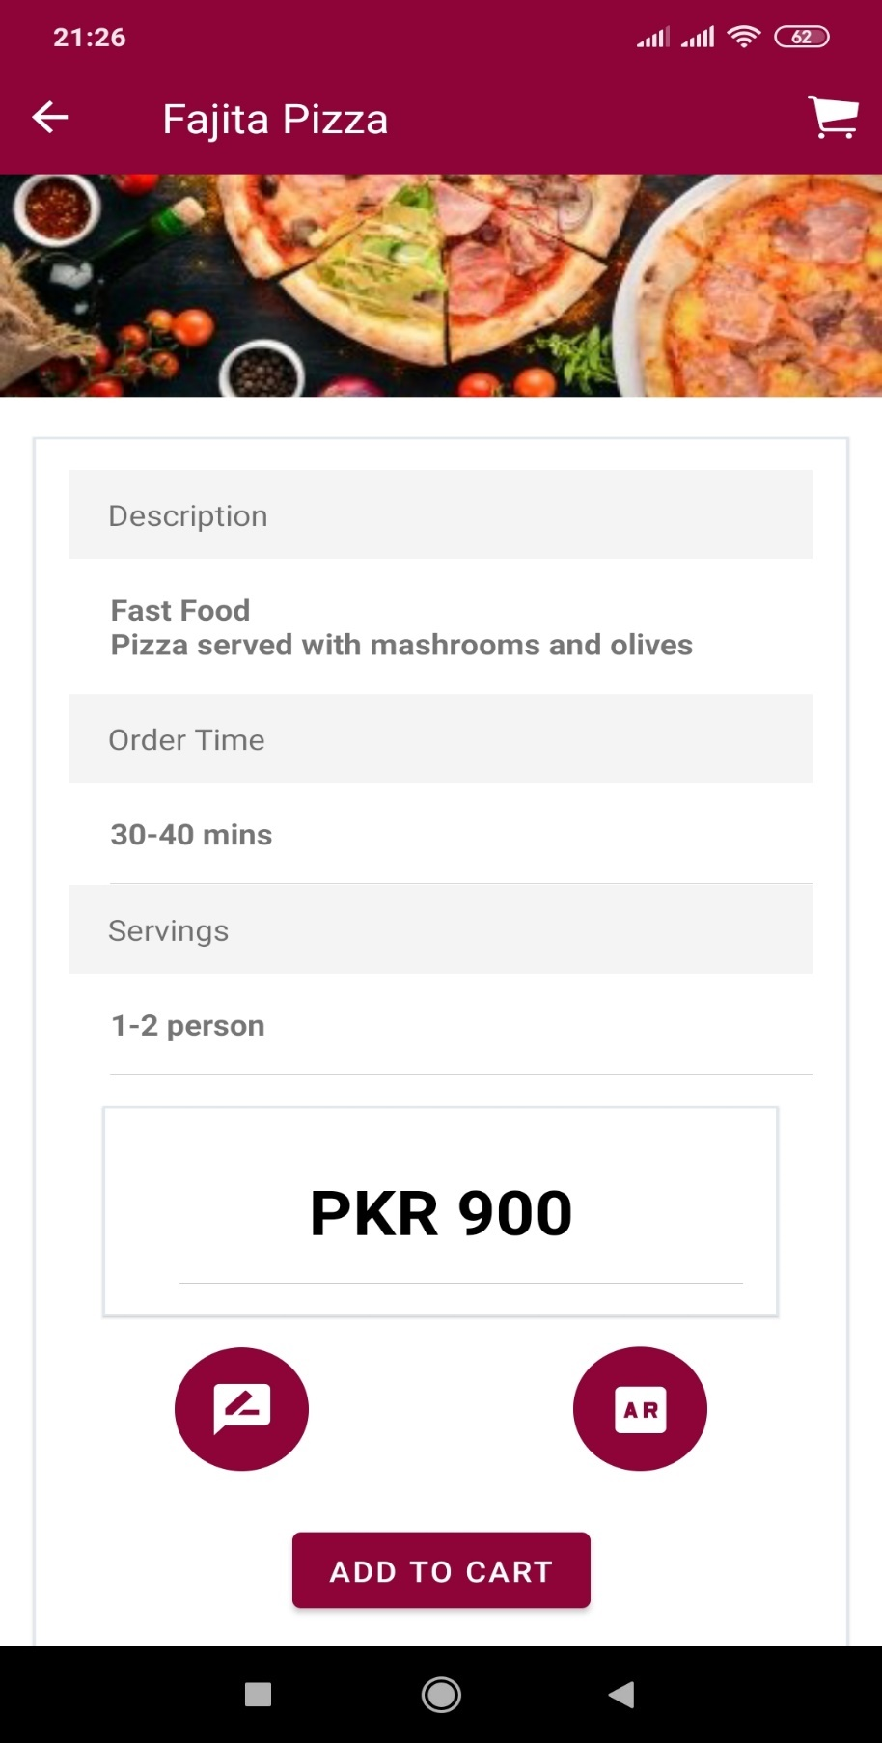

**Cart Screen**

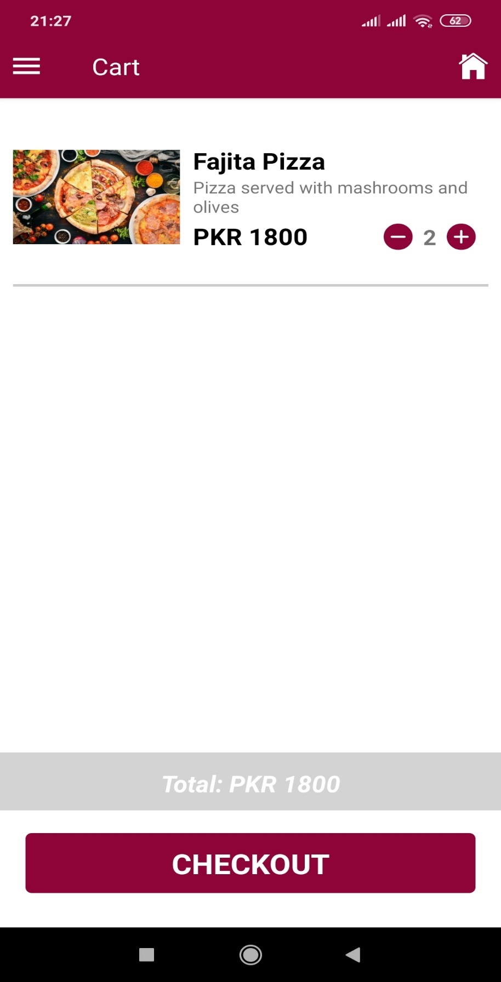

**Location Screen**

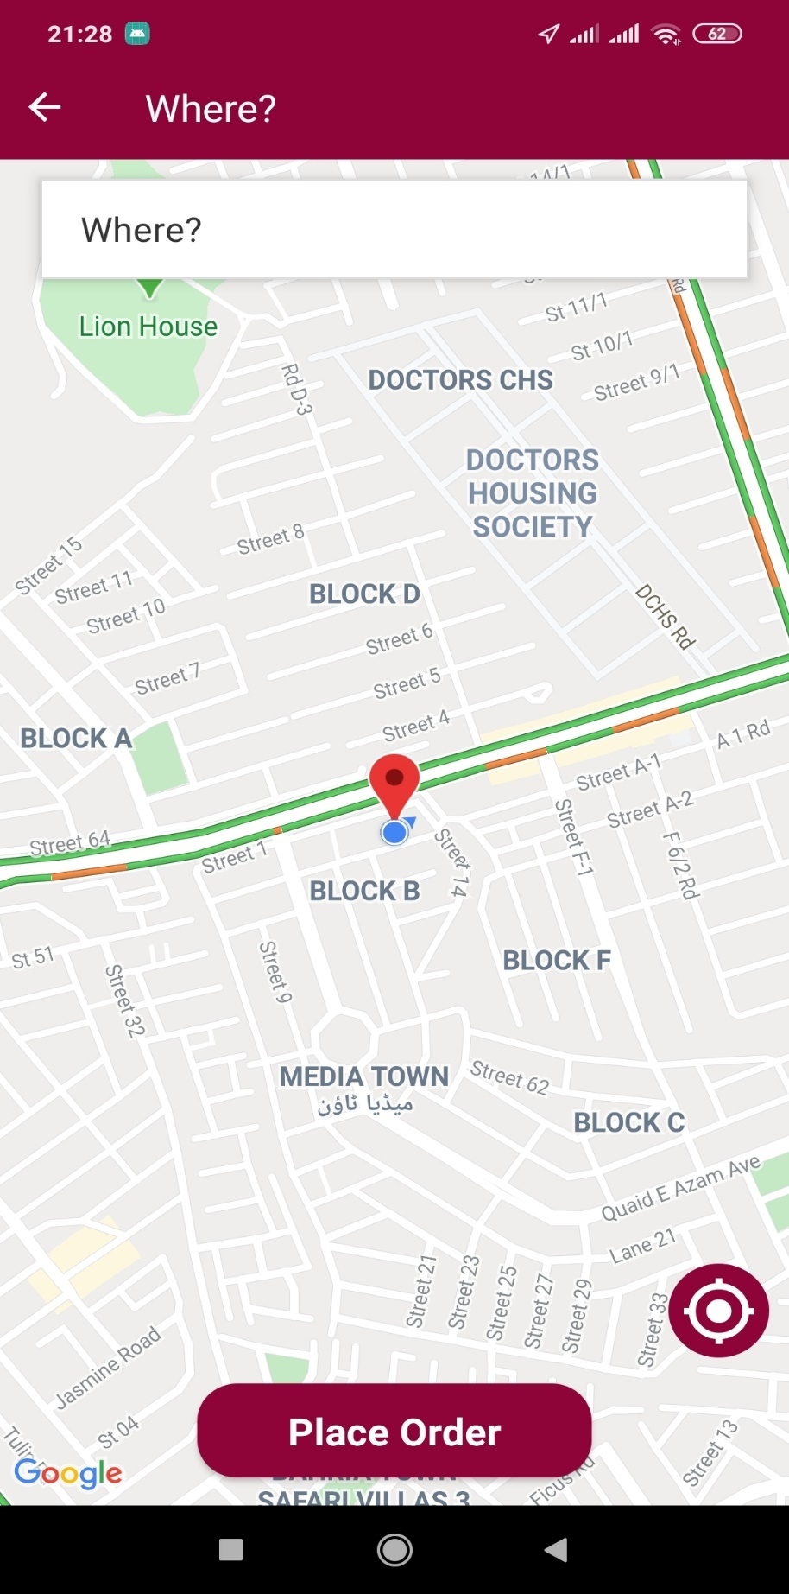

**Rider Dashboard**

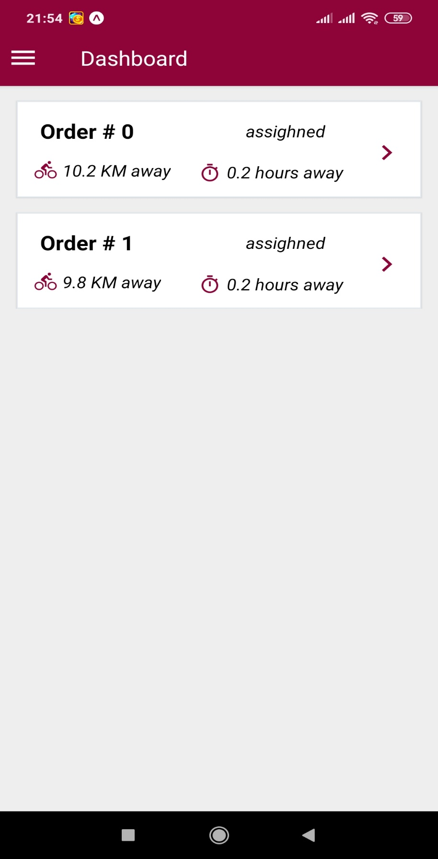

**Order Detail Screen**

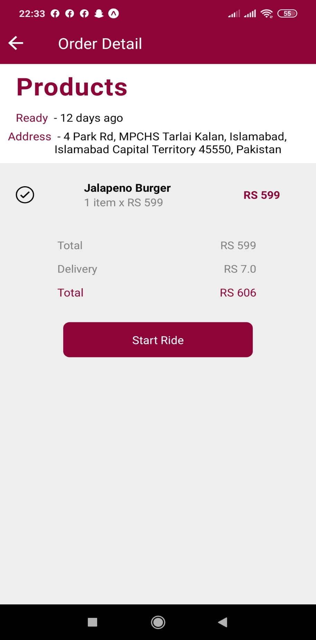

**Location Directions Screen**

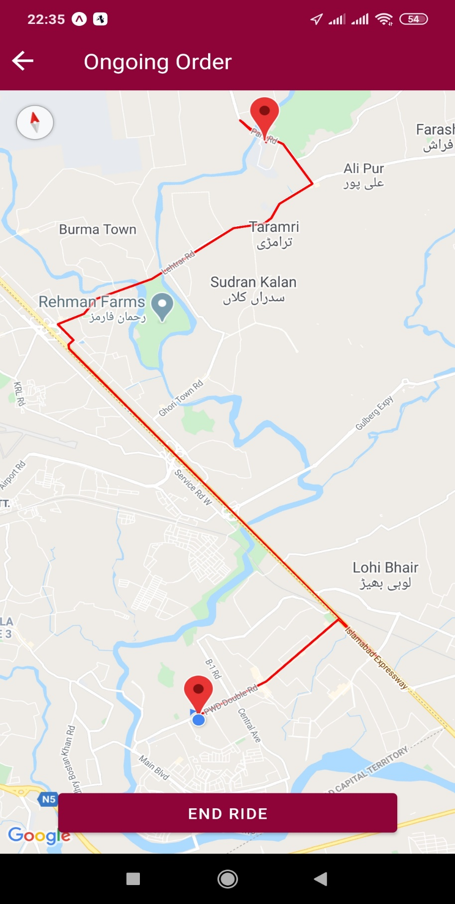

### Web Application interface:

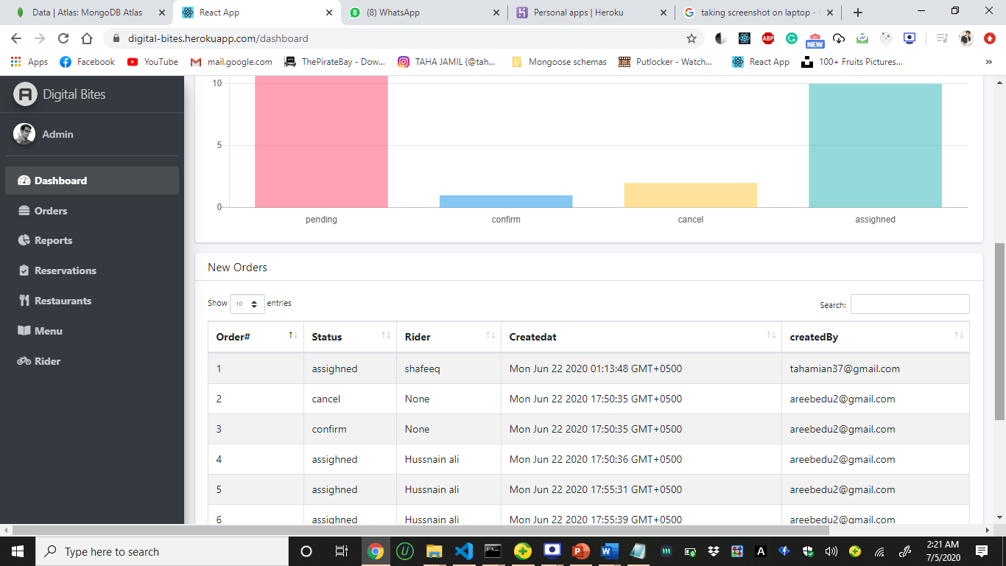

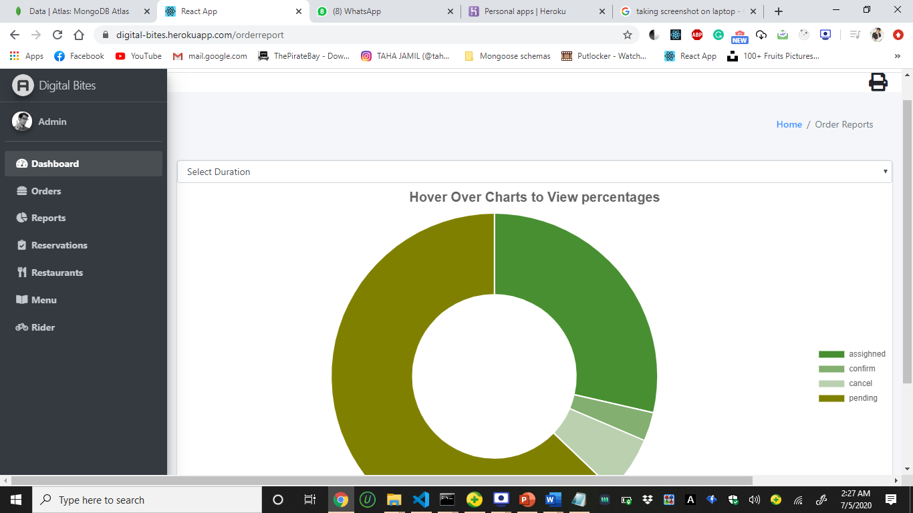

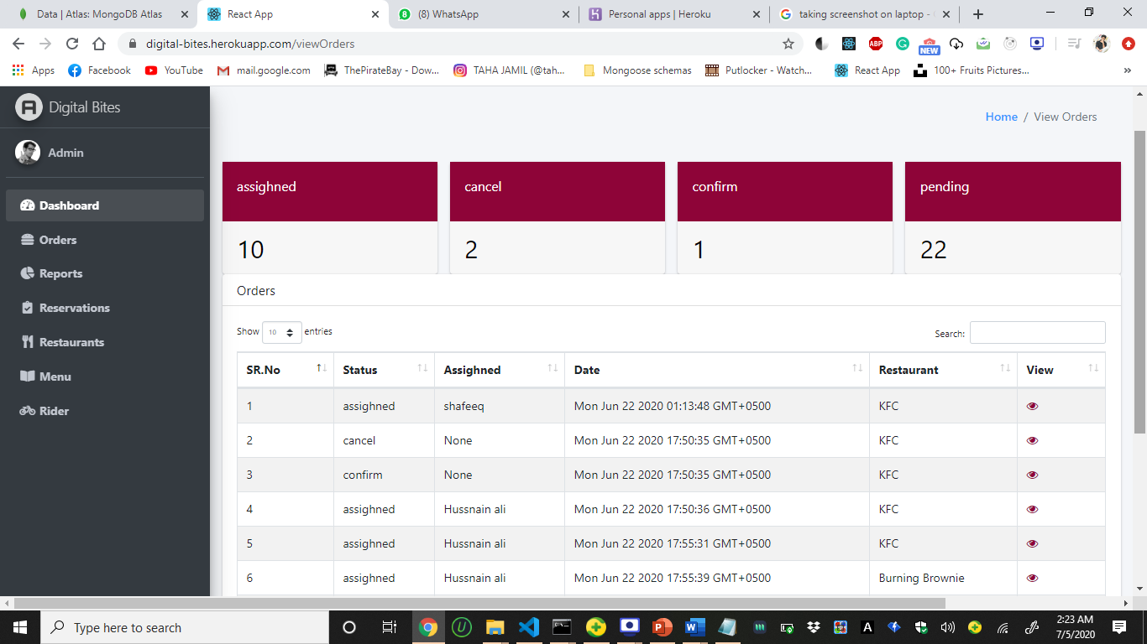

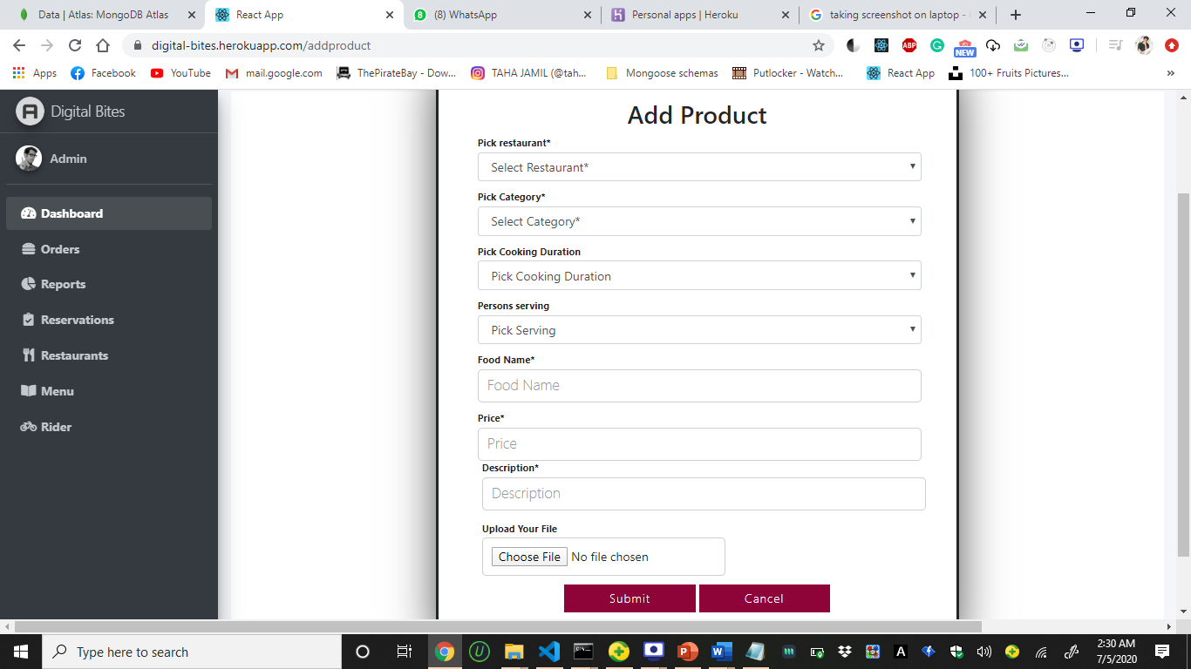

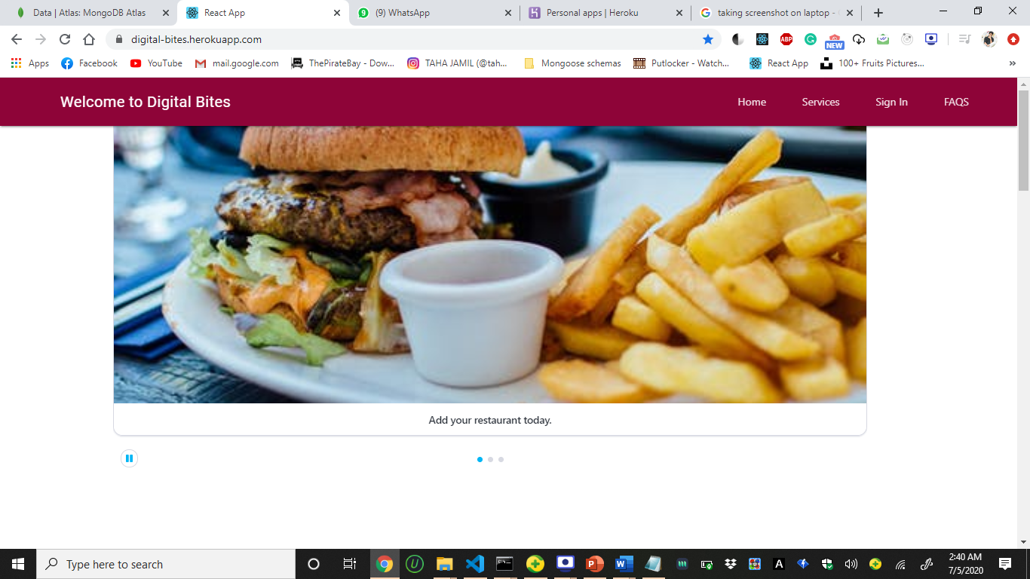

# Testing and Evaluation

This chapter may include the following sections. (Students are required to perform the testing both manually and automatically).



## Manual Testing

### Unit Testing

**Unit Testing 1:** Admin Registration

**Testing Objective:** To ensure the admin registration form is working properly.

**Test Case Id:** **TC_001**

**Test Case Description:** Test the admin profile registration functionality.

**Test Scenario:**

**Table 1.1: Test Cases for Admin Registration**

|  |  |  |  |  |  |
| --- | --- | --- | --- | --- | --- |
| **No.** | **Test Case/Test Script** | **Test Data** | **Expected Result** | **Actual Result** | **Pass/Fail/Not Executed/ Suspended** |
| 1. | Verify Admin Registration after clicking on the ‘Create Account’ button on registration form. | First Name:  Nida  Last Name:  Shahid  Email:  [Nida12@gmail.com](mailto:Nida12@gmail.com)  Password:  Pakistan123  Confirm Password:  Pakistan123 | Successfully register an admin account into the Digital Bites website. | As Expected, the account has been created and super admin can verify the newly created account. | Pass |

**Unit Testing 2:** Admin Login

**Testing Objective:** To ensure the admin login form is working properly.

**Test Case Id:** **TC_002**

**Test Case Description:** Test the admin profile login functionality.

**Test Scenario:**

**Table 1.2: Test Cases forAdmin Login**

|  |  |  |  |  |  |
| --- | --- | --- | --- | --- | --- |
| **No.** | **Test Case/Test Script** | **Test Data** | **Expected Result** | **Actual Result** | **Pass/Fail/Not Executed/ Suspended** |
| 1. | Verify Admin login after clicking on the ‘Login’ button on login form. | Email:  [Nida12@gmail.com](mailto:Nida12@gmail.com)  Password:  Pakistan123  Confirm Password:  Pakistan123 | Successfully logged into the Digital Bites admin dashboard. | As Expected, the admin has been authorized. | Pass |

**Unit Testing 3:** Change Password

**Testing Objective:** To check whether the password is changed into a new one.

**Test Case Id:** **TC_003**

**Test Case Description:** Test the change password for admin profile functionality.

**Test Scenario:**

**Table 1.3: Test Cases for Change Password for Admin**

|  |  |  |  |  |  |
| --- | --- | --- | --- | --- | --- |
| **No.** | **Test Case/Test Script** | **Test Data** | **Expected Result** | **Actual Result** | **Pass/Fail/Not Executed/ Suspended** |
| 1. | Testing whether the customer is able to change his password into a new password. | Email:  [Nida12@gmail.com](mailto:Nida12@gmail.coom)  Password:  Pakistan123 | Successfully change the users password. | As Expected, theusers’s profile password was changed successfully. | Pass |

**Unit Testing 4:** Customer Registration

**Testing Objective:** To ensure the customer registration form is working properly.

**Test Case Id:** **TC_004**

**Test Case Description:** Test the customer profile registration functionality.

**Test Scenario:**

**Table 1.4: Test Cases for Customer Registration**

|  |  |  |  |  |  |
| --- | --- | --- | --- | --- | --- |
| **No.** | **Test Case/Test Script** | **Test Data** | **Expected Result** | **Actual Result** | **Pass/Fail/Not Executed/ Suspended** |
| 1. | Verify Customer Registration after click on the ‘Create Account’ button on registration form. | First Name:  Taha  Last Name:  Jamil  Email:  [tahamian37@gmail.com](mailto:Nida12@gmail.com)  Password:  123456  Confirm Password:  123456 | Successfully register a customer account into the Digital Bites application. | As Expected, a new customer account was created. | Pass |

**Unit Testing 5:** Customer Login

**Testing Objective:** To ensure the customer login form is working properly.

**Test Case Id:** **TC_005**

**Test Case Description:** Test the customer profile login functionality.

**Test Scenario:**

**Table 1.5: Test Cases for Customer Login**

|  |  |  |  |  |  |
| --- | --- | --- | --- | --- | --- |
| **No.** | **Test Case/Test Script** | **Test Data** | **Expected Result** | **Actual Result** | **Pass/Fail/Not Executed/ Suspended** |
| 1. | Verify Customer login after clicking on the ‘Login’ button on login form. | Email:  Tahamian37@gmail.com  Password:  123456 | Successfully logged into the Digital Bites application. | As Expected, the customer has been authorized. | Pass |

**Unit Testing 6:** Add Restaurant Details

**Testing Objective:** To ensure that the admin is able to add details of his restaurant using the Add Restaurant Details form.

**Test Case Id:** **TC_006**

**Test Case Description:** Test the add restaurant details functionality.

**Test Scenario:**

**Table 1.6: Test Cases for Add Restaurant Details**

|  |  |  |  |  |  |
| --- | --- | --- | --- | --- | --- |
| **No.** | **Test Case/Test Script** | **Test Data** | **Expected Result** | **Actual Result** | **Pass/Fail/Not Executed/ Suspended** |
| 1. | Verify that the admin can add details of his/her restaurant using the Add Restaurant Details form on the website after clicking on “Submit” button. | Name:  Burning Brownie  Email:  [Burningbrownie123@gmail.com](mailto:Burningbrownie123@gmail.com)  Contact Number: 03058919043  Cuisine:  Desserts  Estimated Delivery Time:  25  Description:  Cafe and bakery.  Address:  Beverly Centre, Islamabad. | Successfully added a new restaurant by the admin. | As Expected, the admin has added a new restaurant. | Pass |

**Unit Testing 7:** View Restaurant Details

**Testing Objective:** To ensure the admin can view details of the restaurants added by him/her.

**Test Case Id:** **TC_007**

**Test Case Description:** Test the view restaurant details functionality.

**Test Scenario:**

**Table 1.7: Test Cases for View Restaurant Details**

|  |  |  |  |  |  |
| --- | --- | --- | --- | --- | --- |
| **No.** | **Test Case/Test Script** | **Test Data** | **Expected Result** | **Actual Result** | **Pass/Fail/Not Executed/ Suspended** |
| 1. | Verify that the admin is able to view the details of the restaurants entered by him/her by clicking on the “View Restaurant Details” option on the side navigation tab. | Click on the the “View Restaurant Details” option on the side navigation tab | Successfully view the details of the restaurants. | As Expected, the admin was able to view the restaurants successfully. | Pass |

**Unit Testing 8: Update** Restaurant Details

**Testing Objective:** To ensure that the admin is able to update details of his restaurant using the Edit Restaurant Details form.

**Test Case Id:** **TC_008**

**Test Case Description:** Test the edit restaurant details functionality.

**Test Scenario:**

**Table 1.8: Test Cases for Edit Restaurant Details**

|  |  |  |  |  |  |
| --- | --- | --- | --- | --- | --- |
| **No.** | **Test Case/Test Script** | **Test Data** | **Expected Result** | **Actual Result** | **Pass/Fail/Not Executed/ Suspended** |
| 1. | Verify that the admin can update details of his/her restaurant using the Update Restaurant Details form on the website after clicking on “Save” button. | Name:  Burning Brownie  Email:  [Burningbrownie123@gmail.com](mailto:Burningbrownie123@gmail.com)  Contact Number: 03311207266  Cuisine:  Desserts  Estimated Delivery Time:  50  Description:  Cafe and bakery.  Address:  Beverly Centre, Islamabad | Successfully updated the Estimated Delivery Time of the restaurant. | As Expected, the admin was able to update details of the restaurant. | Pass |

**Unit Testing 9:** Delete Restaurant

**Testing Objective:** To ensure that the admin is able to delete a restaurant.

**Test Case Id:** **TC_009**

**Test Case Description:** Test the delete restaurant functionality.

**Test Scenario:**

**Table 1.9: Test Cases for Delete Restaurant**

|  |  |  |  |  |  |
| --- | --- | --- | --- | --- | --- |
| **No.** | **Test Case/Test Script** | **Test Data** | **Expected Result** | **Actual Result** | **Pass/Fail/Not Executed/ Suspended** |
| 1. | Verify that the admin can delete a restaurant by clicking on the Trashcan icon provided. | Admin click on the Trashcan icon provided | Successfully deleted a restaurant by the admin. | As Expected, the admin has deleted a new restaurant. | Pass |

**Unit Testing 10:** Add Cuisine

**Testing Objective:** To ensure that the admin is able to add a cuisine to the restaurant.

**Test Case Id:** **TC -010**

**Test Case Description:** Test the add cuisine functionality.

**Test Scenario:**

**Table 1.10: Test Cases for Add Cuisine Details**

|  |  |  |  |  |  |
| --- | --- | --- | --- | --- | --- |
| **No.** | **Test Case/Test Script** | **Test Data** | **Expected Result** | **Actual Result** | **Pass/Fail/Not Executed/ Suspended** |
| 1. | Verify that the admin can add a cuisine using the Add Restaurant Details form by clicking on the “Submit” button. | Name:  Zinger Burger  Food Type:  Non-Veg  Price: : 450  Description:  Serve with Fries | Successfully added a cuisine to the restaurant by the admin. | As Expected, the admin has added a cuisine. | Pass |

**Unit Testing 11:** Update Cuisine

**Testing Objective:** To ensure that the admin is able to update a cuisine of a restaurant.

**Test Case Id:** **TC -011**

**Test Case Description:** Test the update cuisine functionality.

**Test Scenario:**

**Table 1.11: Test Cases for Update Cuisine Details**

|  |  |  |  |  |  |
| --- | --- | --- | --- | --- | --- |
| **No.** | **Test Case/Test Script** | **Test Data** | **Expected Result** | **Actual Result** | **Pass/Fail/Not Executed/ Suspended** |
| 1. | Verify that the admin can update the cuisine of a restaurant by using the Edit Restaurant Details form and clicking on the “Save” button. | Name:  Zinger  Food Type:  Non-Veg  Price: : 760  Description:  Serve with Fries | Successfully updated the cuisine to the restaurant by the admin. | As Expected, the admin has updated a cuisine. | Pass |

**Unit Testing 12:** View Cuisine Details

**Testing Objective:** To ensure the admin can view details of the Cuisine added by him/her.

**Test Case Id:** **TC_012**

**Test Case Description:** Test the view Cuisines functionality.

**Test Scenario:**

**Table 1.12: Test Cases for View Cuisine Details**

|  |  |  |  |  |  |
| --- | --- | --- | --- | --- | --- |
| **No.** | **Test Case/Test Script** | **Test Data** | **Expected Result** | **Actual Result** | **Pass/Fail/Not Executed/ Suspended** |
| 1. | Verify that the admin is able to view the details of the Cuisines entered by him/her by clicking on the “View Cuisines Details” option on the side navigation tab. | Click on the “View cuisines Details” option on the side navigation tab | Successfully view the details of the cuisine | As Expected, the admin was able to view the Cuisines successfully. | Pass |

**Unit Testing 13:** Delete Cuisine

**Testing Objective:** To ensure that the admin is able to delete a Cuisine

**Test Case Id:** **TC_013**

**Test Case Description:** Test the delete Cuisine functionality.

**Test Scenario:**

**Table 1.13: Test Cases for Delete Cuisine**

|  |  |  |  |  |  |
| --- | --- | --- | --- | --- | --- |
| **No.** | **Test Case/Test Script** | **Test Data** | **Expected Result** | **Actual Result** | **Pass/Fail/Not Executed/ Suspended** |
| 1. | Verify that the admin can delete a Cuisine by clicking on the Trashcan icon provided. | Admin click on the Trashcan icon provided | Successfully deleted a Cuisine by the admin. | As Expected, the admin has deleted a new Cuisine t. | Pass |

**Unit Testing 14 :** Search By cuisines

**Testing Objective:** To ensure that user can search cuisine by name

**Test Case Id:** **TC_014**

**Test Case Description:** Test the Search By cuisines functionality.

**Test Scenario:**

**Table 1.14: Test Cases for Search By cuisines**

|  |  |  |  |  |  |
| --- | --- | --- | --- | --- | --- |
| **No.** | **Test Case/Test Script** | **Test Data** | **Expected Result** | **Actual Result** | **Pass/Fail/Not Executed/ Suspended** |
| 1. | Verify that user can search cuisine by name by typing cuisine name in the search bar | Enter Cuisine name in a search bar | User should be able search his/her desired cuisine by entering cuisine name in a search bar | User is able to search his/her desired cuisine by entering cuisine name in a search bar | Pass |

**Unit Testing 15 :** Search by Restaurant Name

**Testing Objective:** To ensure that user can search restaurant by name

**Test Case Id:** **TC_015**

**Test Case Description:** Test the Search By cuisines functionality.

**Test Scenario:**

**Table 1.15: Test Cases for Search by Restaurant Name**

|  |  |  |  |  |  |
| --- | --- | --- | --- | --- | --- |
| **No.** | **Test Case/Test Script** | **Test Data** | **Expected Result** | **Actual Result** | **Pass/Fail/Not Executed/ Suspended** |
| 1. | Verify that user can search restaurant by name by typing restaurant name in the search bar | Enter restaurant name in a search bar | User should be able search his/her desired restaurant by entering restaurant name in a search bar | User is able to search his/her desired restaurant by entering restaurant name in a search bar | Pass |

**Unit Testing 16:** Place Orders

**Testing Objective:** To ensure the orders are being sent to restaurant properly.

**Test Case Id:** **TC_016**

**Test Case Description:** Test the food ordering functionality.

**Test Scenario:**

**Table 1.16: Test Cases for Place Order**

|  |  |  |  |  |  |
| --- | --- | --- | --- | --- | --- |
| **No.** | **Test Case/Test Script** | **Test Data** | **Expected Result** | **Actual Result** | **Pass/Fail/Not Executed/ Suspended** |
| 1. | Verify that user can place orders. | Food item added to cart | Successfully display a success message and update the order page with the order | Food item is successfully placed for item and a notification of success is displayed | Pass |

**Unit Testing 1.17:** Reservation

**Testing Objective:** To ensure that reservation form is working properly.

**Test Case Id:** **TC_017**

**Test Case Description:** Test the table reservation functionality.

**Test Scenario:**

**Table 1.17: Test Cases for Reservation**

|  |  |  |  |  |  |
| --- | --- | --- | --- | --- | --- |
| **No.** | **Test Case/Test Script** | **Test Data** | **Expected Result** | **Actual Result** | **Pass/Fail/Not Executed/ Suspended** |
| 1. | Verify that user is able to reserve the table in a restaurant | Name:”Areeb”  Mobile No: “03342887281”  No. of People: 4  Date: 29/2/2020  Time: 2:00 | Successfully send the reservation data and display the notification. | Restaurant table is successfully reserved for later and a notification of success is displayed | Pass |
| 2. | Verify that user is able to reserve the table in a restaurant | Name:””  Mobile No: “0334”  No. of People: 4  Date: 29/2/2020  Time: 2:00 | Successfully send the reservation data and display the notification. | Throws error and display the error message | Failed |

**Unit Testing 18:** Order History

**Testing Objective:** To ensure that order history is working properly.

**Test Case Id:** **TC_018**

**Test Case Description:** Test the order history functionality.

**Test Scenario:**

**Table 1.18: Test Cases for Order History**

|  |  |  |  |  |  |
| --- | --- | --- | --- | --- | --- |
| **No.** | **Test Case/Test Script** | **Test Data** | **Expected Result** | **Actual Result** | **Pass/Fail/Not Executed/ Suspended** |
| 1. | Verify user can view the order history of his last ordered food. | Item ordered with date | Successfully display the previous orders on the order page | Successfully displayed the previous orders to user | Pass |

**Unit Testing 19:**View 360 panoramic image

**Testing Objective:** To ensure that user can view restaurant in 360 view .

**Test Case Id:** **TC_019**

**Test Case Description:** Test the View 360 panoramic image functionality.

**Test Scenario:**

**Table 1.19: Test Cases for View 360 panoramic image**

|  |  |  |  |  |  |
| --- | --- | --- | --- | --- | --- |
| **No.** | **Test Case/Test Script** | **Test Data** | **Expected Result** | **Actual Result** | **Pass/Fail/Not Executed/ Suspended** |
| 1. | Verify that user can view restaurant in 360 panoramic view in VR after click on the ‘View in VR button’ | Click on View in VR Button | User should be able to view restaurant in VR and can view different portions of restaurants so he can get idea about the ambiance of restaurant | User is able to view restaurant in VR and can view different portions of restaurants so he can get idea about the ambiance of restaurant | Pass |

**Unit Testing 20 :**View 360 operational guide

**Testing Objective:** To ensure that user can take operational guide to use VR provide by the system

**Test Case Id:** **TC_020**

**Test Case Description:** Test the View 360 operational guide functionality.

**Test Scenario:**

**Table 1.20: Test Cases for View 360 operational guide**

|  |  |  |  |  |  |
| --- | --- | --- | --- | --- | --- |
| **No.** | **Test Case/Test Script** | **Test Data** | **Expected Result** | **Actual Result** | **Pass/Fail/Not Executed/ Suspended** |
| 1. | Verify that user can View 360 operational guide after click on the ‘View 360 operational guide button’ | Click on 360 operational guide button | User should be able to view operational guide  Provide by the digital bites app how to use VR to view restaurant | User is able to view operational guide  Provide by the digital bites app how to use VR to view restaurant | Pass |

**Unit Testing 21 :**Virtual Tour of restaurant

**Testing Objective:** To ensure that user can take Virtual Tour of restaurant.

**Test Case Id:** **TC_021**

**Test Case Description:** Test the Virtual Tour of restaurant functionality.

**Test Scenario:**

**Table 1.21: Test Cases for View Virtual Tour of restaurant**

|  |  |  |  |  |  |
| --- | --- | --- | --- | --- | --- |
| **No.** | **Test Case/Test Script** | **Test Data** | **Expected Result** | **Actual Result** | **Pass/Fail/Not Executed/ Suspended** |
| 1. | Verify that user can take virtual tour of VR after click on the ‘View in VR button’ | Click on View in VR Button | User should be able to take virtual tour of restaurant and view different portions of restaurant | User is able to take virtual tour of restaurant and view different portions of restaurant | Pass |

**Unit Testing 22:** Food Model Placement

**Testing Objective:** To place the model to display the model.

**Test Case Id:** **TC_022**

**Test Case Description:** Test the food model placement in AR functionality.

**Test Scenario:**

**Table 1.22: Test Cases for Food Placement**

|  |  |  |  |  |  |
| --- | --- | --- | --- | --- | --- |
| **No.** | **Test Case/Test Script** | **Test Data** | **Expected Result** | **Actual Result** | **Pass/Fail/Not Executed/ Suspended** |
| 1. | Verify that the food model is placed in AR view. | Egg Breakfast  model | Successful Result with model placed in front. | The food model is properly placed in front of the user | Pass |
| 2. | Verify that the food model is placed in AR view | Adana Kebab model | Successful Result with model placed in front | The food model is properly placed in front of the user | Pass |

**Unit Testing 23:** View User Help

**Testing Objective:** To view the user help.

**Test Case Id:** **TC_023**

**Test Case Description:** Test the view user help functionality.

**Test Scenario:**

**Table 1.23: Test Cases for View User Help**

|  |  |  |  |  |  |
| --- | --- | --- | --- | --- | --- |
| **No.** | **Test Case/Test Script** | **Test Data** | **Expected Result** | **Actual Result** | **Pass/Fail/Not Executed/ Suspended** |
| 1. | Verify that the user help can be view by user in AR view | Text for user help | Successfully show the text for user to use the AR | Text is displayed to user in the AR view beside the food model | Pass |

**Unit Testing 24:** View Items

**Testing Objective:** To display the 3d model of the items.

**Test Case Id:** **TC_024**

**Test Case Description:** Test the view item model functionality.

**Test Scenario:**

**Table 1.24: View Items**

|  |  |  |  |  |  |
| --- | --- | --- | --- | --- | --- |
| **No.** | **Test Case/Test Script** | **Test Data** | **Expected Result** | **Actual Result** | **Pass/Fail/Not Executed/ Suspended** |
| 1. | Verify that 3d model of items in AR is displayed | Adana Kebab | Successfully show user the model to user | 3d model of the food item is displayed properly | Pass |
| 2. | Verify that 3d model of items in AR is displayed | Egg breakfast model | Successfully show user the model to user | 3d model of the food item is displayed properly | Pass |

**Unit Testing 25 :** Give restaurant Reviews

**Testing Objective:** To check that user give reviews to the restaurant successfully

**Test Case Id:** **TC_025**

**Test Case Description:** Test Give restaurant Reviews functionality.

**Test Scenario:**

**Table 1.25: Test Cases for Give restaurant Reviews**

|  |  |  |  |  |  |
| --- | --- | --- | --- | --- | --- |
| **No.** | **Test Case/Test Script** | **Test Data** | **Expected Result** | **Actual Result** | **Pass/Fail/Not Executed/ Suspended** |
| 1. | Verify that user can give reviews and rating to the restaurant by clicking on the ‘give rating button’ | Click on Give restaurant rating button | User should be able to place rating and reviews about the restaurant so other users can get idea which restaurant is best | User is able to place rating and reviews successfully | Pass |

**Unit Testing 26:** View restaurant Reviews

**Testing Objective:** To ensure that user view restaurant Reviews about the particular restaurant

**Test Case Id:** **TC_026**

**Test Case Description:** Test the view restaurant Reviews functionality.

**Test Scenario:**

**Table 1.26: Test Cases for View restaurant Reviews**

|  |  |  |  |  |  |
| --- | --- | --- | --- | --- | --- |
| **No.** | **Test Case/Test Script** | **Test Data** | **Expected Result** | **Actual Result** | **Pass/Fail/Not Executed/ Suspended** |
| 1. | Verify that user can view reviews and rating about the restaurant by clicking on the ‘Rate Restaurant button’ | Click on ‘Rate Restaurant button’ | User should be able to view rating and reviews about the particular restaurant | User is able to view rating and reviews about the particular restaurant | Pass |

**Unit Testing 27:** Give food Reviews

**Testing Objective:** To check that user give reviews to the food item successfully

**Test Case Id:** **TC_027**

**Test Case Description:** Test Give food t Reviews functionality.

**Test Scenario:**

**Table 1.27: Test Cases for Give food Reviews**

|  |  |  |  |  |  |
| --- | --- | --- | --- | --- | --- |
| **No.** | **Test Case/Test Script** | **Test Data** | **Expected Result** | **Actual Result** | **Pass/Fail/Not Executed/ Suspended** |
| 1. | Verify that user can give reviews and rating to the food by clicking on the ‘Rate food button’ | Click on Give food rating button | User should be able to place rating and reviews about the food item so other users can get idea which food item is most liked by the peoples | User is able to place rating and reviews successfully | Pass |

**Unit Testing 28 :** View food review

**Testing Objective:** To ensure that user view food Reviews about the particular restaurant

**Test Case Id:** **TC_028**

**Test Case Description:** Test the view food Reviews functionality.

**Test Scenario:**

**Table 1.28: Test Cases for Give food Reviews**

|  |  |  |  |  |  |
| --- | --- | --- | --- | --- | --- |
| **No.** | **Test Case/Test Script** | **Test Data** | **Expected Result** | **Actual Result** | **Pass/Fail/Not Executed/ Suspended** |
| 1. | Verify that user can view reviews and rating about the food item by clicking on the ‘Rate Restaurant button’ | Click on ‘Rate food button’ | User should be able to view rating and reviews about the particular food item | User is able to view rating and reviews about the particular food | Pass |

**Unit Testing 29 :** View system recommended

**Testing Objective:** To ensure that user can take operational guide to use VR provide by the system

**Test Case Id:** **TC_029**

**Test Case Description:** Test the View 360 operational guide functionality.

**Test Scenario:**

**Table 1.29: Test Cases for View 360 operational guide**

|  |  |  |  |  |  |
| --- | --- | --- | --- | --- | --- |
| **No.** | **Test Case/Test Script** | **Test Data** | **Expected Result** | **Actual Result** | **Pass/Fail/Not Executed/ Suspended** |
| 1. | Verify that user can View 360 operational guide after click on the ‘View 360 operational guide button’ | Click on 360 operational guide button | User should be able to view operational guide  Provide by the digital bites app how to use VR to view restaurant | User is able to view operational guide  Provide by the digital bites app how to use VR to view restaurant | Pass |

**Unit Testing 30 :** FAQ for Admin

**Testing Objective:** To ensure that admin can view FAQS

**Test Case Id:** **TC_030**

**Test Case Description:** Test the FAQ functionality.

**Test Scenario:**

**Table 1.30: Test Cases for FAQ for Admin**

|  |  |  |  |  |  |
| --- | --- | --- | --- | --- | --- |
| **No.** | **Test Case/Test Script** | **Test Data** | **Expected Result** | **Actual Result** | **Pass/Fail/Not Executed/ Suspended** |
| 1. | Verify that admin can View FAQS after click on the ‘FAQS for admin link’ | Click on FAQS for admin link’ | Admin should be able to view FAQS for admin | Admin is able to provide FAQS for admin Provide by the digital bites app | Pass |

**Unit Testing 31 :** FAQ for Customer

**Testing Objective:** To ensure that Customer can view FAQS

**Test Case Id:** **TC_031**

**Test Case Description:** Test the FAQ functionality.

**Test Scenario:**

**Table 1.31: Test Cases for FAQ for Customer**

|  |  |  |  |  |  |
| --- | --- | --- | --- | --- | --- |
| **No.** | **Test Case/Test Script** | **Test Data** | **Expected Result** | **Actual Result** | **Pass/Fail/Not Executed/ Suspended** |
| 1. | Verify that Customer can View FAQS after click on the ‘FAQS for Customer from the drawer’ | Click on FAQS for Customer link’ | Customer should be able to view FAQS for Customer | Customer is able to provide FAQS for Customer Provide by the digital bites app | Pass |

**Unit Testing 32 :** Contact us for Admin

**Testing Objective:** To ensure that admin can contact super admin

**Test Case Id:** **TC_032**

**Test Case Description:** Test the Contact us for Admin functionality.

**Test Scenario:**

**Table 1.32: Test Cases for Contact us for Admin**

|  |  |  |  |  |  |
| --- | --- | --- | --- | --- | --- |
| **No.** | **Test Case/Test Script** | **Test Data** | **Expected Result** | **Actual Result** | **Pass/Fail/Not Executed/ Suspended** |
| 1. | Verify that admin can sent message through email to the super admin | Name: Mair  Email:digibites@gmail.com  Complain: I have certain issues | An email message should be sent to the super admin | An email message is sent to the super admin | Pass |

**Unit Testing 1:** Verify admin request

**Testing Objective:** To ensure the validity of an admin registering into the system

**Test Case Id:** **TC_001**

**Test Case Description:** Test the verify admin request functionality.

**Test Scenario:**

**Table 1.1: Test Cases for Verify Admin Request**

|  |  |  |  |  |  |
| --- | --- | --- | --- | --- | --- |
| **No.** | **Test Case/Test Script** | **Test Data** | **Expected Result** | **Actual Result** | **Pass/Fail/Not Executed/ Suspended** |
| 1. | View a pending admin request and verify by accepting a valid request and canceling an invalid one. | Super Admin clicks on the “Accept Request” or “Decline Request” button. | Successfully verify the admin request as either valid or invalid. | The admin request could not be successfully verified by the super admin. The system throws an error and displays the error message. | Failed |
| 2. | View a pending admin request and verify by accepting a valid request and canceling an invalid one. | Super Admin clicks on the “Accept Request” or “Decline Request” button. | Successfully verify the admin request as either valid or invalid. | As expected, the super admin is able to successfully verify the admin request into the system. | Pass |

**Unit Testing 1:** Remove admin

**Testing Objective:** To ensure the removal of an admin from the Digital Bites system

**Test Case Id:** **TC_001**

**Test Case Description:** Test the remove admin functionality.

**Test Scenario:**

**Table 1.1: Test Cases for Remove Admin**

|  |  |  |  |  |  |
| --- | --- | --- | --- | --- | --- |
| **No.** | **Test Case/Test Script** | **Test Data** | **Expected Result** | **Actual Result** | **Pass/Fail/Not Executed/ Suspended** |
| 1. | Testing whether the super admin is able to successfully remove an admin from the Digital Bites system. | Super Admin clicks on the “Delete Admin” button. | Successfully remove an admin from the Digital Bites system. | As expected, the super admin has successfully deleted the admin. | Pass |

**Unit Testing 1:** Order response

**Testing Objective:** To ensure the cancellation or confirmation of an order request

**Test Case Id:** **TC_001**

**Test Case Description:** Test the order response functionality.

**Test Scenario:**

**Table 1.1: Test Cases for Order Response**

|  |  |  |  |  |  |
| --- | --- | --- | --- | --- | --- |
| **No.** | **Test Case/Test Script** | **Test Data** | **Expected Result** | **Actual Result** | **Pass/Fail/Not Executed/ Suspended** |
| 1. | Testing whether the admin is able to successfully confirm/cancel a pending order request. | Admin clicks on the “Confirm Order” or “Cancel Order” button. | Successfully confirm/cancel a pending order from the system. | As expected, the admin was able to successfully confirm the order. | Pass |

**Unit Testing 1:** Contact Restaurant

**Testing Objective:** To ensure that the customer is able to contact the restaurant successfully.

**Test Case Id:** **TC_001**

**Test Case Description:** Test the contact restaurant functionality.

**Test Scenario:**

**Table 1.1: Test Cases for Contact Restaurant**

|  |  |  |  |  |  |
| --- | --- | --- | --- | --- | --- |
| **No.** | **Test Case/Test Script** | **Test Data** | **Expected Result** | **Actual Result** | **Pass/Fail/Not Executed/ Suspended** |
| 1. | Testing whether the customer is able to contact the restaurant successfully through the Digital Bites application. | Customer clicks on a restaurant that he/she wants to contact. | Successfully contact the restaurant through the Digital Bites application. | As expected, the customer was able to contact the restaurant with the number provided. | Pass |

**Unit Testing 1:** Send Feedback

**Testing Objective:** To ensure that the customer is able to provide feedback to a particular restaurant.

**Test Case Id:** **TC_001**

**Test Case Description:** Test the send feedback functionality.

**Test Scenario:**

**Table 1.1: Test Cases for Send Feedback**

|  |  |  |  |  |  |
| --- | --- | --- | --- | --- | --- |
| **No.** | **Test Case/Test Script** | **Test Data** | **Expected Result** | **Actual Result** | **Pass/Fail/Not Executed/ Suspended** |
| 1. | Testing whether the customer is able to send feedback to a restaurant through the Digital Bites application. | Customer types in feedback in the textarea and then clicks on the “Send Feedback” button. | Successfully send feedback to the restaurant through the Digital Bites application. | As expected, the customer was able to send feedback to the selected restaurant. | Pass |

**Unit Testing 1:** About Us for Admin

**Testing Objective:** To ensure that the admin is able to access the About Us section of the website.

**Test Case Id:** **TC_001**

**Test Case Description:** Test the About Us functionality.

**Test Scenario:**

**Table 1.1: Test Cases for About Us for Admin**

|  |  |  |  |  |  |
| --- | --- | --- | --- | --- | --- |
| **No.** | **Test Case/Test Script** | **Test Data** | **Expected Result** | **Actual Result** | **Pass/Fail/Not Executed/ Suspended** |
| 1. | Testing whether the admin is able to access the About Us section of the Digital Bites website. | Admin clicks on the “About Us” button. | Successfully display the About Us page of the website. | As expected, the admin was able to read information regarding Digital Bites using the About Us page. | Pass |

**Unit Testing 1:** View order report

**Testing Objective:** To ensure that the admin is able to view the order reports of his/her restaurant.

**Test Case Id:** **TC_001**

**Test Case Description:** Test the View Order Report functionality.

**Test Scenario:**

**Table 1.1: Test Cases for View Order Report**

|  |  |  |  |  |  |
| --- | --- | --- | --- | --- | --- |
| **No.** | **Test Case/Test Script** | **Test Data** | **Expected Result** | **Actual Result** | **Pass/Fail/Not Executed/ Suspended** |
| 1. | Testing whether the admin is able to view the reports related to his/her restaurant orders in complete detail. | Admin clicks on the “View Order Reports” button and then applies a filter. | Successfully display the Order reports to the admin. | As expected, the admin was able to successfully view the order reports of the restaurant. | Pass |

**Unit Testing 1:** View cuisine report

**Testing Objective:** To ensure that the admin is able to view the cuisine reports of his/her restaurant.

**Test Case Id:** **TC_001**

**Test Case Description:** Test the View Cuisine Report functionality.

**Test Scenario:**

**Table 1.1: Test Cases for View Cuisine Report**

|  |  |  |  |  |  |
| --- | --- | --- | --- | --- | --- |
| **No.** | **Test Case/Test Script** | **Test Data** | **Expected Result** | **Actual Result** | **Pass/Fail/Not Executed/ Suspended** |
| 1. | Testing whether the admin is able to view the reports related to his/her restaurant cuisines in complete detail. | Admin clicks on the “View Cuisine Reports” button and then selects a filter. | Successfully display the Cuisine reports to the admin. | As expected, the admin was able to successfully view the cuisine reports of the restaurant. | Pass |

**Unit Testing 1:** View user complaints

**Testing Objective:** To ensure that the admin is able to view the user complaints.

**Test Case Id:** **TC_001**

**Test Case Description:** Test the View User Complaints functionality.

**Test Scenario:**

**Table 1.1: Test Cases for View User Complaints**

|  |  |  |  |  |  |
| --- | --- | --- | --- | --- | --- |
| **No.** | **Test Case/Test Script** | **Test Data** | **Expected Result** | **Actual Result** | **Pass/Fail/Not Executed/ Suspended** |
| 1. | Testing whether the admin is able to view the complaints registered by the users of his/her restaurant. | Admin clicks on the “View User Complaints” button. | Successfully display the complaints sent by the restaurant’s customers through the Digital Bites application. | As expected, the admin was able to successfully view the user complaints. | Pass |

**Unit Testing 1:** Send response

**Testing Objective:** To ensure that the admin is able to send a response to a user complaint.

**Test Case Id:** **TC_001**

**Test Case Description:** Test the Send Response functionality.

**Test Scenario:**

**Table 1.1: Test Cases for Send Response**

|  |  |  |  |  |  |
| --- | --- | --- | --- | --- | --- |
| **No.** | **Test Case/Test Script** | **Test Data** | **Expected Result** | **Actual Result** | **Pass/Fail/Not Executed/ Suspended** |
| 1. | Testing whether the admin is able to send responses to the complaints sent to them by their customers. | Admin clicks on the “Send Response” button. | Successfully allow the admin to send a response to a user complaint. | As expected, the admin was able to successfully send a response to the user complaint. | Pass |

# Conclusion and Future Work



## Conclusion

Dine in is increasing day by day, peoples like to spend their weekend by going to different restaurants. Restaurants number increasing significantly, so there will be lot of competition in the near future, so the restaurant which present customer the real look of their food by augmented reality and can present the view of their environment will have a edge on other restaurant s. Peoples will prefer to go to these restaurants , so our system is helping restaurant owners to build their business successfully.

## Future Work

This section will help in explaining the readers where you think the results can lead you. What do you think are the next steps to take? Do you think certain paths seem to be more promising than others?

This section should be petty short. The goal should not be to go into a bunch of details, but instead just a sentence or two explaining each idea. It should just provide enough information as to a possible further development path and why the path may be important.

# References

* <https://www.oreilly.com/library/view/implementing-lean-software/0321437381/>
* <https://books.google.com.pk/books/about/Software_engineering_concepts.html?id=hJ1QAAAAMAAJ&redir_esc=y>
* <https://www.lifewire.com/augmented-reality-on-iphone-4138290>